Module 6
Course Summary, Practicum and Wrap Up

Module 6 Table of Contents

Module 6, Part 1: Trainer Guide 2
Overview for the Trainer 2
Session 2.1: Practicum Logistics and Expectations 4
Session 6.2: Practicum Debrief and Action Planning 6
Exercise 1 6
Exercise 2 9
Session 6.3: Reflection on Training Objectives and Concerns, Expectations, and Strengths 13
Session 6.4: Post-test, Training Evaluation and Closing 15
Exercise 3 16
Module 6, Part 2: Course Content 18
Session 6.1 Course Content: Practicum Logistics and Expectations 18
Session 6.2 Course Content: Practicum Debrief and Action Planning 19
Appendix 6A: Practicum Checklist 21
Appendix 6B: HIV-exposed Infant Care Action Planning and Implementation Template 24
Appendix 6C: Training Evaluation Form 26
References 28

Module 6, Part 1: Trainer Guide

Total Module Time: 225 minutes (3 hours, 45 minutes)
Time before practicum 20 minutes
Time after practicum 205 minutes (3 hours, 25 minutes)

Overview for the Trainer

Session 6.1: Practicum Logistics and Expectations
Activity/Method | Time
Interactive trainer presentation and large group discussion | 15 minutes
Questions and answers | 5 minutes
Total Session Time | 20 minutes

1–2 day Practicum

Session 6.2: Practicum Debrief and Action Planning
Activity/Method | Time
Exercise 1: Final practicum debrief: Small and large group discussion | 45 minutes
Interactive trainer presentation and large group discussion | 10 minutes
Exercise 2: Action planning: Small group work and large group discussion | 60 minutes
Questions and answers | 5 minutes
Total Session Time | 120 minutes

Session 6.3: Reflection on Training Objectives and Concerns, Expectations, and Strengths
Activity/Method | Time
Interactive trainer presentation and large group discussion | 20 minutes
Questions and answers | 5 minutes
Total Session Time | 25 minutes

Session 6.4: Post-test, Training Evaluation and Closing
Activity/Method | Time
Post-test | 25 minutes
Training evaluation: Individual work | 15 minutes
Questions and answers | 5 minutes
Presentation of training certificates and closing | 15 minutes
Total Session Time | 60 minutes

Materials Needed
- Slide set for Module 6
- Flip chart and markers
- Tape or Bostik (adhesive putty)
- Ensure participants have:
- Copies of the Participant Manual
- Copies of the Practicum Checklist (1 copy/participant to give to preceptor, in addition to the copy in Participant Manual Appendix 6A)

Special Instructions
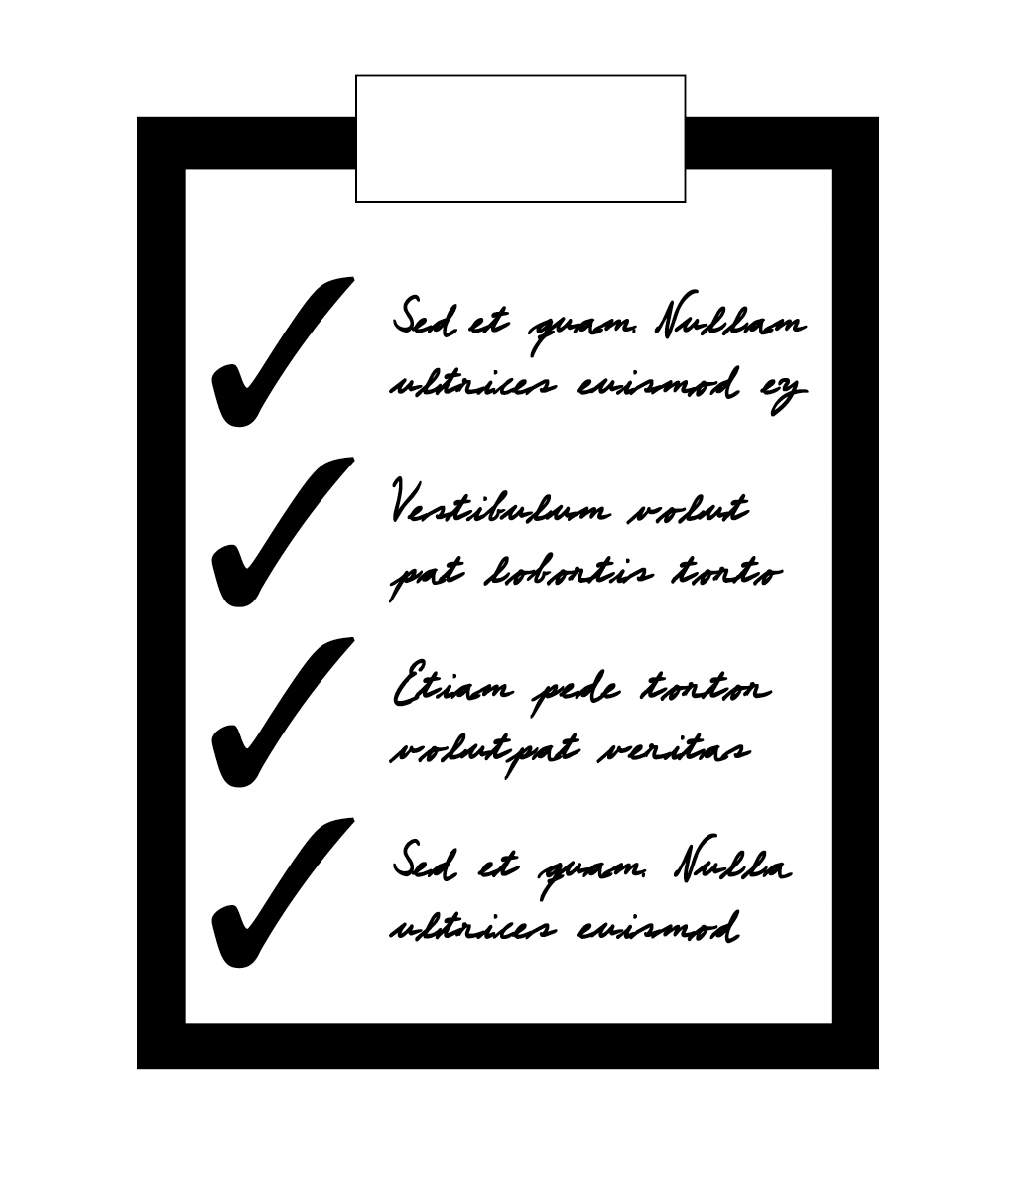 | - One session of this module (Session 6.1) will be conducted before the practicum; the remaining sessions will be conducted after the practicum and provide time to debrief from the practicum and conclude the course.  - Review “Appendix 6A, Practicum Checklist”. This checklist includes the key core competencies taught during this training and that will be practised during the practicum. Revise the checklist as needed based on the context and practicum opportunities.  - Ensure you have copies of the post-test for all participants

Session 2.1: Practicum Logistics and Expectations

Total Session Time: 20 minutes

Session Objective
After completing this session, participants will:
- Understand the practicum logistics and expectations

Trainer Instructions
Slides 1–5
Step 1: | Session Objective  Explain that the purpose of this session is to introduce the practicum and that the remaining sessions will be completed after the practicum.  Note to trainer: The practicum is discussed further in Trainer Manual Introduction iv: Organizing the Practicum.
Step 2: | Introduce the Practicum  Introduce the practicum to participants using the slide set and explain that this is their chance to practise in a clinical setting the skills they have learned during the past several days.
Step 3: | Ask participants the following questions:  - Have you participated in practicum sessions as part of other trainings?  - If so, what was helpful about these practicum sessions? What could have been done better?  - What are your expectations for this practicum session on Infant HIV Testing?
Step 4: | Logistics  Review the practicum logistics and the assignment of participants to preceptors. Discuss plans for the practicum debrief (on the last day of the training).  Allow time for questions.
Step 5: | Core Competencies  Refer participants to Appendix 6A: Practicum Checklist. Go over the key skills participants will be asked to demonstrate during the practicum, using the checklist as a guide. Remind participants that they may not have an opportunity to practise all of these skills during the formal practicum session, but that they will continue to receive mentorship and support after the training. The checklist can also be used as part of ongoing supportive supervision and mentoring activities.  Ask participants if there are skills or areas on the practicum checklist that they do not feel comfortable with or that they would like to review. Take the needed time to review content areas and skills, pulling in lessons learned from case studies and reviewing key content information as needed.
Step 6: | Conduct During the Practicum  Lead a discussion about conduct, confidentiality, and client consent during the practicum, using the slide set and course content material. Add any additional guidance or rules based on lessons learned during prior practicum sessions.  Make These Points  - The supervised practicum is a chance for participants to apply what they have learned during the training in a clinical setting.  - It is important to be kind, friendly, and respectful when interacting with clients, caregivers, healthcare providers, and managers at the health facility.  - Remember that confidentiality is of extreme importance. Discussions and observations made during the practicum should only be shared with other participants, trainers, or preceptors in your practicum group. If there is need to discuss a case with the wider group for learning purposes, always maintain patient confidentiality by changing client names and any other identifying information.  Answer any remaining questions.
Step 7: | Remind participants of the logistics, including start time, for the practicum. Also let them know date/time and place after the practicum when the group will reconvene to debrief the practicum and complete the training.

Session 6.2: Practicum Debrief and Action Planning

Total Session Time: 120 minutes (2 hours)

Session Objectives
After completing this session, participants will be able to:
- Identify their own strengths and weaknesses in providing infant HIV testing services
- Share ideas for a site-specific action plan to initiate or improve infant HIV testing services

Trainer Instructions
Slides 6–7
Step 1: | Session Objectives  Begin by reviewing the session objectives listed above.
Step 2: | Exercise 1  Assign participants to small groups of 4–6 participants and lead Exercise 1, which provides an opportunity to debrief the completed supervised clinical practicum session.

Exercise 1

Exercise 1: Final practicum debrief: Small and large group discussion
Purpose | To share experiences and lessons learned during the practicum
Duration | 45 minutes
Advance Preparation | None
Introduction | This debrief will provide you with an opportunity to discuss your practicum experiences and to learn from each other.
Activities | Small Group Discussion (25 minutes):  - Break participants into small groups. Mix participants so that they are NOT with people who were in their practicum group (if possible). The objective of this exercise is to encourage participants from different practicum groups to interact and share with one another.  - Give each group a flip chart and markers. Ask participants to take about 25 minutes to discuss and write down responses to the following questions:  - What was your overall experience during the practicum?  - What skills did you find the most difficult to perform?  - What skills did you find the least difficult?  - In which areas would you like more mentoring in the future?  - What did you learn during the practicum that you did not expect to learn?  - What was your most memorable experience during the practicum?  - Once the training is over, how can participants and preceptors continue to support each other in building their skills?  Large Group Discussion (20 minutes):  - Bring the large group back together and ask each of the small groups to briefly present the key points of their discussion back to the large group. The facilitator should note on flip chart and discuss:  - Areas where participants want more mentoring  - How participants and preceptors can continue to support each other  - If possible, allow preceptors to present a summary of their overall experience during the clinical practicum session. Note that individual participant performance should not be discussed in the large group. Instead, preceptors should present key observations made during the practicum, including participant strengths and areas where they still need improvement. Preceptors can also suggest ways for participants to continue building their skills after returning to their sites.
Debriefing | - Congratulate participants on a job well done during the practicum session.  - Remind participants that they will need to continue practicing the skills they learned during the training after they return to their health facilities.  - Encourage participants to help mentor each other as well as other healthcare providers at their facility to ensure that quality infant HIV testing services are provided to all mothers living with HIV and their families.
Adapted from: ICAP. Module 15: Supervised Clinical Practicum. Adolescent HIV Care and Treatment: A Training Curriculum for Health Workers, Trainer Manual (1).

Trainer Instructions
Slides 8–13
Step 4: | Training is the First Step  Remind participants that this training is only the first step in improving and expanding infant HIV testing services. Explain that, during the next exercise, participants will work together to plan the specific actions they will take once they have completed the training and return to their facilities to implement what they have learned.
Step 5: | The WHO Global Strategy on People-centred and Integrated Health Services  Explain that before we start our action plan, we need to talk about people-centred services. Until now we have focused on training you to provide quality, evidence-based services that are scientifically and medically appropriate. But quality services are just one aspect of care. Services also have to be people-centred to attract and retain clients.  Ask participants:  - What do you think is meant by people-centred care?  Fill in using the slide set and Session 6.2 Course Content.
Step 6: | Ask participants:  - In your own clinical practice what do you (your colleagues) do to ensure that your services are people-centred?  - How would you go about making your services more people-centred? [Answers will vary, but encourage participants to get feedback from clients, clients who have dropped out of care, and colleagues and to start by addressing their suggestions. Encourage them to review national or local reports on the topic or review manuals from other clinics or programmes to find out what others have done to attract and retain women of childbearing age. They might also want to consider visiting a neighbouring clinic was a good reputation amongst clients.]  Make These Points  - People-centred care is as important as the provision of evidence-based practice.

Trainer Instructions
Slide 14
Step 7: | Exercise 2  Lead participants through Exercise 2, which will give them the chance to work with other participants from their facility to plan and prioritize what needs to be done and by whom to improve infant HIV testing services when they return to work.  Based on the discussion of people-centred services, in undertaking this action plan, participants should be thinking about the improvements they need to make to welcome and retain clients: whether those changes are in terms of updating practice or making services accessible.

Exercise 2

Exercise 2: Action planning: Small group work and large group discussion
Purpose | To create an action plan to initiate or improve infant HIV testing services at participants’ individual facilities
Duration | 60 minutes
Advance Preparation | - Review Appendix 6B: HIV-exposed Infant Care Action Planning and Implementation Template and make additional copies for participants to write on during the training.
Introduction | Now that you are familiar with some of the key steps that need to be carried out when implementing infant HIV testing services, you will have an opportunity to work with your colleagues to create a site-specific action plan to implement and improve services for mothers with HIV and their children at your own facilities. Remember that this action plan should be achievable and should complement any existing work plans at your facility.  Keep in mind that you will not be able to finish your action plan today, all we expect is that you develop an initial rough draft. I hope that you will take today’s draft to your manager when you get back to work as a way of initiating a discussion on the process of either adding your action plan to an existing strategic plan or consulting with colleagues and administrators to finalize this action plan and use it as a working document to guide the improvement of infant HIV testing services.
Activities | Small group work  - Break participants into small groups so that healthcare providers from the same facilities are together. Where there are only 1 or 2 people from a particular health facility, match them with representatives from similar health facilities (i.e., similar in terms of facility size, rural vs urban, high/low HIV prevalence, etc)  - Ask each small group to assign a facilitator and a notetaker; the notetaker might be the person who has a laptop computer and an electronic copy of Appendix 6B. Groups with representatives from more than one health facility should each take notes. Give each group extra copies of “Appendix 6B: HIV-exposed Infant Care Action Planning and Implementation Template” if needed.  - Ask participants to think through their clinic’s targets around HIV-exposed infant services  - Is your facility reaching all recently delivered mothers with HIV in your area?  - Is your facility testing all HIV-exposed infants at the 4–6 week visit?  - Are all HIV-infected infants getting into care? Do they stay in care until at least 3 months after breastfeeding?  - Is your facility testing 100% of HIV-exposed infants at 9 months of age and again 3 months after cessation of breastfeeding?  - Do clients miss appointments or drop out of care? Why?  - What percentage of your facility’s HIV-exposed infants acquire HIV? What can be done to improve this figure?  - Ask the participants in each group to spend about 60 minutes discussing and filling in “Appendix 6B: HIV-exposed Infant Care Action Planning and Implementation Template,” thinking about what they would like to achieve in the next 6 months. Remind them to think about the specific circumstances at their own facilities as they discuss each section and to be practical—not trying to take on too many activities at once and focusing on the activities that will have the most impact on the availability and quality of services for HIV-exposed infants. They should use the questions in the box below to help with brainstorming.  - Note that, for each objective, participants should talk about likely challenges to implementing the action items and potential solutions to each. Point out the shaded rows for recording these anticipated challenges and possible solutions.  - Wander from group to group to provide support and assistance as needed. After about 25 minutes, mention to participants that they should be about half-way done. After about 50 minutes, ask the small groups to review their 6-month action plan and to draw a star next to the top 3 priority actions.  Report back and large group discussion  - Bring the large group back together and ask each small group to give a brief (5 minute) presentation on their discussion, focusing on the priority items listed in their action plan.  - Discuss the next steps for the action plans. Participants from the same facility will likely need to meet again to complete their action plans. All participants will need to solicit input from their health facility managers and supervisors before their action plan can be finalized.  - Remind participants that the action plans are living documents and that they should be reviewed and updated on a regular basis. For many of the participants, the action plan may be added to an existing facility action plan or strategy document rather than remaining a stand-alone document.
Debriefing | - Emphasize that it is important to begin talking about and writing down a specific action plan now, while everything learned during the training is still fresh in participants’ minds.  - Remind participants that asking colleagues, managers, and supervisors for feedback on the plan can help to ensure that it is realistic and that it has the support of a wider range of clinic staff.  - Reiterate the importance of updating the action plan regularly, perhaps every 3 to 6 months at first.

Exercise 2: Action planning: Small group work and large group discussion,
Questions to help with brainstorming
Identifying patients
- What is your clinic’s system for identifying exposed infants?
- Who will be responsible for identifying HIV-exposed infants in your clinic?

Conducting testing
- Who will test HIV-exposed infants in your clinic?
- How will those who did not attend this training be trained?
- Where will patients be tested?
- Will the test be done during the clinical encounter or will the child be sent to another staff member to do the test? If referring to another staff member, how will the referral process work to ensure that patients don’t get lost?

Recording data
- Do you have your own tracking system for exposed infants?
- Which register(s) or database(s) will you use you use?
- If you are HIV testing in multiple locations, how will the data be centralized?

Processing specimens
- Who will be responsible for storage and quality control?
- Where will specimens be stored?
- Who will be responsible for packaging specimens for transport?
- For clinics, how and when will you get the specimens to the central site for pickup?
- Who will be responsible for ordering new kits/supplies? From where will you get them?

Retrieving data and interpreting results
- Who will be responsible for retrieving, recording, and organizing results?
- Where will clients pick up their results?
- Who will communicate the results of an HIV test to the parents/guardian?

HIV-exposed infant care
- Who will be responsible for the follow-up, assessment, ongoing care, and counselling for exposed infants?
- Where is co-trimoxazole handed out?
- How will you trace infants who don’t return for their regular appointments? How will you follow babies who need repeat testing after weaning?
- How do you address the care of the mother? Do the mother and infant receive care together on the same day, or on separate visits?
- Do the infants get all services, including immunizations on the same day, or need to return for separate visits?
- What if someone doesn’t return to pick up HIV test results? What will you do if an infant has a positive NAT result but has not returned to the clinic? Does your clinic have a system for identifying patients who have not returned for their results and/or the resources to find them in the community? *If not started on ART, HIV-infected infants have a high risk of mortality, so tracking those lost to follow-up should be prioritized*

Linking to care
- What is your referral system for HIV-positive infants? Infants who are severely ill?
- How will you ensure that these children get into care?
- Who at your health centre can help facilitate referrals and ensuring that these infants get into care? Could volunteers, lay providers, outreach workers, or expert clients assist with this?

Adapted from: ICAP. Module 16: Action Planning, Course Evaluation, and Closure. Adolescent HIV Care and Treatment: A Training Curriculum for Health Workers, Trainer Manual (2).

 | Trainer Instructions
Step 8: | Allow 5 minutes for questions and answers on this session.

Session 6.3: Reflection on Training Objectives and Concerns, Expectations, and Strengths

Total Session Time: 25 minutes

Session Objectives
After completing this session, participants will:
- Have discussed whether or not the training objectives were achieved
- Have reflected on the concerns, expectations, and strengths discussed on the first day
- Have listed next steps, including training follow-up and supportive supervision

Trainer Instructions
Slides 15–21
Step 1: | Session Objectives  Begin by reviewing the session objectives listed above.
Step 2: | Training Objectives  Review the training objectives in Module 1, Appendix 1B, asking for a volunteer to read each of the objectives out loud. The Training Objectives also appear in the slides.  After each objective, discuss as a group:  - Did we meet this learning objective during the training?  - How confident do you feel that you will be able to do this when you return to your facility?  - What extra support would you like in this area?  Record answers on flip chart, especially those referring to areas that require extra support.  Make These Points  - There were a number of learning objectives for the training, most of which we have hopefully met.  - Ongoing support, mentoring, and technical assistance will be provided to healthcare providers to help them implement the skills and knowledge developed during this training.

Trainer Instructions
Slides 22–23
Step 3: | Strengths, Concerns, and Expectations  - Refer to the lists of strengths, concerns, and expectations compiled during the first exercise of Module 1 (Exercise 1: “Getting to Know Each Other: Large group discussion and individual reflection”). The lists of strengths, concerns, and expectations should still be posted on the training room wall and participants should also locate their own lists of strengths, concerns, and expectations from the first training day.  - Reinforce the importance of the strengths that each participant brings to his or her work. Ask if anyone would like to add to the strengths list and record contributions on the flip chart.  - Ask: Would anyone like to discuss their current perspective on the concerns listed during the “Getting to know each other” exercise?  - Review the expectations and compare them with what was actually covered. Note any expectations that were not met and discuss next steps to help ensure that these expectations are met in the near future.
Step 4: | Most Valuable Information & Priorities  Go around the room and ask each participant to share:  - What was the most valuable information or skill you learned during this training? (If participants need help, re-word the question by asking: What is the 1 thing you will take away from this training and share with your co-workers who did not attend?)  - What is 1 action that you will prioritize in your work with HIV-exposed infants?
Step 5: | Allow 5 minutes for questions and answers on this session.

Session 6.4: Post-test, Training Evaluation and Closing

Total Session Time: 60 minutes

Session Objectives
In this session, participants will:
- Complete the training post-test
- Evaluate the training and given suggestions for improvement

Trainer Instructions
Slides 24–45
Step 1: | Session Objectives  Begin by reviewing the session objectives listed above.
Step 2: | Objective of Post-test  Distribute the post-test to all participants, explaining that it contains the same questions as the pre-test they took the first day of training.  As in Module 1, explain that the objective of the post-test is not to look at individual scores, but rather to find out what the group as a whole knows about infant HIV testing and how much the group’s knowledge has improved since the beginning of the training. Results of the post-test and how they compare with pre-test scores will help improve future trainings and will provide trainers with important information on ongoing mentoring and supervision needs.
Step 3: | Administer Post-test  If you wanted to compare individual pre- and post-test results, participants should identify their post-test form as they did for their pre-test (on the first day of training).  Give participants about 20 minutes to individually complete the questions and ask them to hand their completed post-tests to a trainer when they have finished.  After the post-test, ask participants how they felt answering the questions today, compared with on the first day of training.
Step 4: | Review Post-test Answers  Once you have all the post-tests, review the answers to each question using Module 1: Appendix 1C. Pre-Post Test and the slides as guides.  Tell participants that the post-test scores will be compared to the pre-test scores to get a sense of how much they, as a group, have learned.
Step 5: | Exercise 3  Lead participants through Exercise 3, which will give them a chance to evaluate the training.
Step 6: | After the Training: Note to Trainers  Once the training is complete, calculate how many participants got question 1 correct, how many got question 2 correct, etc. until you have calculated the number correct for every question. Compare the pre-test scores with the post-test scores and discuss the results with your co-trainers and supervisors. Include the scores and any recommendations in the training report.

Exercise 3

Exercise 3: Training evaluation: Individual work
Purpose | To get participants’ feedback on the training
Duration | 15 minutes
Advance Preparation | Refer to the section entitled “Training Evaluation Form” in Section iii. Managing the Training Session: Tips for the Trainer of the introduction to the Trainer Manual for additional guidance.
Introduction | Now we will take a few minutes to evaluate the training. We encourage you to give honest feedback, both positive and negative). The evaluation forms will be reviewed carefully and your feedback will help us improve future trainings.
Activities | - Refer participants to Appendix 6C: Training Evaluation Form. Remind them that they do not have to write their name or position on the form if they do not want to, but that it would be helpful for them to provide the name of their facility (if they feel comfortable doing so).  - Give participants 10–15 minutes to complete the training evaluation.  - When they have finished, ask participants to put their evaluation forms face down in a pile in the front of the room.
Debriefing | Thank participants for their feedback and suggestions and reiterate the importance of this feedback for improving future trainings.
Adapted from: ICAP. Module 16: Action Planning, Course Evaluation, and Closure. Adolescent HIV Care and Treatment: A Training Curriculum for Health Workers, Trainer Manual (2).

Trainer Instructions
Slide 46
Step 8: | Congratulate Participants and Give Certificates  Once again, congratulate participants on a job well done. Present each participant with a training completion certificate (or ask an invited guest to do so), which you will find on the last page of this module.
Step 9: | Closing  If a guest speaker was invited, ask that person to say a few words to close the training. If there is no guest speaker, the trainers can formally close the training.

Module 6, Part 2: Course Content

Session 6.1 Course Content: Practicum Logistics and Expectations

Core Competencies
Participants will be asked to practise and demonstrate a number of skills learned during the training. Refer to Appendix 6A: Practicum Checklist for more information on these core competencies. Preceptors will be available to help and mentor participants as they master the skills learned during training.

Conduct During the Practicum
- Remember that we are guests at the health facility and must respect the wishes of the healthcare providers and managers who work at the facility.
- Keep all discussions and observations during the practicum confidential. Only share with other participants, trainers, or preceptors, and only for learning purposes. When discussing cases after the practicum, change any identifying information about specific clients so that no one will be able to guess who is being described.
- Always inform the preceptor if you need to take a break or leave the facility for any reason during the practicum.
- Always introduce yourself to other healthcare providers and clients. Tell them that you are currently completing a course about infant HIV testing and that the training includes observation and practise in the health facility.
- Always ask caregivers for their verbal consent for you to observe or practise skills. Keep in mind that clients have the right to refuse to consent or to withdraw their consent at any time. Participants and preceptors are obligated to concede to the client’s request.
- Always ask the preceptor if you have a question or concern.

Preceptors will be using Appendix 6A: Practicum Checklist to assess participant performance during the practicum. Participants should familiarize themselves with the content of this form, including how preceptors will make their final evaluations.

Session 6.2 Course Content: Practicum Debrief and Action Planning

The WHO Global Strategy on People-centred and Integrated Health Services
There are many different aspects involved in the successful provision of HIV-exposed infant care. This training focused on the provision of quality, evidence-based services that are scientifically and medically appropriate. But anyone who has been treated poorly at a healthcare facility will tell you that in order to attract and retain clients, the staff at a healthcare facility have to be more than technically competent. Their services must also be people-centred.

The WHO global strategy on people-centred and integrated health services (see definitions in box below) represents a fundamental shift in the way health services should be funded, managed and delivered. Without a people-centred and integrated health services approach, health care will become increasingly fragmented, inefficient and unsustainable. The strategy proposes that all people have access to health services provided in a way that responds to their needs and that are equitable, safe, effective, efficient, timely and of an acceptable quality.

Within the context of HIV care service delivery, people-centred care includes:
- Building healthcare providers’ skills for effective communication with people;
- Providing information and supporting people to make informed decisions and for their active engagement in their own care and self-management;
- Offering a patient appointment system and acceptable frequency of facility visits;
- Avoiding long health facility waiting times during clinical consultations, medication pick-up or laboratory services;
- Coordinating care when people require multiple services (e.g. TB and HIV treatment, family-centred care); and
- Providing comprehensive integrated services, as appropriate and relevant.

People-centred and Integrated Health Services
People-centred health services involve an approach to care that consciously adopts the perspectives of individuals, families and communities and sees them as participants as well as beneficiaries of trusted health systems that respond to their needs and preferences in humane and holistic ways. People-centred care requires that people have the education and support they need to make decisions and participate in their own care. It is organized around the health needs and expectations of people rather than diseases.

Integrated health services are health services that are managed and delivered in a way that ensures that people receive a continuum of health promotion, disease prevention, diagnosis, treatment, disease management, rehabilitation and palliative care services at the different levels and sites of care within the health system and according to their needs, throughout their whole life.

Source: WHO, 2015 (3) and 2016 (4)

Appendix 6A: Practicum Checklist
Adapted from: ICAP. Module 15: Supervised Clinical Practicum. Adolescent HIV Care and Treatment: A Training Curriculum for Health Workers, Trainer Manual (1).

Preceptor instructions: Use 1 checklist per participant in your group. As you observe the participant using a specific skill, grade performance in the “Rating” column as GOOD, FAIR, or POOR. Be prepared to share your comments with the participant. Participant instructions: Complete this checklist during the practicum, assessing your own performance. In the “Comments” column, record areas where you feel you need improvement or further study.

Name of Participant: _____________ Dates of Practicum: ______________
Name of Preceptor(s): _____________ Name of Health Facility: _______________
Core competencies | Rating | Comment
Demonstrates how to routinely screen infants for HIV-exposure status
Observes at least 1 HIV-exposed infant routine 4–6 week visit, from beginning to end
Conducts at least 1 HIV-exposed infant focused clinical examination
Assesses growth (weight, length) for at least 2 HIV-exposed infants and plots on growth chart
Discusses infant ARV prophylaxis with at least 1 caregiver of HIV-exposed infants
Discusses co-trimoxazole prophylaxis with at least 1 caregiver of HIV-exposed infant
Provides adherence screening and support for at least 1 caregiver of an HIV-exposed infant
Provides infant and young child feeding counselling for at least 1HIV-exposed infants
Assesses mother’s health, ART adherence, and (if applicable) viral suppression
Conducts all steps of the pre-test session for at least 1 HIV-exposed infant caregiver
Conducts all steps of the post-test session for at least 1 HIV-exposed infant caregiver
Uses open-ended questions when communicating with and counselling caregivers
Empathizes with the caregivers and shows understanding
Avoids words that sound judging when communicating with caregivers
Orders correct HIV test procedure (virological vs serological testing) based on infant age
Correctly interprets HIV test result based on infant age and breastfeeding status
Uses Universal Precautions when handling body fluids and sharps
Identifies the best place to prick the infant according to infant size and age
Follows correct procedure when pricking infant for DBS: shows mother how to hold infant, warms the area, washes hands, cleans area to be pricked
Correctly collects blood from at least 2 infants on at least 2 DBS filter papers (samples must be valid)
Correctly dries, packs, labels and stores DBS specimens to send to the laboratory
Completes all laboratory forms associated with shipping DBS samples to the laboratory
Uses register to identify when follow up is required on a delayed or missing result
Uses register to identify which patients have not yet showed for a result that has been returned

Note to trainers: If POC testing is widely used, provide participants with exposure to POC testing during practicum experience.

FINAL EVALUATION BY PRECEPTORS:

Name of participant: ___________________________________________

Tick one:

____ Demonstrated a majority of core competencies effectively and is ready to start providing infant HIV testing services in a clinical setting

____ Demonstrated some core competencies effectively, but still needs more practice before providing infant HIV testing services in a clinical setting

____ Unable to demonstrate most skills and should participate in the training course again before providing infant HIV testing services in a clinical setting

Additional comments:

Preceptor(s) signature(s): _______________________________

Date: ______________________________

Appendix 6B: HIV-exposed Infant Care Action Planning and Implementation Template

Instructions: After brainstorming areas for improvement at your facility, select 2–3 objectives that you think are the most important areas for improvement. For each objective, list specific activities, persons, responsible, resources needed, timeline, and how activity outcomes will be measured (means of verification).

Objective | What is the specific activity? | Who is responsible? | What resources or support are needed? | When will the action happen? | Means of verification
 | 1.
 | 2.
 | 3.
 | 1.
 | 2.
 | 3.
 | 1.
 | 2.
 | 3.
 | 1.
 | 2.
 | 3.
 | 1.
 | 2.
 | 3.
Anticipated challenges to implementing this objective and possible solutions:
1.
2.
3.
4
Adapted from: Adapted from: ICAP. Module 16: Action Planning, Course Evaluation, and Closure. Adolescent HIV Care and Treatment: A Training Curriculum for Health Workers, Trainer Manual (2).

Appendix 6C: Training Evaluation Form

Name (optional): ______________________________________

Date: _____________

INSTRUCTIONS: Please rate the following statements on a scale from 1 to 5.
 | Strongly Disagree | Disagree | Neither agree nor disagree | Agree | Strongly Agree
- The training objectives were clear. | 1 | 2 | 3 | 4 | 5
- This training met my expectations. | 1 | 2 | 3 | 4 | 5
- The technical level of this training was appropriate. | 1 | 2 | 3 | 4 | 5
- The pace of this training was appropriate. | 1 | 2 | 3 | 4 | 5
- The facilitators were engaging (i.e., interesting). | 1 | 2 | 3 | 4 | 5
- The information I learned in this training will be useful to my work. | 1 | 2 | 3 | 4 | 5
- I am confident that after this training, I will be able to provide high quality HIV-related care, treatment, and support services to HIV-exposed infants. | 1 | 2 | 3 | 4 | 5

How helpful were each of the training modules to you and your work? If you have specific comments, please write them on the next page.
 | Not helpful |  |  |  | Very helpful
Module 1: Course Introduction | 1 | 2 | 3 | 4 | 5
Module 2: Testing of HIV-exposed Infants | 1 | 2 | 3 | 4 | 5
Module 3: Comprehensive Care for HIV-exposed Infants | 1 | 2 | 3 | 4 | 5
Module 4: Pre-test Information and DBS Collection for Infant Virological Testing | 1 | 2 | 3 | 4 | 5
Module 5: Post-test Counselling for Infant HIV Testing | 1 | 2 | 3 | 4 | 5
Module 6: Course Summary, Practicum and Wrap Up | 1 | 2 | 3 | 4 | 5

What was the best part of this training?

How could we improve this training?

Other comments:

Thank you for your participation and for your commitment to HIV-exposed infants and their families!

References

1. ICAP. Module 15: Supervised Clinical Practicum. Adolescent HIV Care and Treatment: A Training Curriculum for Health Workers, Trainer Manual. https://icap.columbia.edu/tools_resources/adolescent-hiv-care-and-treatment-a-training-curriculum-for-health-workers/2012.
2. ICAP. Module 16: Action Planning, Course Evaluation, and Closure. Adolescent HIV Care and Treatment: A Training Curriculum for Health Workers, Trainer Manual. https://icap.columbia.edu/tools_resources/adolescent-hiv-care-and-treatment-a-training-curriculum-for-health-workers/2012.
3. WHO. WHO global strategy on people-centred and integrated health services: Interim report. http://apps.who.int/iris/bitstream/handle/10665/155002/WHO_HIS_SDS_2015.6_eng.pdf;jsessionid=B29437C4D3EAE0F12E69D5B8F465FFF3?sequence=1; 2015.
4. WHO. Consolidated Guidelines on the Use of Antiretroviral Drugs for Treating and Preventing HIV Infection: Recommendations for a Public Health Approach. 2016.

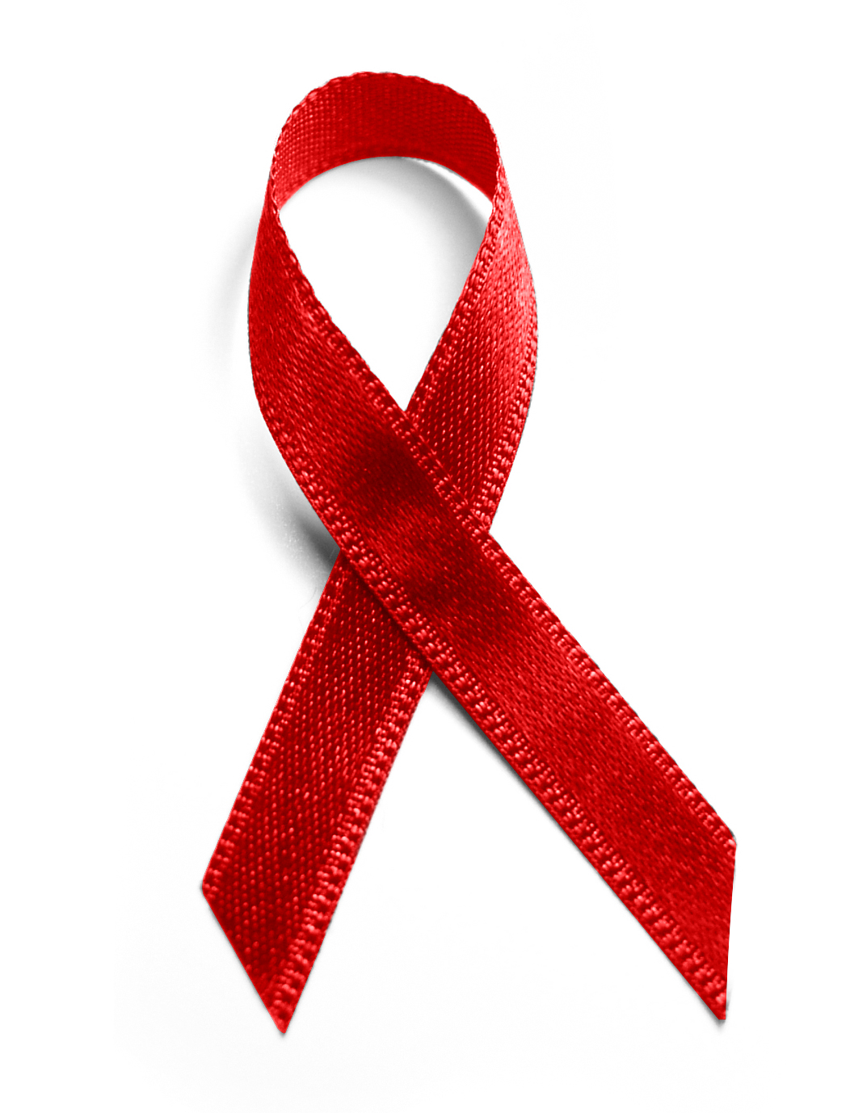
This Certificate is awarded to
for successful completion of clinical training in
Infant HIV Testing

Trainer

Official

Date

