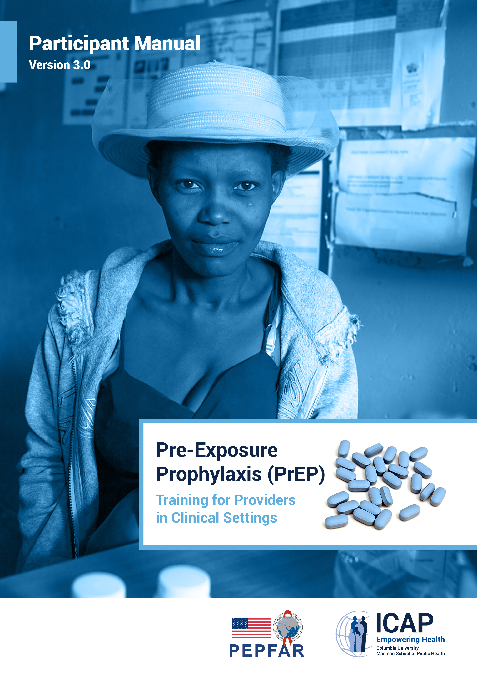

*Pre-Exposure Prophylaxis (PrEP) Training for Providers in Clinical Settings: Participant Manual, Version 3.0,* wasdeveloped by ICAP at Columbia University in collaboration with the U.S. Centers for Disease Control and Prevention (CDC), with funding from the U.S. President’s Plan for AIDS Relief (PEPFAR) under the terms of cooperative agreement #U2GGH000994. Its contents are solely the responsibility of the authors and do not necessarily represent the views of the U.S. Government.

The training was developed as a set of tools that are adaptable to each county’s context and guidelines. The use of PrEP is evolving, so it is expected that these documents will require updating over time as recommendations change.

Organizations and entities that choose to adapt these documents for their own use should credit ICAP at Columbia University and note that their work is an adaption.

For questions about the contents or use, please contact ICAP at icap-communications@columbia.edu.

**Recommended Citation**

*Pre-Exposure Prophylaxis (PrEP) Training for Providers in Clinical Settings: Participant Manual, Version 3.0.* New York: ICAP at Columbia University; 2019.

ICAP at Columbia University

Mailman School of Public Health

722 West 168th Street, 13th Floor

New York, NY 10032, USA

Email: [icap-communications@columbia.edu](mailto:icap-communications@columbia.edu)

Web: [www.icap.columbia.edu](http://www.icap.columbia.edu)

**Foreword**

Despite remarkable progress in HIV treatment, annual new infections have hovered close to 2 million globally for several years, with an estimated 1.8 million new HIV infections in 2017. Thus, large numbers of individuals remain at substantial risk for acquisition of HIV infection. Key populations at substantial risk include sex workers (SW), men who have sex with men (MSM), transgender persons (TG), and people who inject drugs (PWID), as well as other priority populations such as sexually active adolescent girls and young women in southern Africa. These realities compel the need for continued efforts to expand access to effective HIV prevention interventions while at the same time continuing the scale-up of access to HIV treatment programs for individuals living with HIV.

PrEP is an efficacious HIV prevention intervention. It involves the use of antiretroviral drugs (ARVs) by HIV-negative persons to prevent acquisition of HIV. Several clinical trials have demonstrated the efficacy of PrEP in MSM and transgender women, serodiscordant couples, heterosexual men and women, and PWIDs. PrEP is provided as a component of a package of HIV prevention interventions, including: regular HIV testing; promotion and provision of condoms; screening and management of sexually transmitted infections (STIs); risk reduction counseling; and harm reduction interventions. There is global consensus that PrEP is an important tool in the package and that it should be offered to people at substantial risk for HIV infection as part of a combination HIV prevention approach.

Health care providers, and HIV service providers in particular, are important gatekeepers of PrEP and play a crucial role in creating HIV prevention programs that are effective and that reach the individuals who would most benefit from PrEP. The goal of ICAP’s PrEP training package is to equip clinical providers with the skills to provide PrEP in a safe, effective manner. The training provides information on the evidence for PrEP effectiveness, on PrEP procedures, and on monitoring and evaluation of PrEP service delivery. PrEP offers a unique opportunity to confront the HIV epidemic, prevent HIV acquisition by individuals at risk for HIV, and reach global targets.

This training is intended for healthcare workers who are already familiar with the basics of HIV prevention, care, and treatment. It is anticipated that facilities will need to adapt this training to reflect specific contexts and to include evidence from new research and experience in the use of PrEP.

ICAP at Columbia University

New York City

March 2019

Web: [http://icap.columbia.edu](http://icap.columbia.edu/)

# CONTENTS

[ACRONYMS vi](#_Toc2634763)

[TRAINING OVERVIEW 1](#_Toc2634764)

[MODULE 1: PrEP BASICS 4](#_Toc2634767)

[Introduction to PrEP 4](#_Toc2634768)

[Definitions 5](#_Toc2634769)

[Global Progress of PrEP 5](#_Toc2634770)

[Differences Between PrEP, PEP, and ART 5](#_Toc2634771)

[Why We Need PrEP 6](#_Toc2634772)

[Key Population Definitions 6](#_Toc2634773)

[PrEP Studies 7](#_Toc2634774)

[PrEP Use in a Routine Setting 10](#_Toc2634775)

[PrEP Regimens and Side Effects 13](#_Toc2634776)

[Risk Behaviors, HIV Drug Resistance, and Sexually Transmitted Infections 14](#_Toc2634777)

[Module 1 Summary 14](#_Toc2634778)

[MODULE 2: PrEP SCREENING AND ELIGIBILITY 15](#_Toc2634779)

[WHo Should Receive PrEP? 15](#_Toc2634780)

[Acute HIV Infection 16](#_Toc2634781)

[Substantial Risk for HIV Infection 18](#_Toc2634782)

[Serodiscordant Couples 19](#_Toc2634783)

[Creatinine and Estimated Creatinine Clearance 20](#_Toc2634784)

[PrEP Use During Pregnancy 20](#_Toc2634785)

[Women and PrEP 20](#_Toc2634786)

[Willingness to Use PrEP As Prescribed 21](#_Toc2634787)

[The Screening for Substantial Risk and Eligibility Form 21](#_Toc2634788)

[Clinical Scenarios 21](#_Toc2634789)

[Screening Role-Plays 22](#_Toc2634790)

[Module 2 Summary 23](#_Toc2634791)

[MODULE 3: INITIAL AND FOLLOW-UP PrEP VISITS 24](#_Toc2634792)

[Initial PrEP Visit Suggested Procedures 24](#_Toc2634793)

[Supporting Adherence 28](#_Toc2634794)

[Approaches to Promoting Adherence 31](#_Toc2634795)

[Integrated Next Step Counseling 32](#_Toc2634796)

[HIV Risk Reduction Strategies 33](#_Toc2634797)

[iNSC Role Plays 34](#_Toc2634798)

[PrEP Follow-Up Visits 34](#_Toc2634799)

[PrEP Discontinuation 37](#_Toc2634800)

[PrEP Clinical Pathway 37](#_Toc2634801)

[Information, Education, and Communication 38](#_Toc2634802)

[Module 3 Summary 39](#_Toc2634803)

[MODULE 4: MONITORING AND MANAGING PrEP SIDE EFFECTS, SEROCONVERSION, AND STIGMA 40](#_Toc2634804)

[Monitoring and Managing Creatinine Elevation 40](#_Toc2634805)

[Seroconversion on PrEP 40](#_Toc2634806)

[PrEP Special Situations 41](#_Toc2634807)

[Minimizing PrEP Stigma 41](#_Toc2634808)

[Gaps in PrEP Knowledge and Need for Continued Surveillance 42](#_Toc2634809)

[Module 4 Summary 42](#_Toc2634810)

[MODULE 5: PrEP MONITORING AND EVALUATION TOOLS 43](#_Toc2634811)

[Monitoring and Evaluation Forms 43](#_Toc2634812)

[M&E Practice Scenarios 45](#_Toc2634813)

[Sample Data for PrEP Monthly Summary Form 47](#_Toc2634814)

[Entry Points for PrEP 48](#_Toc2634815)

[PrEP Client and Clinic Flow 49](#_Toc2634816)

[Discontinuing PrEP 51](#_Toc2634817)

[PrEP Outreach for Follow-Up 52](#_Toc2634817)

[PrEP Client Definitions 52](#_Toc2634818)

[Module 5 Summary 53](#_Toc2634818)

[MODULE 6: POST-TRAINING ASSESSMENT, EVALUATION, AND CLOSING 54](#_Toc2634819)

[APPENDIX 5](#_Toc2634820)5

[A. Pre-and Post-Training Assessment for PrEP Training for Providers in Clinical Settings 56](#_Toc2634821)  
[B. Materials Needed for Participant Folders 58](#_Toc2634821)

[C. PrEP Clinical Pathway 59](#_Toc2634822)

[D. Screening for Substantial Risk of HIV Infection 60](#_Toc2634823)

[E. Provider Checklist for Initial PrEP Visit 61](#_Toc2634824)

F. Provider Checklist for Follow-Up PrEP Visits 62

[G. Provider Checklist for Substantial Risk 63](#_Toc2634825)

H. Frequently Asked Questions about PrEP 64

# ACRONYMS

|  |  |
| --- | --- |
| AHI | acute HIV infection |
| ART | antiretroviral therapy |
| ARV | antiretroviral |
| CDC | Centers for Disease Control and Prevention |
| FSW | female sex worker |
| FTC | emtricitabine |
| Ab/Ag | antibody/antigen |
| HBsAg | hepatitis B surface antigen |
| HBV | hepatitis B virus |
| HCV | hepatitis C virus |
| HIV | human immunodeficiency virus |
| HIV-DR | HIV drug resistance |
| HTS | HIV testing services *or* HIV testing strategy |
| iNSC | integrated next step counseling |
| IPV | intimate partner violence |
| LTFU | loss to follow-up, lost to follow-up |
| MSM | men who have sex with men |
| NSC | next step counseling |
| PEP | post-exposure prophylaxis |
| PMTCT | prevention of mother-to-child transmission [of HIV] |
| PrEP | pre-exposure prophylaxis |
| PWID | person who injects drugs |
| RCT | randomized controlled trial |
| RNA | ribonucleic acid |
| RPR | rapid plasma reagin (test for syphilis) |
| STI | sexually transmitted infection |
| TasP | treatment as prevention |
| TDF | tenofovir disoproxil fumarate |
| TG | transgendered person |
| UNAIDS | Joint United Nations Programme on HIV/AIDS |
| VMMC | voluntary male medical circumcision |
| WHO | World Health Organization |
| 3TC | lamivudine |

# TRAINING OVERVIEW

# Training Goals and Development

The goal of the *Pre-Exposure Prophylaxis* (*PrEP) Training for Providers in Clinical Settings* is to equip HIV care providers with the knowledge and skills necessary to provide PrEP to appropriate candidates and with high quality in order to decrease the risk of HIV infection.

ICAP at Columbia University used a backward design approach to develop this training. First, content and training experts were identified. Together, these experts developed a series of competency statements (tasks or skills) that HIV care providers would need in order to provide PrEP to appropriate candidates with the required level of proficiency. Next, the team created learning objectives and assessment measures to describe what HIV care providers should be able to achieve at the end of the training program. These learning objectives were then sequenced and grouped into 6 learning modules. Finally, the team created learning activities and training tools for all learning objectives. Training tools include a trainer manual, a participant manual, job aids, tools for monitoring and evaluation (M&E), and a comprehensive slide set with essential content, visuals, and talking points.

**Competencies and Content Areas**

During the training, health providers will develop core competencies—specifically, they will be able to:

Identify eligible candidates for PrEP.

Assess individual risk for HIV.

Educate and counsel PrEP candidates and users.

Assess medical eligibility for PrEP.

Prescribe PrEP.

Conduct clinical and laboratory assessments during follow-up PrEP visits.

Determine how PrEP M&E tools can be used locally.

Provide adherence education, counseling and support to PrEP candidates and users.

This is a classroom-based training. Content areas include:

PrEP basics.

PrEP screening and eligibility.

Initial and follow-up PrEP visits.

Monitoring and managing PrEP side effects, seroconversion, and stigma.

M&E tools for local use.

The target population for this training includes providers and related health care team members with *existing* knowledge and experience in HIV prevention, care, and treatment programs, including:

Physicians.

Medical officers.

Clinical officers.

Nurses.

Nurse midwives.

Prevention and treatment counselors.

Lay or peer outreach workers and educators.

M&E staff.

## Participant Manual

The participant manual is divided into 6 modules, each containing the learning objectives, all content to be delivered (from the slides), scenarios, role-plays, and instructions for pair and small group activities. Participants will use the manuals throughout the training. In some training sessions, participants will close their manuals in order to attend to an interactive trainer presentation. In other sessions, participants will have their manuals open in order to read content or follow activity instructions. Participants should retain their manuals after the training’s end. Please review the entire participant manual before leading the training.

**PrEP Resources**

**PrEP Resources for Providers**

Centers for Disease Control and Prevention. *Pre-Exposure Prophylaxis (PrEP).* [http://www.cdc.gov/hiv/risk/prep/.](http://www.cdc.gov/hiv/risk/prep/) Accessed January 11, 2019.

Fonner VA, Dalglish SL, Kennedy CE, et al. Effectiveness and safety of oral HIV pre-exposure prophylaxis for all populations. *AIDS.* 2016; 30(12): 1973-1983. doi:10.1097/QAD.0000000000001145.

Glidden DV, Amico KR, Liu AY, et al. Symptoms, side effects and adherence in the iPrEx open-label extension. *Clin Infect Dis.* 2016; 62(9):1172-1177. <https://doi.org/10.1093/cid/ciw022>.

Mofenson LM; for the World Health Organization. *Review: Safety of Tenofovir PrEP in Pregnant and Breastfeeding HIV-Uninfected Women and Their Infants.* <https://www.childrenandaids.org/sites/default/files/2018-05/PrEP%20in%20Pregnancy%20Review%20Presentation_11%20August%202016.pdf>. Accessed January 11, 2019.

PrEP Watch. [http://www.prepwatch.org/.](http://www.prepwatch.org/)

The Fenway Institute. *PrEP Clinical Study Data Sheet.* <http://www.projectinform.org/pdf/prepstudydata.pdf>. Accessed January 11, 2019.

UNAIDS. *M&E Guidelines: M&E of Key Populations at Higher Risk for HIV.* Geneva: UNAIDS; 2018. <http://www.unaids.org/en/dataanalysis/monitoringandevaluationguidance>. Accessed January 11, 2019.

UNAIDS. *Oral Pre-Exposure Prophylaxis: Putting a New Choice in Context. Geneva: UNAIDS; 2015.* <http://www.unaids.org/sites/default/files/media_asset/UNAIDS_JC2764_en.pdf>. Accessed January 11, 2019

World Health Organization. *Consolidated Guidelines on the Use of Antiretroviral Drugs for Treating and Preventing HIV Infection: Recommendations for a Public Health Approach.* 2nd edition. Geneva: World Health Organization; 2016. <http://www.who.int/hiv/pub/arv/arv-2016/en/>. Accessed January 11, 2019.

World Health Organization. *PrEP.* Geneva: WHO; 2018. [http://www.who.int/hiv/topics/prep/en/://www.who.int/hiv/topics/prep/en/](http://www.who.int/hiv/topics/prep/en/:/www.who.int/hiv/topics/prep/en/). Accessed January 11, 2019.

World Health Organization. *Preventing HIV during Pregnancy and Breastfeeding in the Context of PrEP: Technical Brief.* Geneva: World Health Organization; 2017. <https://www.who.int/hiv/pub/toolkits/prep-preventing-hiv-during-pregnancy/en/>. Accessed January 11, 2019.

World Health Organization. Public health approach to quality HIV testing in the context of antiretroviral drugs. Paper presented at: Centre for the AIDS Programme of Research in South Africa; December 12-13, 2017; Durban, South Africa. <http://www.who.int/hiv/pub/meetingreports/quality-hiv-testing-meeting/en/index1.html>. Accessed January 11, 2019.

World Health Organization. *WHO Implementation Tool for Pre-Exposure Prophylaxis of HIV Infection.* Geneva: World Health Organization; 2018. <http://www.who.int/hiv/pub/prep/prep-implementation-tool/en/>. Accessed January 11, 2019.

**PrEP Resources for PrEP Users**

Centers for Disease Control and Prevention. *HIV/AIDS: PrEP.* <https://www.cdc.gov/hiv/risk/prep/index.html>. Accessed March 1, 2019.

Centers for Disease Control and Prevention. *PrEP: An HIV Prevention Option.* Video. <https://www.youtube.com/watch?v=TR8-3uAuZGo>. Accessed March 1, 2009.

Please PrEP Me. *What Is PrEP?* [http://www.PleasePrEPMe.org/resources](http://www.pleaseprepme.org/resources). Accessed January 11, 2019.

PrEP Project. What Is PrEP? http://www.whatisprep.org. Accessed January 11, 2019.

PrEPWatch. The Basics. https://www.prepwatch.org/about-prep/basics/. Accessed March 1, 2019.

*PrEP Facts: Rethinking HIV Prevention and Sex.* <https://www.facebook.com/groups/PrEPFacts/>. Accessed January 11, 2019.

PrEP Project. *What Is PrEP?* [http://www.whatisprep.org](http://www.whatisprep.org/). Accessed January 11, 2019.

PrEPWatch. *The Basics.* <https://www.prepwatch.org/about-prep/basics/>. Accessed March 1, 2019.

Terrence Higgins Trust. *What Is PrEP?* [http://www.iwantprepnow.co.uk](http://www.iwantprepnow.co.uk/). Accessed January 11, 2019.

# MODULE 1: PrEP BASICS

###### LEARNING OBJECTIVES

After completing Module 1, participants will be able to:

* Define PrEP.
* Differentiate PrEP from post-exposure prophylaxis (PEP) and antiretroviral therapy (ART).
* Describe the need for PrEP.
* Identify people at risk and people at substantial risk for HIV infection.
* Identify key populations (KPs) for PrEP at the local level.
* Explain the relationship between PrEP effectiveness and adherence.
* State the key reasons why PrEP is needed.
* Specify the PrEP regimens approved by WHO and within one’s own country.
* Identify concerns regarding the implementation of PrEP.
* Explain the risks and benefits of PrEP.

### INTRODUCTION to PrEP

HIV prevention needs change over a lifetime. Combination prevention is a mixof biomedical, behavioral, and structural interventions that decrease risk of HIV acquisition. Greater impact may come from combining approaches than from using single interventions alone.

Antiretroviral drugs (ARVs) used as PrEP provide an important *additional* prevention tool.

**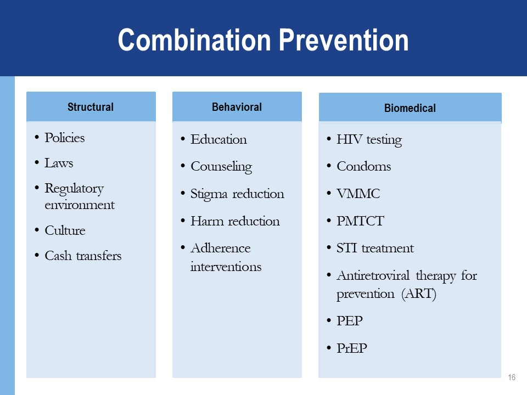**

### DEFINiTIONS

PrEP is the use of ARVs by people who are HIV negative to prevent the acquisition of HIV *before* exposure to the virus.

Pre = Before

Exposure = Activity that can lead to HIV infection

Prophylaxis = Prevention

PEP is short-term antiretroviral treatment to reduce the likelihood of HIV infection after potential exposure, either occupationally or nonoccupationally—for instance, through sexual intercourse.[[1]](#footnote-1)

### GLOBAL PROGRESS OF PrEP

2012: FDA approval in the United States

2015: WHO recommendation

2016: Southern African guidelines on PrEP for persons at risk, including adolescents

2018: Adolescents included in PrEP recommendations in the United States

Regulatory approval in dozens of countries

Access through programs and research in several others

### DIFFERENCES BETWEEN PrEP, PEP, and ART

##### PrEP and PEP

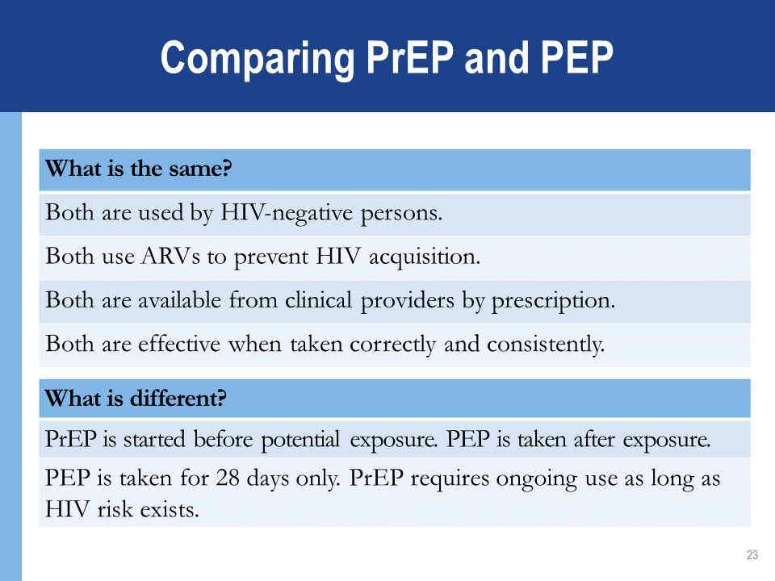

##### ART and PrEP

Treatment for HIV infection requires lifelong ART and consistently high adherence to achieve viral suppression.

PrEP is needed during periods of substantial HIV risk.

Individuals taking PrEP receive regular risk assessment. Discontinuing PrEP is appropriate when they:

* Are no longer at substantial risk for HIV infection.
* Decide to use other effective prevention methods.

Motivation for adherence is different.

* ART is taken regularly by HIV-positive persons to remain healthy and keep from infecting others.
* PrEP is taken by HIV-negative persons who are largely healthy to avoid acquiring HIV infection.

### WHY WE NEED PrEP

Several effective HIV prevention interventions already exist, including condoms and harm reduction for persons who inject drugs (PWID).

Global annual HIV infections have remained consistently close to  
2 million for several years, declining in recent years.

HIV incidence remains high among key and vulnerable populations: PWID, sex workers (SWs), transgender persons (TG), and men who have sex with men (MSM).

PrEP provides an *additional* prevention intervention to be used *together* with existing interventions like condoms.

PrEP is notmeant to replace or be a substitute for existing prevention interventions.

(The trainer will provide information on local epidemiology.)

### KEY POPULATION DEFINITIONS

“Key populations” are groups of people most at risk for contracting HIV. They include:

Men who have sex with men.

Transgender people.

Sex workers.

People who inject drugs.

People in prisons and other closed settings (PP).

Other priority populations include:

Clients of sex workers.

Migrant workers.

Fisher folk.

Adolescent girls and young women (AGYW).

### PrEP STUDIES

****

**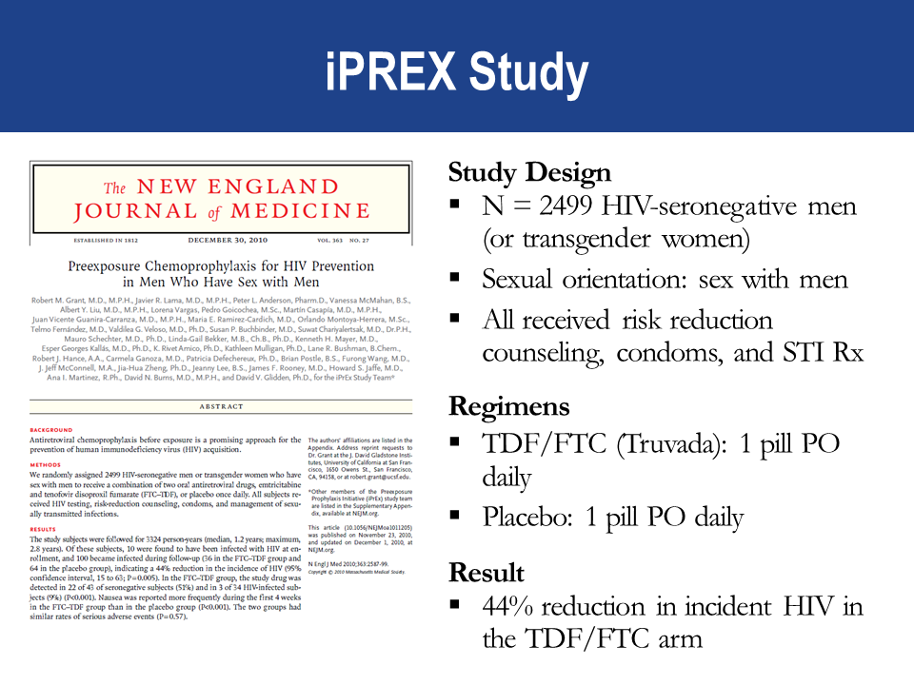**

##### 

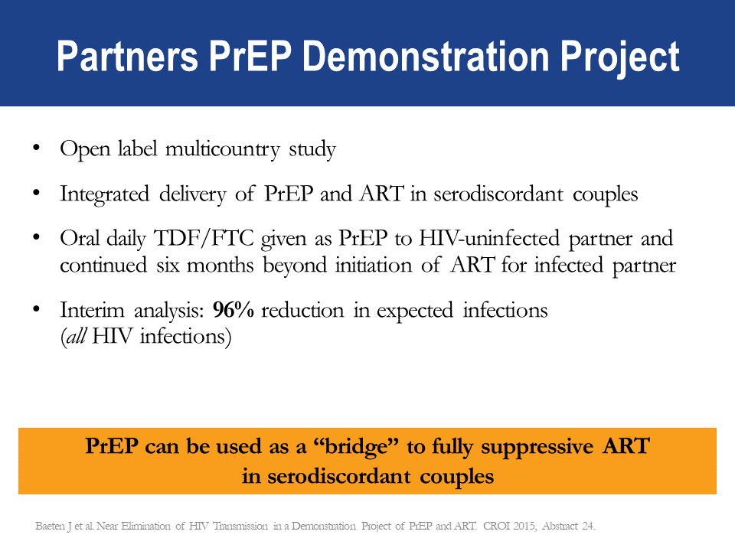

**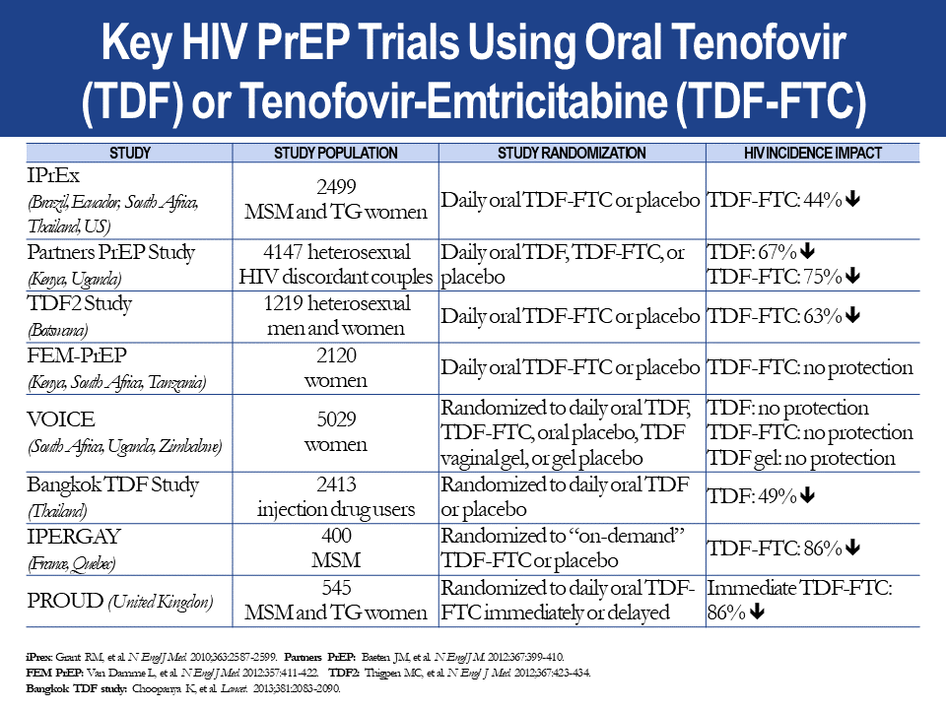**

##### Evidence PrEP Works

PrEP efficacy was measured in:

11 randomized control trials (RCT) comparing PrEP with placebo.

3 RCTs comparing PrEP with no PrEP (e.g. delayed PrEP or “no pill”).

3 observational studies.

Multiple demonstration projects across the globe.

PrEP was found to be effective in reducing HIV acquisition.

PrEP was most effective in studies with high adherence.

Quantifiable drug in plasma increased efficacy estimates to 74–92%.

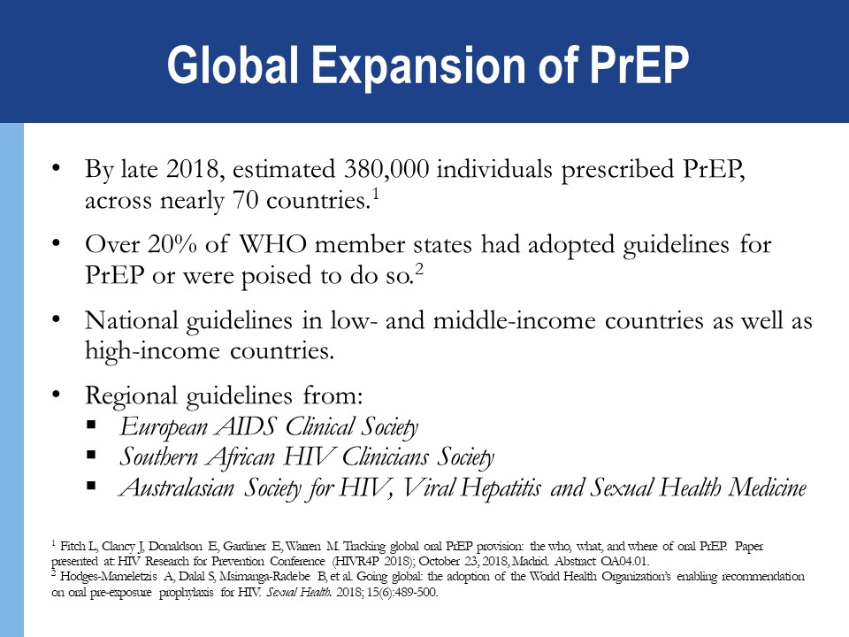

### 

### PrEP Use in a Routine Setting

A large health care system operating in San Francisco, USA, assessed uptake of PrEP and PrEP outcomes from July 2012 to February 2015.

Among 801 individuals evaluated for PrEP:

82% initiated PrEP

The mean duration on PrEP during the observation period 7.2 months.

No HIV infections occurred.

30% of PrEP users were diagnosed with an STI in the 6 months following PrEP initiation.

Among a small subset asked about behavior change during PrEP use, 56% reported no change in condom use; 41% reported a decrease in use; 17% reported increase in use.

##### Adherence

**Taken as prescribed, PrEP works! Both ART and PrEP must be taken correctly and consistently.**

Highest PrEP effectiveness was in trials with PrEP use of more than 70% (risk ratio = 0.30, 95% confidence interval: 0.21–0.45, P<0.001) compared with placebo).[[2]](#footnote-2)

**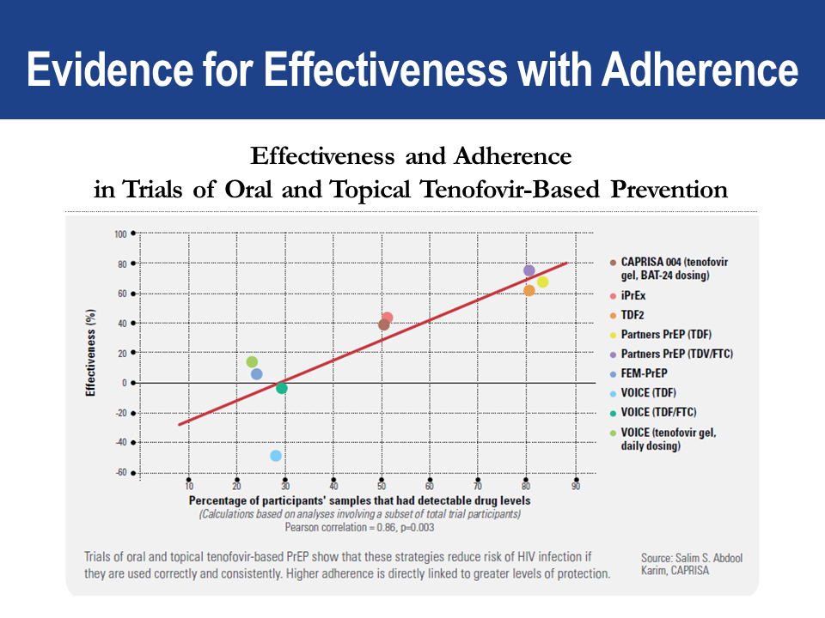**As “Effectiveness and Adherence in Trials of Oral and Topical Tenofovir-Based Prevention” graph indicates, the higher the percentage of participant samples with detectable PrEP drug levels, **the greater the efficacy.**

**Adherence to drugs** means that an individual is taking prescribed medications *correctly* and *consistently.* It involves taking the correct drug in the correct dose:

At a consistent frequency (the same number of times per day).

At a consistent time of day.

**Adherence with follow-up** means that clients attend *all* scheduled clinical visits and observe all required protocols, including:

Clinic and lab assessments.

Prescription refills.



##### Countries Using PrEP

The medication used in PrEP has been approved in several countries—among them:

|  |  |  |
| --- | --- | --- |
| Australia | France | Taiwan |
| Belgium | Kenya | Thailand |
| Botswana | Lesotho | United Kingdom |
| Brazil | Namibia | United States |
| Canada | Netherlands | Zambia |
| Czech Republic | Peru | Zimbabwe |
| Denmark | South Africa |  |

### PrEP REGIMENS AND SIDE EFFECTS

##### PrEP Regimens

**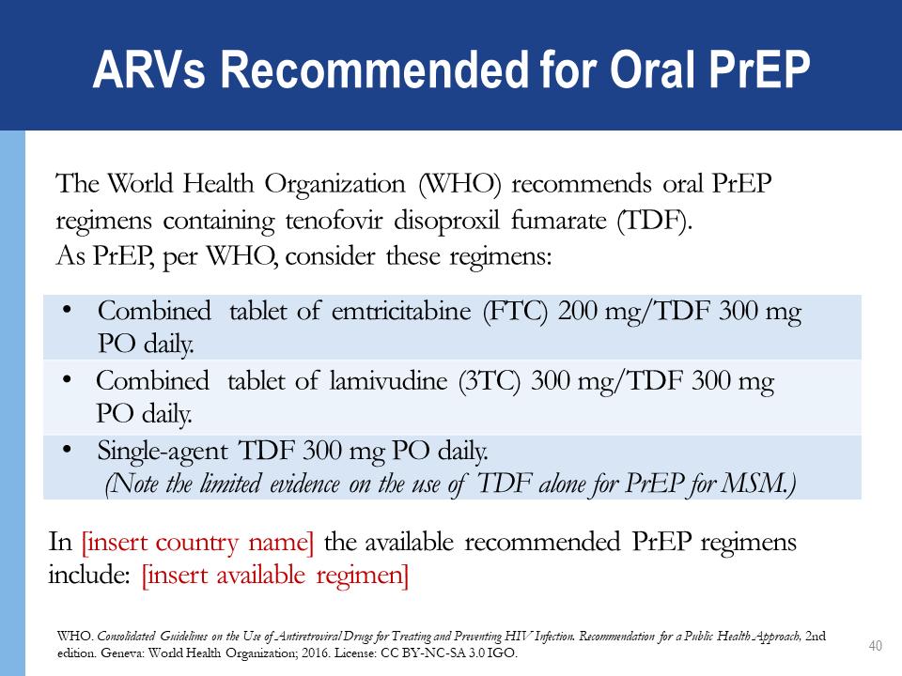**

##### PrEP Side Effects: Reports from RCTs

Approximately 10% of participants in randomized controlled trials experienced side effects. The side effects were mild and usually did not persist beyond the first month.

Side effects may include:

Gastrointestinal (GI) side effects (nausea, vomiting, abdominal pain).

Creatinine elevation (typically reversible).

Loss of bone mineral density; recovers after stopping PrEP.

##### Side Effects Reported from the iPrEx Open-Label Extension Observational Study

In the multisite iPrEx Open-Label Extension (iPrEx OLE) Observational Study, a PrEP cohort taking daily oral TDF/FTC:

39% of participants reported any PrEP-related (mainly mild) side effects.

A “start-up syndrome” has been reported:

GI symptoms included: nausea, flatulence, diarrhea, abdominal pain, vomiting, and headaches. Other symptoms included headache and skin problems or itching.

The “start-up syndrome” is transient but can influence adherence:

Side effects among PrEP users peaked around Month 1 and symptoms resolved by Month 3.

Adherence counseling should focus on the transient nature of the start-up syndrome.

### RISK BEHAVIORS, HIV Drug Resistance, AND Sexually Transmitted Infections

Will PrEP encourage people to use condoms less often or to have more sexual partners (i.e., “risk compensation”)?

There was *no*evidence of this in clinical trials, where participants received regular counseling, screening, and access to condoms and lubricants.

Evidence from real-world PrEP implementation shows declines in self-reported condom use and increases in STI diagnoses among some PrEP users.

Combination prevention should include quality counseling and access to condoms and lubricants.

Will PrEP lead to more HIV drug resistance (HIVDR)?

HIVDR in PrEP users was rare in clinical trials.

HIVDR occurred mostly in cases where the person had undiagnosed HIV infection when starting PrEP.

HIVDR will not occur when adherence to PrEP is high and HIV seroconversion does not occur.

If adherence is suboptimal and HIV infection occurs while on PrEP, there can be risk of HIVDR.

Optimal PrEP adherence is crucial.

Health providers must support and monitor adherence and teach PrEP users to recognize signs and symptoms of acute HIV infection.

Does PrEP protect against other STIs?

PrEP does *not* protect against syphilis, gonorrhea, chlamydia, or human papilloma virus (HPV).

Only condoms protect against STIs and pregnancy.

PrEP protects against HIV.

PrEP also provides modest protection against herpes simplex virus type 2 in heterosexual populations.

PrEP should be provided within a package of prevention services, includingSTI screening and management, risk reduction counseling, condoms, and contraceptives.

Can PrEP be used with drugs or alcohol?

Yes. Using drugs or drinking alcohol will not affect the safety or effectiveness of PrEP.

However, drugs and alcohol could make you forget to take the PrEP tablets.

### Module 1 Summary

##### What We Know about PrEP

PrEP can be used by HIV-negative persons to *reduce* the risk of HIV acquisition.

Daily oral PrEP with TDF-containing regimens is currently recommended.

PrEP should be taken as an *additional* prevention intervention.

PrEP is *effective* if taken correctly and consistently.

PrEP can be used by at-risk populations, including heterosexual men and women, MSM, SWs, PWID, and transgender women, among others.

PrEP is *safe* and has minimal side effects.

# MODULE 2: PrEP SCREENING AND ELIGIBILITY

###### LEARNING OBJECTIVES

After completing Module 2, participants will be able to:

* Name the 5 main eligibility criteria for PrEP.
* Use the standard medical screening form for PrEP eligibility and substantial risk.
* Name the contraindications for PrEP.
* Explain how to exclude acute HIV infection (AHI).

### WHO SHOULD RECEIVE PrEP?

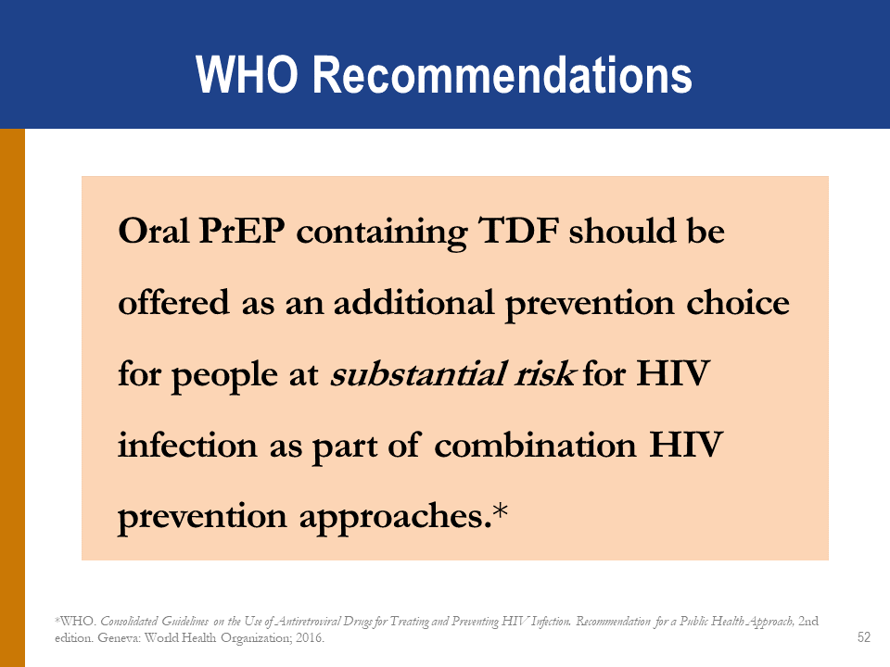

##### Exclude HIV Infection Before Starting PrEP

PrEP is a prevention intervention for people who are HIV negative.

All people at substantial risk for HIV and who may be eligible for PrEP should be offered HIV testing prior to PrEP initiation.

HIV testing must be done using national guidelines and algorithms.

Ideally, use rapid HIV tests at point of care.

Promptly link clients who test HIV positive to HIV treatment and care services.

*(The trainer will provide the national algorithm.)*

****

### 

### ACUTE HIV INFECTION

AHI is the early phase of HIV diseasecharacterized by an initial burst of viremia.

AHI infection develops within 2 to 4 weeksafter someone is infected with HIV.

Approximately 40–90% of clients with AHI will experience “flu-like” symptoms.

These symptoms are not specific to HIV but occur in many other viral infections.

Clients with AHI can be asymptomatic.

Do *not*initiate a client on PrEP if AHI is suspected. The flu-like symptoms appear days to weeks after exposure and may include:

Fever

Fatigue

Anorexia

Rash (often erythematous maculopapular)

Pharyngitis

Generalized lymphadenopathy

Mucocutaneous ulceration

Headache

Aseptic meningitis

Radiculitis, myelitis

May present with thrush, zoster, or other opportunistic infections (OIs), if CD4 depressed

These symptoms are not specific to HIV; they occur in many other viral infections.

Remember, many clients with AHI are asymptomatic.

##### Symptoms_of_acute_HIV_infection.png

##### Diagnosis of Acute HIV Infection

During AHI, antibodies might be absent or be below the level of detection.

* Serological testing using rapid tests might be negative.

AHI can be diagnosed using “direct” viral tests like HIV RNA or HIV antigen testing.

In the absence of HIV RNA and antigen testing, if AHI is suspected, PrEP should be deferred for 4 weeks.

* Repeat the HIV serological test after 4 weeks to reassess eligibility.

### SUBSTANTIAL RISK FOR HIV INFECTION

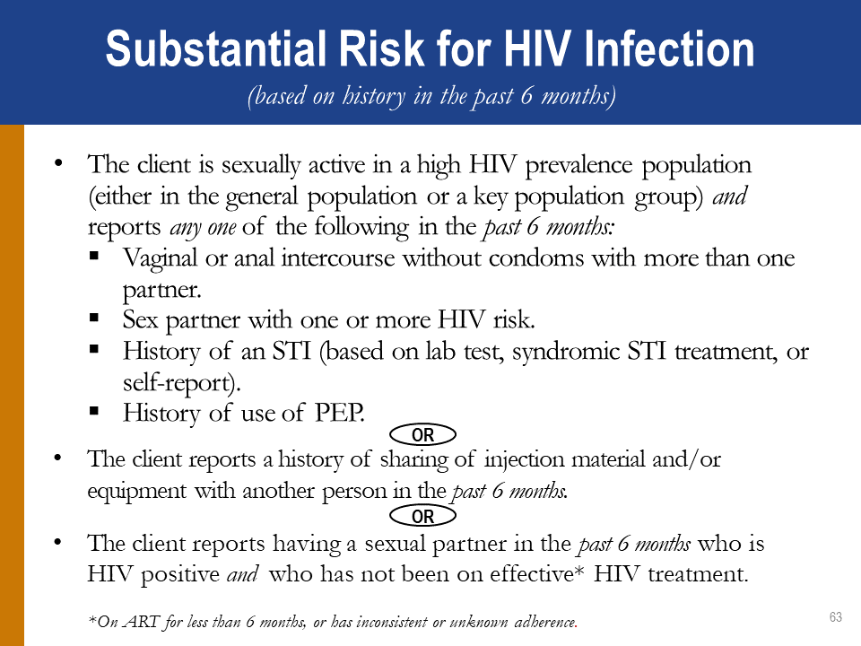

Potential Signs of Risk

Situations that may prompt a person to consider starting PrEP include:

Alcohol and recreational drug use before sex.

Leaving a long-term monogamous relationship.

Leaving school or home at an early age.

Screening for Substantial Risk

Frame screening questions in terms of people’s behavior rather than their sexual identity.

In your screening questions, refer to a defined time period (e.g. 6 months).

Remember to be sensitive, inclusive, nonjudgmental, and supportive.

Be careful not to develop a screening process that might discourage PrEP use.

##### Screening Questions

General Screening Questions

In the past 6 months:

*  Have you had sex with more than one partner?
*  Have you had sex without a condom?
*  Have you had sex with people whose HIV status you do not know?
*  Are any of your partners at risk for HIV infection?
*  Have you had sex with a person who has HIV?

Serodiscordant Couples

For a person who has a partner with HIV:

* Is your partner taking ART for HIV?
* Has your partner been on ART for more than 6 months?
* Do you regularly discuss your partner’s adherence to HIV treatment (i.e., at least monthly)?
* Do you know your partner’s last viral load? What was the result? And when was the testing done?
* Do you wish to have a child with your partner?
* Are you and your partner consistently using condoms?

Additional Factors

Are there aspects of your situation that may indicate higher risk for HIV? Have you:

* Received money, housing, food, or gifts in exchange for sex?
* Been forced to have sex against your will?
* Been physically assaulted by anyone, including a sex partner?
* Taken PEP to prevent HIV infection?
* Had an STI?
* Injected drugs or hormones using shared equipment?
* Used recreational or psychoactive drugs?
* Been required to leave your home?
* Moved to a new place?
* Lost your job?
* Had fewer than 12 years schooling or left school early?

### SERODISCORDANT COUPLES

PrEP can protect the HIV-negative partner in a heterosexual relationship with an HIV-positive (i.e., serodiscordant) partner if:

The partner with HIV has been taking ART for fewer than 6 months.

* It takes 3 to 6 months on ART to suppress viral load.
* In studies of serodiscordant couples, PrEP has provided a useful bridge to full viral suppression during this time.

The HIV-negative partner is not confident of the HIV-positive partner’s adherence to treatment or has other sexual partners besides the partner on treatment.

The HIV-negative partner is aware of gaps in the HIV-positive partner’s treatment adherence.

The couple is not communicating openly about treatment adherence and viral load test results.

### CREATININE AND ESTIMATED CREATININE CLEARANCE

Tenofovir disoproxil fumarate (TDF) can be associated with a small decrease in estimated creatinine clearance (eGFR) early during PrEP use. Usually this does not progress.

PrEP is not indicated if eGFR\* is < 60ml/min.

eGFR = estimated glomerular filtration rate using Cockcroft-Gault equation:   
Estimated CrCl = [140-age (years)] x weight (kg) x f   
where f=1.23 for men and 1.04 for women / [72 x serum creatinine (μmol/L)]

You can use an online calculator to determine the eGFR:

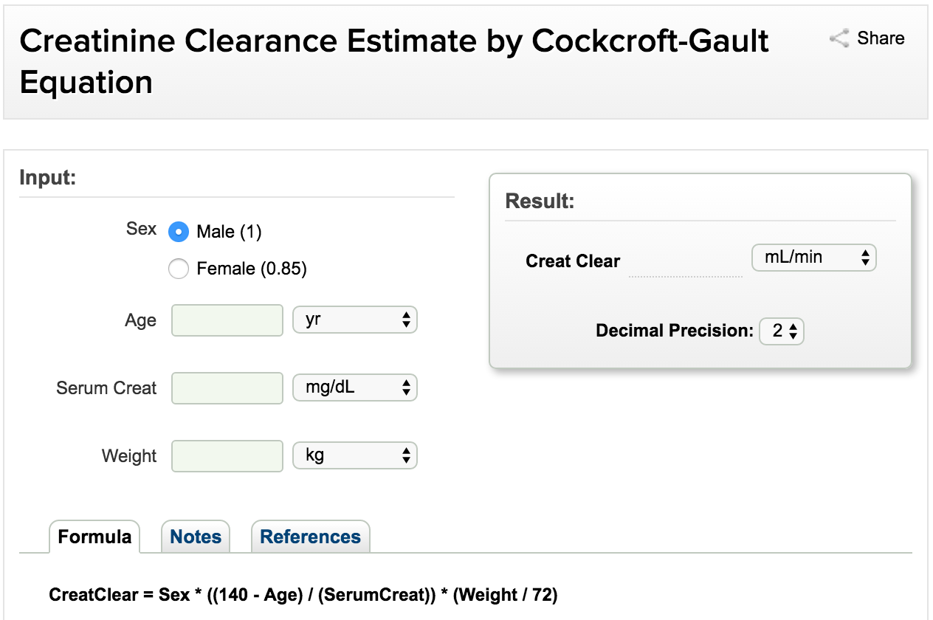

<http://reference.medscape.com/calculator/creatinine-clearance-cockcroft-gault>

### PrEP Use During Pregnancy

In settings with high-prevalence, generalized epidemics, women acquire HIV during pregnancy and breastfeeding.

Existing safety data support the use of PrEP in pregnant and breastfeeding women who are at continuing substantial risk of HIV infection. WHO guidelines state that there is no safety-related rationale for disallowing or discontinuing PrEP use during pregnancy and breastfeeding for HIV-negative women who are receiving PrEP and remain at risk of HIV acquisition.

Surveillance of maternal, pregnancy, and infant outcomes is ongoing to identify any safety concerns.

### Women and PrEP

PrEP does not affect the efficacy of hormonal contraceptives. Taking them together does not make them less effective.

PrEP does not protect against pregnancy.

PrEP is safe and can be continued during pregnancy and breastfeeding.

### Willingness to Use PrEP As Prescribed

Education and counseling are provided to support clients to make an informed choice about PrEP.

Clients must not be coerced into using PrEP. Research indicates that adherence is higher among people who are aware that they are at risk for HIV infection and are motivated to take PrEP.

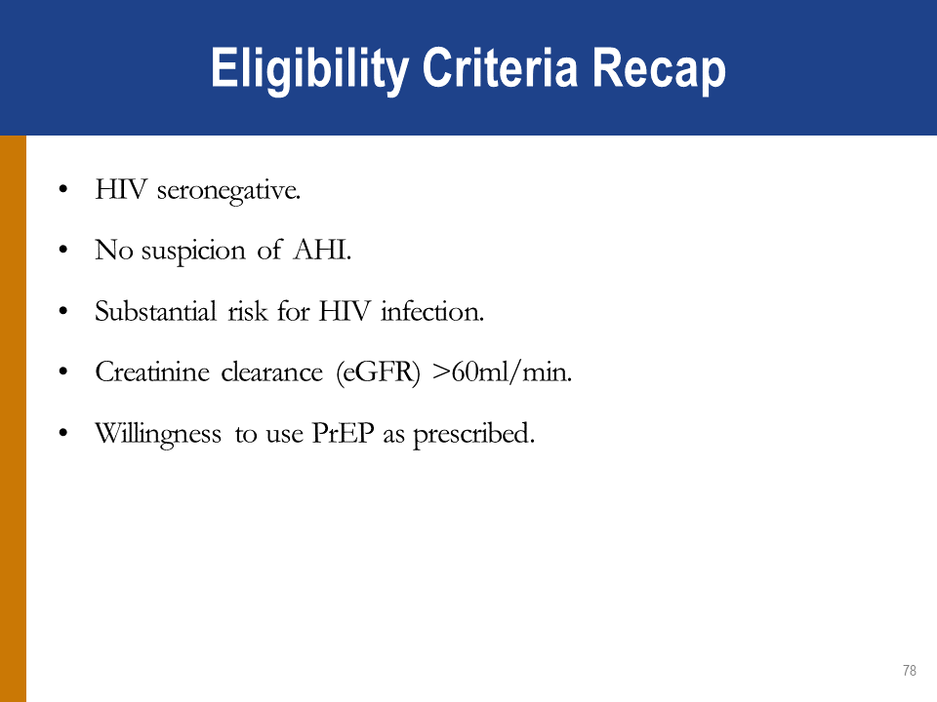

### The SCREENING FOR SUBSTANTIAL RISK AND ELIGIBILITY FO**RM**

In the brainstorming session, we identified what types of questions you must ask in order to screen for PrEP eligibility. Use of a standard form can ensure that screening is done in a consistent manner and is well documented.

The source for completing the screening form is the client.

### CLINICAL SCENARIOS

**Clinical Scenario 1**

Joseph, a 22-year-old man, presents at the clinic because he is interested in starting PrEP. He reports using condoms sometimes during sex with his HIV-positive male partner. His partner is healthy and has been on ART for 4 years. His most recent viral load from “a few months ago” was reported as 1200 copies/mL. Their last unprotected intercourse was last week. Joseph is in good health and takes no medications. His rapid HIV antibody test today is negative.

Is Joseph a candidate for PrEP?

If so, what did you consider in order to determine eligibility?

##### Clinical Scenario 2

Marie, an 18-year-old woman, comes to the clinic because she feels sick and is afraid she might have HIV. She reluctantly explains that, during the past year, she has been having sex for money or gifts in order to support her 2 children. Some of her partners have used condoms and others have not. She does not know whether her partners have HIV. Marie reports that she has been feeling run-down and sick for the past few weeks. Her rapid HIV antibody test today is negative.

Is Marie a candidate for PrEP?

If so, why?

What other information would you need in order to determine eligibility?

##### Clinical Scenario 3

Geraldine, a 30-year-old wife and mother, presents at the clinic because she has heard that she can get drugs that will prevent her from getting HIV. She suspects that her husband has been injecting drugs, as he has needle marks on his arms. Geraldine is afraid that her husband might have HIV and that he will infect her. She reports that her husband has not been tested. Geraldine’s rapid HIV antibody test today is negative.

Is Geraldine a candidate for PrEP?

If so, why?

What other information might you need in order to determine eligibility?

##### Clinical Scenario 4

Daniel is a 25-year-old man who presents at the clinic seeking treatment for “blisters.” He reports that, during the past several days, he has had a few painful blisters around his mouth and on his genitals. He declines to report his sexual activity; he says he is a married man and faithful to his wife. He asks whether he can take just one pill for the blisters here at the clinic, so that his wife or neighbors do not find out that he is taking pills. Daniel does not want to take any medications ongoing, as his neighbors or church might find out and conclude that he has HIV. He declines to take an HIV test.

Is Daniel a candidate for PrEP?

Why?

### SCREENING ROLE-PLAYS

##### Screening Role-Play Scenario 1

Justine, a 19-year-old sex worker with a live-in boyfriend, was born a male but has been living as a woman since she was 15. She has had sex with multiple male partners over the last 6 months, a few times without condoms. She does not know whether she has any STIs, but she has no symptoms.

Justine’s boyfriend is living with HIV and has been on ART for about a year. He has adhered to the treatment regimen very well and is in good health. Justine is proud of him for this. Justine and her boyfriend use condoms during sex.

A few weeks ago, Justine was tested for HIV after a scary encounter with a client. The test was negative. Justine has come to the clinic today because she is feeling poorly. She has had a fever and chills in recent days and wants medicine in order to feel better.

▶ *Participant Instructions: Skip sections 1 and 2 of the screening tool. Role-play sections 3, 4, and 6 of the screening tool. After the role-play, you will complete Section 5 with the whole group. In addition to the question prompts in Section 4, you may need to use other questions such as the ones brainstormed earlier.*

##### Screening Role-Play Scenario 2

Lucien, 25 years old, is a married man who has sex regularly with men outside his marriage as well as with his wife. His wife does not know about the sex with men. With male partners, Lucien insists on using condoms during sex but he does not do so with his wife.

Lucien has come to the clinic because the last time he was with a man, the condom broke, and he is worried that he might have gotten HIV. He does not know the HIV status of his male sex partners. He assumes that his wife does not have HIV, but she has not been tested. He does not use drugs or share injecting material with others.

▶ *Participant Instructions: Skip sections 1 and 2 of the screening tool. Role-play sections 3, 4, and 6 of the screening tool. After the role-play, you will complete Section 5 with the whole group. In addition to the question prompts in Section 4, you may need to use other questions such as the ones brainstormed earlier.*

### MODULE 2 SUMMARY

##### PrEP Eligibility, Screening, Side Effects, and Contraindications

Providers should informand counsel potential PrEP users and conduct an individualized risk assessment.

Eligibility for PrEP includes:

* At substantial risk for HIV infection.
* HIV seronegative.
* No suspicion of AHI.
* No contraindications to the ARVs used in the PrEP regimen.
* Willingness to use PrEP as prescribed.

PrEP screening questions should be framed in terms of a person’s behavior.

Side effects in clinical trials were rare and when they occurred they were mild.

Contraindications for PrEP include:

* Current or suspected HIV infection.
* Renal impairment as defined by estimated creatinine clearance of <60 ml/min.

# MODULE 3: INITIAL AND FOLLOW-UP PrEP VISITS

###### LEARNING OBJECTIVES

After completing Module 3, participants will be able to:

Specify the procedures for the initial PrEP visit.

Demonstrate knowledge of national guidelines for HIV testing services (HTS) and local algorithms for HIV testing.

Describe the rationale for and content of brief counseling during the initial PrEP visit.

Follow the Integrated Next Step Counseling (iNSC) process to counsel clients on sexual health and PrEP adherence.

Specify the suggested procedures for follow-up PrEP visits.

Describe the rationale for and content of follow-up counseling at each visit.

Name typical challenges that facilities and providers may face when implementing PrEP, and strategies for addressing those challenges.

### INITIAL PrEP VISIT SUGGESTED PROCEDURES

|  |  |
| --- | --- |
| **Investigation** | **Rationale** |
| HIV test using national HTS guidelines algorithm | Assessment of HIV infection status. |
| AHI symptom checklist | To assess for AHI. |
| Serum creatinine | To identify pre-existing renal impairment. |
| Hepatitis B surface antigen (HBsAg) | To identify undiagnosed hepatitis B (HBV) infection.  To identify those eligible for HBV vaccination. |
| RPR | To diagnose and treat syphilis infection. |
| STI screening | To diagnose and treat STI.  Syndromic or diagnostic STI testing, depending on local guidelines. |
| Pregnancy testing | To ascertain pregnancy. |
| Brief counseling | To assess substantial risk for HIV.  To assess HIV prevention options and provide condoms and lubricants.  To discuss desire for PrEP and willingness to take PrEP.  To plan for effective PrEP use and sexual and reproductive health. |

##### Provider Checklist for Initial PrEP Visit

Use this checklist (in the Appendix of this manual) as overall guidance during initial PrEP visits. You may need to customize the list to align with national guidelines and practices at your facility, as it may not contain everything done at your facility during an initial PrEP visit.

##### Initial PrEP Counseling

Initial counseling should:

Increase awareness of PrEP as a choice.

Explain how PrEP works.

Cover sexual health and PrEP as part of combination HIV prevention.

Help clients decide whether PrEP is right for them.

Educate clients about the importance of adherence and follow-up visits.

Explain symptoms of AHI.

Review common adherence strategies

Describe common PrEP side effects and side effect management.

##### Initial Visit Counseling Messaging

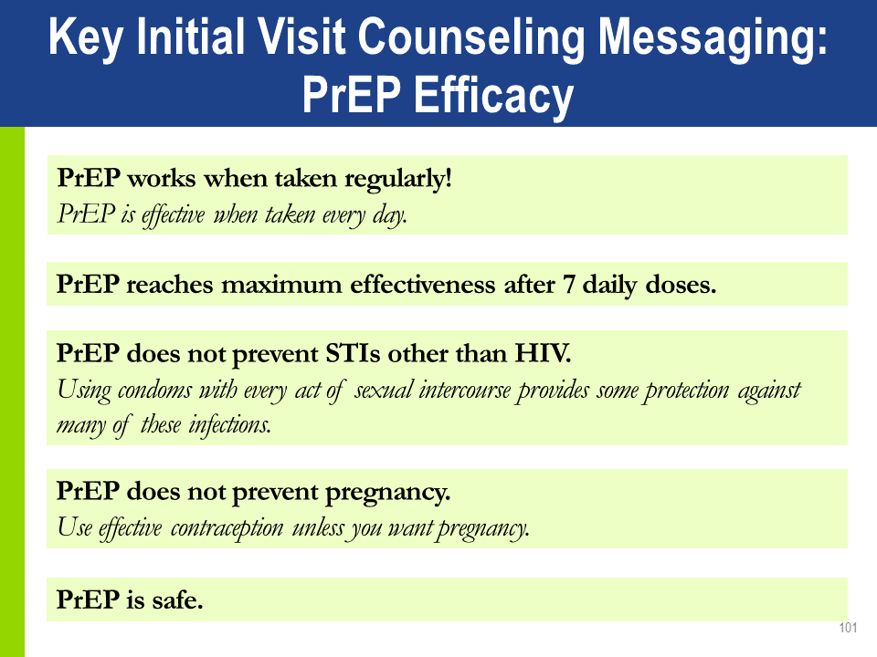

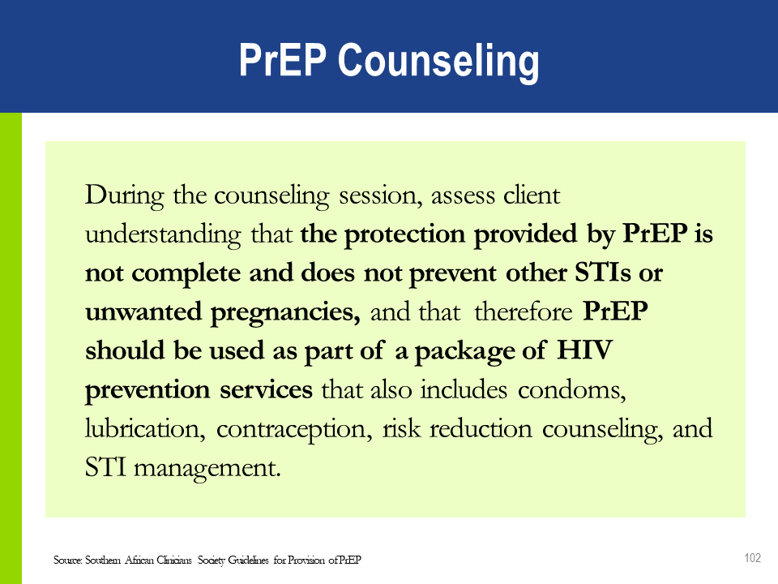

##### Health Care Worker Discussion Prompts for Initial PrEP Visits[[3]](#footnote-3)

Sexual Behavior

* What has been going on for you sexually over the past couple of months?
* How much of the time did you use condoms?
* What has made it easier to use condoms during sex? What has made it more difficult?
* What concerns do you have about your sexual activities?
* How might taking PrEP impact your sexual activity?

Drug Use

* Did you use any drugs in the last 12 months?
* If yes, which drugs (e.g., alcohol, opioids, stimulants, cannabis)?
* And how did you use them (smoking, orally, injecting)?
* When did you last use drugs (and which ones)?
* How often do you use drugs (once a year, once a month, once a week, once a day—or more frequently)?
* Has your drug use ever been a problem for you? *[Note: Referral to drug services may be appropriate if locally available.]*
* Do you think your drug use may put you at risk for becoming infected by HIV or transmitting HIV?

Plan for Staying HIV and STI Negative

* In what ways are you reducing your risk of getting HIV and other STIs now?
* What steps have you considered for the future?
* You are reducing your risk for HIV by deciding to take PrEP. Let’s talk about how PrEP fits into your risk reduction efforts. *[Emphasize that PrEP will reduce the risk of acquiring HIV but it will NOT reduce the risk of acquiring other STIs.]*
* What other ideas or plans, if any, do you have for staying HIV and STI negative?

Preparing for Effective PrEP Use

* Do you have any experience taking a medicine daily?
* What is your experience with taking a medicine daily?
* Are you now taking any medication on a daily, long-term basis? *[If so, you may need to refer the client to a pharmacist or other health care provider.]*
* When you have taken medicines in the past, how did you remember to take them? What helps you remember to take your pills?
* What is your plan for taking your PrEP pill daily?
* What will you do about taking your pill if you are away from home for a night or more?
* What will you do if you miss a dose of your PrEP pill?
* What is your understanding of possible PrEP side effects? How will you cope with side effects if you have them?

Understanding Context

Understanding social and cultural context is critically important.

People at risk of acquiring HIV infection often experience stigma from multiple sources.

* MSM, SWs, and PWID are criminalized in many places, making them reluctant to seek HIV care.
* Transgender individuals often face stigma, discrimination, and violence.

In health care settings, addressing barriers may also mean acknowledging and redressing the imbalance in power between the providers of services and those seeking services.

### SUPPORTING ADHERENCE

**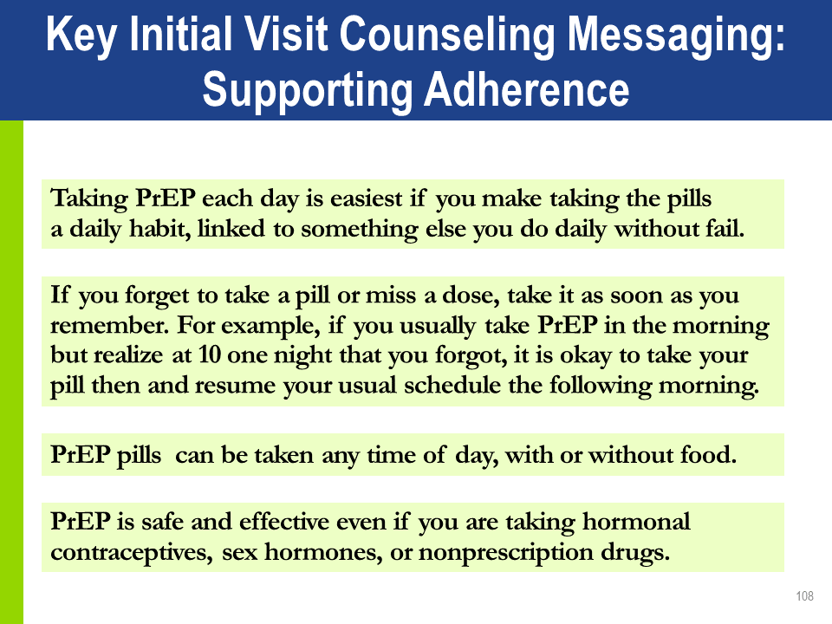**

##### Adherence Strategies

Link PrEP to a daily routine or event like brushing teeth or eating breakfast.

Take your pill at the same time every day.

Identify what to do if a dose is missed.

Use a pillbox.

Identify significant others who can support PrEP adherence.

Use reminder alarms, text messages, or a calendar.

Have a back-up supply of pills in your bag or purse.

* In case your routines are disrupted (i.e., if you stay out overnight, go on holiday, or skip meals), consider carrying extra pills.

##### Common Reasons for Low Adherence to ART

|  |  |  |  |
| --- | --- | --- | --- |
| **Individual Factors** | **Medication-Related Factors** | | **Facility-Related Factors** |
| * Forgetting doses * Being away from home * Changes in daily routines * Depression or other illness * Limited understanding of treatment benefits * Lack of interest in or desire to  take the medicines * Substance or alcohol use * Absence of supportive environment * Fear of stigma and discrimination | | * Adverse events * Pill burden * Complexity of dosing regimens * Dietary restrictions * In contrast to ART, PrEP requires taking just one tablet daily and does not mandate any dietary restrictions | * Distance to health services * Access to pharmacies * Long waiting times to receive care and obtain refills * Burden of direct and indirect costs of care |

##### Understanding Nonadherence: Voluntary vs. Involuntary

|  |  |
| --- | --- |
| **Voluntary Nonadherence**  *(intentionally by a client)* | **Involuntary Nonadherence**  *(not intentionally by a client)* |
| * Not convinced PrEP is needed. * Does not believe PrEP works or is working. * Does not like taking pills. * Has experienced side effects; wishes to avoid side effects. * Has experienced stigma while taking PrEP. * Does not believe it is necessary to take every day. * Does not want to take with alcohol or other drugs. * Wishes to avoid others witnessing pill taking. | * Forgot to take pill. * Forgot to refill prescription. * Has competing priorities (e.g., employment, child care). * Has difficulty with personal organization  and scheduling. * Affected by depression or other unaddressed mental illness. * Cannot afford PrEP medication, laboratory tests, or other costs. * Does not want to come to the health care facility (or cannot afford to do so). * Dissatisfaction with health care provider interactions. * No place to store medication. * Unaddressed substance use issues, especially dependence on alcohol or other drugs. * Insufficient food to take pills. |

##### Lessons from ART Programs

Health care providers can positively influence adherence in many ways. They can:

Facilitate accurate knowledge and understanding of medication benefıts and requirements.

Express confidence in the effectiveness of PrEP.

Prepare for and manage side effects.

Identify social support.

Build self-effıcacy for adherence.

Develop a routinized daily schedule that includes regular pill taking.

Maintain an open line of communication with PrEP clients.

Monitor adherence.

**Approaches to PrEP Medication-Adherence Support**

| **Support Issue** | **Provider Options** |
| --- | --- |
| **Understand PrEP—have adequate, accurate knowledge** | * Briefly explain or provide materials about: * Indications for medication. * The anticipated risks and benefits of taking medication. * How to take it (one pill per day). * What to do if one or more doses are missed. * Assess for misinformation. |
| **Prepare for and manage side effects** | * Educate on side effects to expect, for how long, how to manage them. * Educate on AHI signs and symptoms and how to obtain prompt evaluation and care. |
| **Foster self-efficacy** | * Provide PrEP role models via on-on-one peer supporters or champions * Establish PrEP support groups. |
| **Routinized daily schedule** | * Discuss how to integrate daily dose with other daily events and what to do when away from home. * Recommend or provide medication-adherence tools: * Pill boxes. * Phone apps, pager, or SMS reminder services. |
| **Provider support** | * Regularly assess adherence. * Ask for a client self-report. * Use technology (SMS reminders, smart phone apps). * Various providers or health care workers can support adherence (pharmacist, peer workers.). |
| **Social  support** | * Discuss privacy issues for PrEP user. * Offer to meet with partners or family members if they are supportive. |
| **Mental health and substance abuse** | * Consider screening for depression or substance abuse problems. * Provide or refer to mental health or substance abuse treatment and relapse prevention services when appropriate. |
| **Population-specific challenges** | * Consider tailored medication-adherence support for:   + Adolescents.   + People with unstable housing.   + Transgender women. * Others with specific stressors that may interfere with medication adherence. |

##### Adherence Assessments

Discuss adherence at each visit. When you do:

To encourage realistic, honest discussion about challenges or issues a client might be facing, avoid putting your own judgment on him or her.

Encourage PrEP clients to self-report pill taking in order to understand their experience with adherence.

Ask about adherence over the last 3 days. (Short-term recall tends to be better than long-term recall.)

Additional methods to monitor adherence:

Pharmacy refill history.

Pill count.

##### Drug Supply

Clients who have some medication supply in reserve tend to show better adherence.

Providing an **extra week’s supply of medication at the first visit** will ensure an adequate supply for daily dosing until the next visit.

This is important in case the follow-up visit is delayed for any reason.

If you cannot give an extra week’s supply, schedule the client’s next visit a week before pill supply will run out.

### Approaches to Promoting Adherence

Several approaches can be used to promote PrEP adherence:

Motivational Interviewing—This helps PrEP users explore their feelings and motivations for PrEP use, and reasons for non-use of medicines, and negative experiences with medicines.

Informed-Choice Counseling (ICC)—This was adapted from family planning to address the challenges of informing the choice of PrEP and developing a plan for adherence. More information on this approach can be found in “Guidance for Providing Informed Choice Counseling on Sexual Health for Women Interested in Pre-Exposure Prophylaxis (PrEP),”available at ww.fhi360.org.

Integrated Next Step Counseling (iNSC)—This method is discussed later in the training.

##### Essential Features of PrEP Adherence Counseling

The foregoing counseling approaches share 3 features.**[[4]](#footnote-4)** They are all:

Context specific: Valuing each client’s context, situation and decisions.

Client centered: Attentive to unmet needs that may challenge PrEP use or adherence.

Focused on problem solving: Emphasizing the client’s choice.

##### PrEP Counseling Is Client-Centered

The term “client-centered” refers to seeing clients as the expert on their lives. The counselor serves as a guide to assist in setting and reaching goals.

Client-centered counseling emphasizes respecting an individual’s experiences and choices.

The approach can increase a client’s motivation to use PrEP correctly, because it addresses clients’ perceptions about the consequences of nonadherence vs. adherence.

##### PrEP Counseling Is About Problem Solving

Problem solving is not counselor driven, with health care workers telling clients what their problems are or what they must do to fix those problems.

PrEP counseling helps clients identify factors that either facilitate accessing PrEP, or are barriers to it.

PrEP counseling helps clients identify the factors that influence their behaviors and develop strategies to reduce any barriers.

### Integrated Next Step Counseling

Integrated next step counseling was used in the iPrEx OLE study to counsel individuals   
on sexual health promotion more generally, *with specific emphasis on PrEP adherence for   
individuals on PrEP.*

The model is client centered and focused on problem solving, starting with the client’s identification of personal goals and of barriers and facilitators to achieving those goals.

This counseling is a conversation about all the things someone is doing or considering doing to protect their sexual health.

iNSC is used to deliver negative HIV test results and serves both as post-test HIV counseling and as counseling on the decision to use PrEP in a single brief, targeted, tailored conversation.

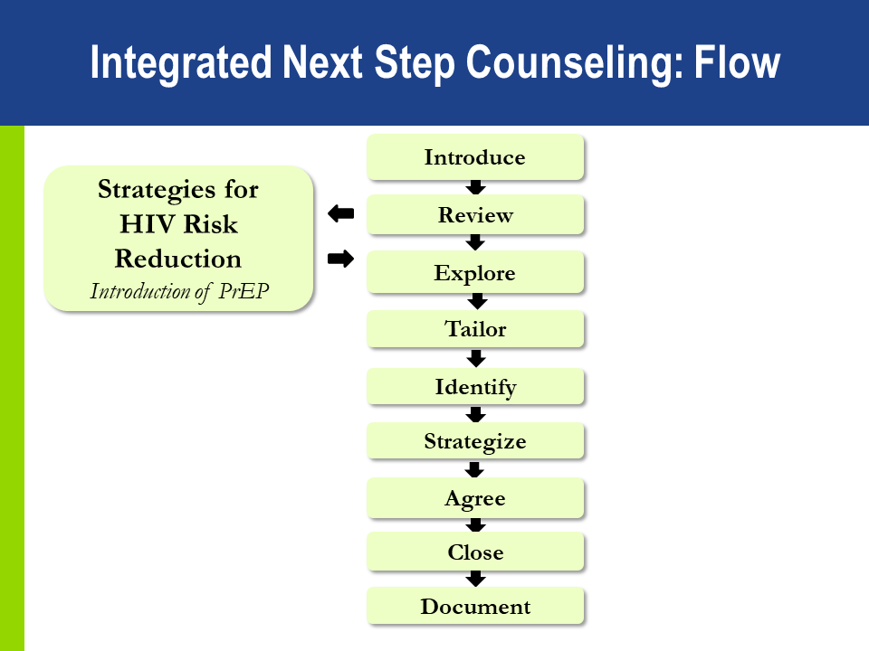

iNSC Steps, Components, and Examples[[5]](#footnote-5)

| **iNSC Step** | **Critical Components** | **Example Prompts** | |
| --- | --- | --- | --- |
| **Introduce** the counseling session | Explain what you are talking about and why. Get permission to proceed. | | *I would like to take a few minutes to check in with you about your goals and how to meet them. Is that okay?* |
| **Review the** client’s experiences | Ask about what the client already knows about PrEP and how he or she learned it. | | *Thank you. Can you tell me a little about what you have heard about PrEP and about your experiences with PrEP?* |
| **Explore** context of client-specific facilitators and barriers | Use open-ended questions to explore factors or situations that help make pill taking a little easier; and those that make it harder or a little more difficult. | | *What seems to make PrEP easy to take or harder to take?* |
| **Tailor** the discussion to focus on making pill taking easier | This pause allows the provider or counselor to consider how to tailor the next question based on information gathered in earlier steps. | | *Let me think for a moment about what you have said.* |
| **Identify** adherence-related needs | | Guide the conversation toward identifying the client’s perceptions of what would help to best integrate PrEP use into daily life | | *Given everything going on right now, what would need to happen for it to feel a little easier to work this regimen into your daily life?* | |
| **Strategize** with the client on the next step | | Work with the client to identify one or more viable strategies for increasing effective PrEP use. | | *How could that happen?*  *What are some ideas for how you could approach that?* | |
| **Agree** on which strategy will be tried next | | Ask which strategy (or strategies) the client is willing to try or continue using. | | *Of the things that we have talked about, which might you be willing to try between now and the next time we meet?* | |
| **Close and document the session** | | Summarize the discussion and thank the client. | | *What I’m hearing is that \_\_\_\_\_\_ would really make it feel easier to work PrEP into your life and that you’ll give it a try between now and the next time we meet. Thank you for talking with me and I look forward to talking again.* | |

### HIV Risk Reduction Strategies

Explore HIV prevention options with the client. PrEP is one of several options that can help a client decrease their risk of HIV infection, including:

Consistent use of male or female condoms.

Diagnosis and treatment of STIs.

Mutual monogamy.

Post-exposure prophylaxis.

Needle and syringe access programs, opioid substitution therapy, and other harm reduction strategies.

PrEP is more effective when used in combination with other prevention options.

##### Peer Workers for PrEP

Outreach workers, including lay or peer workers, are uniquely able to engage people who may benefit from PrEP but do not routinely access health care.

Lay and peer workers can provide nonjudgmental, respectful support. Peers with PrEP experience can be effective role models. PrEP services that include lay providers from KP groups can help reduce client concerns about stigma and can help increase PrEP uptake

##### Role of Peers in Promoting PrEP

Peers play an important role in promoting PrEP, delivering accurate messaging, and supporting adherence. They are an effective “first line” in introducing PrEP to clients at community events and outreach activities and in clinic waiting rooms.

Include peer providers in PrEP discussions and trainings.

### **iNSC ROLE-PLAYS**

**iNSC Role-Play Scenario 1**

Geraldine, a 30-year-old wife and mother, asks about starting PrEP. She presented at the clinic because she heard that she could get drugs that would prevent her from getting HIV. She suspects that her husband has been injecting drugs, because he has needle marks on his arms. Geraldine is afraid that her husband might have HIV and that he will infect her. She reports that her husband has not been tested. Geraldine’s rapid HIV antibody test today was negative. She is eager to start PrEP but worries that her husband might see her taking pills and become abusive or make her stop taking the medication.

**iNSC Role-Play Scenario 2**

Joseph, a 22-year-old man, presented at the clinic because he is interested in starting PrEP. He reports using condoms sometimes during sex with his HIV-positive male partner. His partner is healthy and has been on ART for 4 years. His most recent viral load from “a few months ago” was reported as 1200 copies/mL. Their last unprotected intercourse was last week. Joseph is in good health and is taking no medications. His rapid HIV antibody test today was negative. Joseph reports that he loves to live life from moment to moment. He says that he is not good at “following orders” and is worried that he might forget to take his pills.

### Prep Follow-Up Visits

Clients on PrEP require regular visits with the health provider. Programs should decide on the optimal frequency of visits for monitoring PrEP use. The suggested follow-up visit schedule is:

A month after initiating PrEP.

Every 3 months thereafter.

Outside regular monitoring visits, clients should also consult their providers if they experience adverse events, side effects, or signs or symptoms of AHI.

##### PrEP Follow-Up Counseling

During follow-up counseling, discuss:

Current sexual health behaviors (e.g., sexual health and drug use behaviors).

Non-PrEP sexual health protection strategies (e.g., condom use).

Assessment of continued risk for HIV and continuing need for PrEP.

Intention to remain on PrEP.

Facilitators and barriers to PrEP use.

Adherence problems.

Common adherence strategies.

Challenges of disclosure.

Reasons for ongoing monitoring while on PrEP.

**Dosing requirements** for highest protection.

What to do **if a dose is missed.**

How to recognize symptoms of **AHI.**

**Side effects and side-effects management.**

How to **safely discontinue** and **restart** PrEP (if appropriate).

Follow-Up PrEP Visit Procedures

|  |  |
| --- | --- |
| **Intervention** | **Schedule Following PrEP Initiation** |
| Confirmation of HIV-negative status | * At one month follow-up * Every 3 months. |
| Review the client’s HIV risk | * Every visit |
| Address side effects | * Every visit |
| Brief adherence counseling | * Every visit |
| Estimated creatinine clearance | * At least every 6 months, or more frequently if there is a history of conditions affecting the kidney, such as diabetes or hypertension |

In addition, at every visit:

Provide STI screening, condoms, and contraception as needed.

Counsel clients on AHI symptoms and advise them to come back as soon as possible for evaluation if these symptoms occur.

##### **Provider Checklist for Follow-Up PrEP Visits**

Use this checklist (found in the Appendix) as overall guidance during follow-up PrEP visits.

You may need to customize the list to align with national guidelines and the practices at your facility, as it may not contain everything done at your facility during a follow-up PrEP visit.

##### Repeat HIV Testing

Repeat HIV testing is needed to inform decisions on whether to continue or discontinue PrEP. Repeat HIV testing using national guidelines:

1 month after starting PrEP.

Every 3 months thereafter.

Remember the limitation of serological tests during AHI in the “window” period from HIV infection to detection of antibodies, and also that exposure to ARVs can decrease sensitivity of serological tests.

Stop PrEP if AHI is suspected.

##### Provider Checklist for Substantial Risk

You will use this checklist (found in the Appendix of this manual) during every follow-up visit to assess for substantial risk of HIV infection.

##### Assessing PrEP Adherence

Monitoring PrEP use and adherence is important. However, it is important that it be done in an open-ended and nonjudgmental manner. Take a neutral approach to adherence behavior to support the client in finding solutions to adherence challenges. It is helpful to:

Normalize adherence challenges:

*“Many people have trouble remembering to take a daily pill, especially when starting a new medication. Has this happened to you?”*

Ask about difficulties adhering, not nonadherence:

*“Tell me about any difficulties you have had in taking your daily pill.”*

Instead of:

*“Have you missed doses of your medication?”*

##### Discussion Prompts for PrEP Follow-Up Visits[[6]](#footnote-6)

Sample Open-Ended Questions about Adherence

* How has it been for you to take PrEP?
* What side effects have you had, if any?
* What helps you remember to take your pill?
* What challenges do you experience in taking the pills? When are you more likely to forget?
* What are your concerns about missing PrEP pills?
* What have been your experiences with missing PrEP doses?
* What helps or might help you to take your pills regularly?

Strategies to Help with PrEP Adherence

* Use a pill box.
* Take PrEP pills with other daily medicines.
* Use a phone alarm.
* Mark doses taken on a calendar.
* Have more support from your partner, a family member, or a friend.
* What keeps you motivated to take the PrEP pills?
* What might help make taking PrEP even easier?

Behavior and Activity

* Has taking PrEP changed what else you do to protect yourself from getting HIV and STIs (for example, topping versus bottoming, using condoms, discussing HIV and STI status and/or testing with partners)?
* Has PrEP made you feel safer about sex?
* Has PrEP made it easier for you to take charge of your health?
* In addition to taking PrEP, what are your plans to stay HIV negative?

Confirm a Clear Plan for Staying HIV and STI Negative

* What I hear you saying is that you currently reduce your risk for HIV by *[fill in protective behaviors]* and also you talked about your desire or plan with *[fill in name of person(s)].* Have I understood you correctly?
* What other ideas or plans, if any, do you have for staying HIV- and STI negative?

### PrEP Discontinuation

Starting PrEP does not mean staying on PrEP for life. People often move in and out of substantial risk for HIV. A variety of life changes may prompt a person to stop PrEP, for example:

A partner with HIV achieves viral suppression on ART.

A relationship becomes mutually monogamous.

Sex work or injection drug use stops.

Other risks change.

Education and support for safe stops and restarts of PrEP use are essential. A client who decides to stop PrEP should:

Contact his or her health care provider.

Continue to take PrEP for 28 days after the last potential exposure to HIV.

### PrEP Clinical Pathway

This document is in the Appendix. The graphics may be customized to align with national guidelines.

### INFORMATION, EDUCATION, AND COMMUNICATION

Facilities may use materials and activities for information, education, and communication (IEC) to address challenges around PrEP acceptance and adherence.

##### Frequently Asked Questions about PrEP

You may use this job aid during PrEP visits (in the Appendix) to ensure that all appropriate PrEP information has been given to a client.

Clinics should adapt the list to their context, adding any questions that clients ask frequently.

You may also want to add to this job aid any questions and answers that surfaced during our discussion, and that you think would be helpful for clients to know.

##### Representative IEC Materials

There are many online that will fit your local context; here are a few**.**

*U.S. Centers for Disease Control and Prevention Website*

“PrEP.” https://www.cdc.gov/hiv/basics/prep.html

“PrEP 101” [fact sheet]. https://www.cdc.gov/hiv/pdf/library/factsheets/prep101-consumer-info.pdf

“Are You Ready for PrEP?” [poster]. https://www.cdc.gov/actagainstaids/pdf/campaigns/starttalking/stsh-prep-infographic-basics.pdf

“Are You Ready for PrEP? How Can I Start PrEP?” [poster]. https://www.cdc.gov/actagainstaids/pdf/campaigns/starttalking/stsh-prep-infographic-access.pdf

“Are You Ready for PrEP? Is PrEP Right For Me?” [poster]. https://www.cdc.gov/actagainstaids/pdf/campaigns/starttalking/stsh-prep-infographic-right2.pdf

*IEC Materials from the New York City Government*

http://www1.nyc.gov/site/doh/health/health-topics/prep-pep.page

https://www1.nyc.gov/assets/doh/downloads/pdf/ah/beplay-staysure-booklet.pdf

*IEC Materials from South Africa*

<http://desmondtutuhivfoundation.org.za/wp-content/uploads/2017/10/6-facts-about-PrEP-poster.pdf>

<https://www.prepwatch.org/wp-content/uploads/2016/09/factsheet_PrEPsa_sept2016.pdf>

*Demand Generation Resources from OPTIONS Consortium’s PrEP Communications Accelerator*

<http://accelerator.prepwatch.org/about/>

##### Peer Outreach for Follow-Up

Trained peer supporters can play an important role in outreach to PrEP clients. Peer outreach workers may be better able to reach clients in community settings than other clinic staff.

Clients may feel more able to discuss adherence and retention challenges with peer supporters than with health professionals.

### MODULE 3 SUMMARY

Prescribe PrEP as part of a comprehensive HIV prevention strategy.

Confirm a negative HIV test immediately prior to initiating PrEP.

Ensure there are no contraindications to PrEP.

Ensure clients have correct information about PrEP.

Develop an adherence support plan with the client and monitor adherence at each visit.

Conduct risk reduction counseling at each visit.

# MODULE 4: MONITORING AND MANAGING PrEP SIDE EFFECTS, SEROCONVERSION, AND STIGMA

###### LEARNING OBJECTIVES

After completing Module 4, participants will be able to:

* Explain how to manage creatinine elevation.
* List additional causes of creatinine elevation.
* Explain how to manage seroconversion.
* Develop strategies to minimize PrEP stigma.
* Give examples of gaps in knowledge about PrEP.
* Describe how M&E tools might be adapted for local use.

### MONITORING AND MANAGING CREATININE ELEVATION

Approximately 1 in every 200 PrEP users may develop an elevation of serum creatinine. This is defined as a 50% increase above baseline or an elevation above the normal range. Renal impairment is defined as having an estimated creatinine clearance of <60 ml/min.

Creatinine elevations have usually reversed after stopping PrEP. It is important to monitor transient creatinine elevation and be alert for signs of chronic or severe renal insufficiency.

##### Managing Creatinine Elevation

Common causes of chronic or severe renal insufficiency include: diabetes mellitus, uncontrolled systemic hypertension, hepatitis C infection, liver failure, and preeclampsia during pregnancy.

Stop PrEP if creatinine elevation is confirmed on a separate specimen and if estimated creatinine clearance decreases to <60 ml/min.

After PrEP is stopped, creatinine should be checked for another 1 to 3 months and PrEP restarted if eGFR returns to > 60 ml/min.

Consider additional causes and management of creatinine elevations if:

* Creatinine elevation reaches more than 3 times the baseline.
* Renal function or creatinine elevations do not return to normal levels within 3 months after stopping PrEP.

### SEROCONVERSION ON PrEP

In clinical trials, the level of protection was strongly correlated with adherence.

HIV infection can be prevented with consistent use of PrEP.

HIV seroconversion after prescribing PrEP can occur if PrEP is not used correctly or consistently, or if HIV infection was undiagnosed at the time of PrEP initiation.

Counseling should include information to help PrEP users recognize AHI signs and symptoms, which should prompt a clinic visit without delay.

##### Managing Seroconversion

If a person using PrEP tests positive for HIV, PrEP should be stopped immediatelyand the person referred for prompt initiation of HIV treatment. Transition from PrEP to HIV treatment without a gap avoid the risk of resurgence in viral load, immunological injury, and secondary transmissions**.**

The PrEP M&E tools package includes a Seroconversion Tracker. Tracking seroconversion is important to inform gaps in care and identify needs for increased outreach to PrEP clients if adherence is an issue.

### PrEP “SPECIAL SITUATIONS”

|  |  |
| --- | --- |
| **Situation** | **Recommendation** |
| **Hormonal contraception** | * PrEP does not affect the efficacy of hormonal contraceptives and hormonal contraceptives do not affect PrEP efficacy. |
| **Pregnancy and breastfeeding** | * Safety data support the use of PrEP in pregnant and breastfeeding women who are at continued substantial risk for HIV infection. |
| **Hepatitis B infection** | * HBV vaccination is appropriate for people at substantial risk for HBV or HIV infection. |
| **Management of recent HIV exposure with PEP** | * People who have been exposed to HIV in the past 72 hours should be offered PEP. * WHO recommends PEP consisting of TDF/3TC (or FTC), preferably combined with a boosted protease inhibitor, for 28 days  (per national guidelines). * PEP may be transitioned to PrEP after 28 days if the HIV test remains negative and there is substantial ongoing risk of HIV acquisition. |

### MINIMIZING PrEP STIGMA

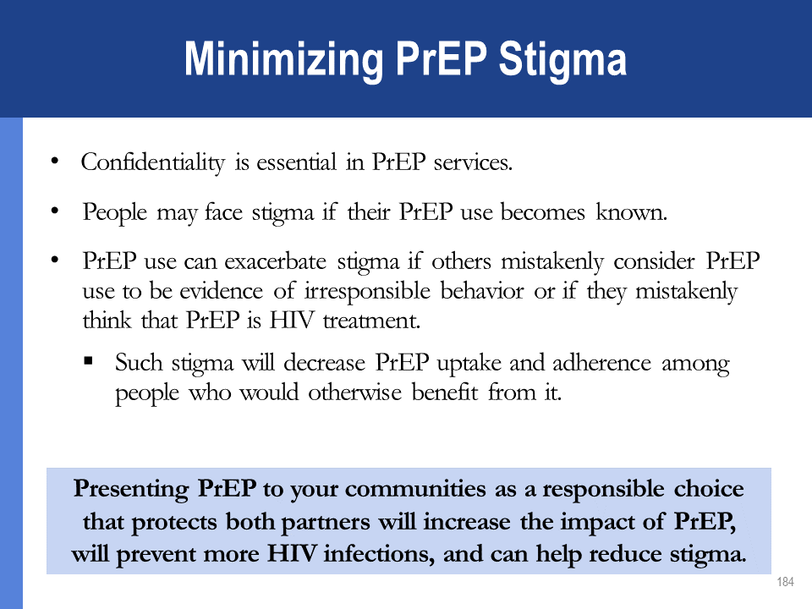

### GAPS IN PrEP KNOWLEDGE AND NEED FOR CONTINUED SURVEILLANCE

Current gaps in knowledge related to PrEP implementation include:

Renal safetyof FTC/TDF PrEP in people with diabetes mellitus and uncontrolled systemic hypertension.

3TC use in combination with TDF for PrEP (although for HIV treatment, 3TC is equivalent to FTC).

Comparison of daily vs. on-demand PrEP regimens.

Effectiveness of on-demand oral PrEP regimens for women.

Clinical HBV reboundwhen stopping FTC/TDF PrEP: Not observed among people with current HBV infection in clinical trials, though most excluded people with HBV infection.

WHO recommends offering PrEP as part of a comprehensive HIV prevention package that is integrated with PMTCT and antenatal and postnatal care programs in settings of high HIV incidence. However, there is a need for continued surveillance of maternal, pregnancy, and infant outcomes as PrEP is rolled out for women of childbearing age.[[7]](#footnote-7)

### MODULE 4 SUMMARY

PrEP users should be informed about how to recognize signs and symptoms of AHI.

If someone using PrEP tests positive for HIV, stop PrEP immediately and start ART as soon as possible, without a gap after PrEP is discontinued.

If confirmation of a positive HIV test result is delayed for more than a few hours, transition to fully suppressive ART (3 ARVs per national treatment guidelines).

Ideally, blood creatinine (eGFR) should be measured before starting PrEP and *at least every 6 months*after PrEP is started. Initiation of PrEP should not be delayed while waiting for creatinine results.

# MODULE 5: PrEP MONITORING AND EVALUATION TOOLS

###### LEARNING OBJECTIVES

After completing Module 5, participants will be able to:

* Correctly complete the PrEP Screening Log, PrEP Facility Record, Seroconversion Tracker, and PrEP Client Register.
* Use the Provider Checklist for Substantial Risk during PrEP follow-up visits.
* Correctly complete the PrEP Monthly Summary Form and the PrEP Quarterly Cohort Report.
* Describe how PrEP M&E tools might be adapted for local use.
* Identify the correct order of the steps that health care workers should take during an initial PrEP visit.
* Identify at which steps of the initial PrEP visit the health care worker should complete or refer to the PrEP Screening Log, PrEP Screening for Substantial Risk and Eligibility form, Integrated Next Step Counseling Flow, PrEP Client Register, and PrEP Facility Record.
* Identify the correct order of the steps that health care workers should take during a follow-up PrEP visit.
* Identify at which steps of the follow-up PrEP visit the health care worker should complete or refer to the Provider Checklist for Substantial Risk, Integrated Next Step Counseling Flow, PrEP Client Register, and PrEP Facility Record.
* Use the Provider Checklist for Initial PrEP Visit and Provider Checklist for Follow-Up PrEP Visits to guide initial and follow-up PrEP visits.

### MONITORING AND EVALUATION FORMS

The M&E forms covered in this module are:

PrEP Screening for Substantial Risk and Eligibility

PrEP Screening Log

PrEP Facility Record

PrEP Client Register

Seroconversion Tracker

PrEP Monthly Summary Form

PrEP Quarterly Cohort Report

##### PrEP Screening for Substantial Risk and Eligibility (from Module 3)

The client is the source for the information needed to complete this screening form.

##### PrEP Screening Log

Complete the PrEP Screening Log after the initial PrEP Screening.

The Screening Log should include *everyone* who is screened for PrEP, regardless of whether they are eligible for PrEP or decline it.

The log shows how many of those screened are eligible for PrEP, and among those eligible, how many accept or decline PrEP.

The source document to complete the Screening Log is the PrEP Screening for Substantial Risk and Eligibility form.

The data help inform clinics and ministries of health of the PrEP eligibility and acceptability rate and the main reasons for ineligibility for and declining of PrEP.

The data can inform increased outreach and education efforts and IEC materials.

The fact that a large number of people screened are ineligible can inform how the screening form might be revised—for example, by adding additional KP or vulnerable groups.

##### PrEP Facility Record

This form is completed after the initial PrEP screening, for clients who agree to start PrEP.

The provider must ask questions of the client in order to complete some sections of the form.

Other sections are completed using test results and information obtained during PrEP screening.

This form is completed with the client, along with consulting the PrEP Screening for Substantial Risk and Eligibility form.

The form’s PrEP Follow-Up Visits section will be completed at each follow-up visit.

##### PrEP Client Register

As each new client starts PrEP, the relevant information is added to this register, and the client’s follow-up visits are recorded.

The Source document to complete this form is the PrEP Facility Record.

##### Seroconversion Tracker

Seroconversion can occur when:

The client had AHI before starting PrEP.

The client has had poor adherence and has been exposed to HIV.

*Importance of the Seroconversion Tracker*

The tracker is completed during follow-up visits for PrEP clients who seroconvert to HIV positive.

Source documents for completing this form are the PrEP Client Register and ART records.

Refer to the Variable and Code Definitions as needed when completing the tracker.

The tracker will help ensure appropriate linking and follow-up on clients diagnosed with HIV and can facilitate reporting of seroconversions for surveillance.

##### PrEP Monthly Summary Form

Optimally, all data from all HIV testing points referring for PrEP within a facility should be combined and reported here.

The number of clients testing HIV negative is the “denominator” for assessing coverage of who is eligible for PrEP screening. Data for the HIV testing and results table should be taken from the clinic HIV testing services registers.

Source documents for completing this form are the PrEP Client Register and the PrEP Screening Log.

##### PrEP Quarterly Cohort Report

This form is used to collect and track data per quarter and PrEP cohort.

The source for completing this document is the PrEP Client Register.

### M&E PRACTICE SCENARIOS

##### M&E Practice Scenario 1

Joseph, a 22-year-old man, presented at the clinic because he is interested in starting PrEP. He reports using condoms sometimes during sex with his HIV-positive male partner. His partner is healthy and has been on ART for 4 years. His most recent viral load from “a few months ago” was reported as 1200 copies/mL. Their last unprotected intercourse was last week. Joseph is in good health and takes no medications. His rapid HIV antibody test today was negative. Joseph reports that he loves to live life from moment to moment. He says that he is not good at “following orders” and is worried that he might forget to take his pills. Joseph has agreed to start PrEP.

##### M&E Practice Scenario 2

Marie, an 18-year-old woman, presented at the clinic because she feels sick and is afraid she might have HIV. She reluctantly explains that, during the past year, she has been having sex for money or gifts in order to support her 2 children. Some of her partners have used condoms and others have not. She does not know whether her partners have HIV. Marie reports that she has been feeling run-down and sick for the past few weeks. Her rapid HIV antibody test today is negative. After you determine that there is no suspicion of AHI, Marie has agreed to start PrEP.

##### M&E Practice Scenario 3

Geraldine, a 30-year-old wife and mother, is interested in starting PrEP. She presented at the clinic because she heard that she could get drugs that will prevent her from getting HIV. She suspects that her husband has been injecting drugs, as he comes home with needle marks on his arms. Geraldine is afraid that her husband might have HIV and that he will infect her. She reports that her husband has not been tested. Geraldine’s rapid HIV antibody test today was negative. She is eager to start PrEP but worries that her husband might see her taking pills and become abusive or make her stop taking the medication. Geraldine has agreed to start PrEP.

##### M&E Practice Scenario 4

Gabrielle, a 25-year-old married woman, has come to the clinic distressed because of her husband’s behavior. Lately, he has been staying out all night has needle marks on his arms when he returns. She is afraid that he might be using drugs. Gabrielle has come to the clinic to get medicine to protect against any infection that her husband might have. She feels that she cannot control his behavior, but she can try to protect herself.

Despite the problems with her husband, Gabrielle has sex (vaginal) with her husband almost every week. Her husband does not like to use condoms. Gabrielle does not know whether her husband has HIV, as he refuses to get tested; he says that such tests are for “bad people.” She fears, though, that he may be having sex with other women.

Gabrielle has not had any STIs. She has not taken PEP. She does not use drugs or share injecting material with others. She last had sex with her husband 2 nights ago. She feels fine and does not have a fever, or cold or flu-like symptoms. Her rapid HIV antibody test today is negative. Gabrielle has decided to start PrEP.

##### **M&E** Practice **Scenario 5**

Justine, a 19-year-old sex worker with a live-in boyfriend, was born a male but has been living as a woman since she was 15. She has had sex with multiple male partners over the last 6 months, a few times without condoms. She does not know whether she has any STIs, but she has no symptoms.

Justine’s boyfriend is living with HIV and has been on ART for about 1 year. He has adhered to the treatment regimen very well and is in good health. Justine is proud of him for this. Justine and her boyfriend use condoms during sex.

A few weeks ago, Justine was tested for HIV after a scary encounter with a client. The test was negative. Justine has come to the clinic today because she is feeling poorly. She has had a fever and chills in recent days and wants medicine in order to feel better. You determine that there is no suspicion of AHI. Justine agrees to start PrEP.

##### **M&E** Practice **Scenario 6**

Lucien, 25 years old, is a married man who has sex regularly with men outside his marriage, as well as with his wife. His wife does not know about the sex with men. Lucien insists on using condoms during sex with men but he does not do so with his wife.

Lucien has come to the clinic because the last time he was with a man, the condom broke, and he is worried that he might have gotten HIV. He does not know the HIV status of his male sex partners. He assumes that his wife does not have HIV but she has not been tested. He does not use drugs or share injecting material with others. Lucien’s HIV test is negative. He agrees to start PrEP.

##### **M&E** Practice **Scenario 7**

Anne, a sex worker, is interested in starting PrEP. She uses condoms during sex with clients but not with her stable partner, whose HIV status is unknown. She had a negative HIV test 6 months ago and wants to avoid HIV infection, because she would like to have a baby with her partner. She is using an injectable hormonal contraceptive as she used to forget to take her oral contraceptives every day. Anne’s HIV test is negative. She has decided to start PrEP.

### Sample Data for PrEP Monthly Summary Form

**Clients Who Received HIV Testing for PrEP Screening**

| **GENDER** | **AGE** | **HIV STATUS** | **SITUATION** |
| --- | --- | --- | --- |
| Female | 21 | Negative | Male partner is HIV positive |
| Female | 18 | Positive | Sex worker |
| Male | 35 | Negative | Injects drugs; AHI suspected |
| Female | 17 | Negative | Was born a male |
| Male | 19 | Negative | Has sex with men |
| Male | 25 | Negative | Female partner is HIV positive |
| Female | 31 | Negative | Husband has sex with men |
| Female | 26 | Negative | Was born a male |
| Male | 45 | Positive | Has sex with men |
| Female | 20 | Negative | Sex worker |
| Male | 28 | Negative | Has sex with SW; AHI suspected |
| Male | 23 | Negative | Has sex with men |
| Female | 32 | Positive | Injects drugs |
| Male | 22 | Negative | Sex worker |
| Female | 52 | Negative | Husband has sex with SW |
| Female | 19 | Negative | Injects drugs |

#### Clients Who Started PrEP

* Determine based on HIV test results and AHI information above.

Returning PrEP Clients Who Received Follow-Up HIV Testing

| **GENDER** | **AGE** | **HIV STATUS** | **SITUATION** | **FOLLOW-UP TEST** |
| --- | --- | --- | --- | --- |
| Female | 21 | Negative | Male partner is HIV positive | Negative |
| Female | 18 | Positive | Sex worker |  |
| Male | 35 | Negative | Injects drugs; AHI suspected | Negative |
| Female | 17 | Negative | Was born a male | Negative |
| Male | 19 | Negative | Has sex with men | Negative |
| Male | 25 | Negative | Female partner is HIV positive | Negative |
| Female | 31 | Negative | Husband has sex with men | Positive |
| Female | 26 | Negative | Was born a male | Negative |
| Male | 45 | Positive | Has sex with men | Positive |
| Female | 20 | Negative | Sex worker | Negative |
| Male | 28 | Negative | Has sex with SW; AHI suspected | Positive |
| Male | 23 | Negative | Has sex with men | Negative |
| Female | 32 | Positive | Injects drugs |  |
| Male | 22 | Negative | Sex worker | Positive |
| Female | 52 | Negative | Husband has sex with sex workers | Negative |
| Female | 19 | Negative | Injects drugs | Negative |

**Instructions for PrEP Quarterly Cohort Report**

Use your completed PrEP Monthly Summary Form and the information (*below)* to complete the PrEP Quarterly Cohort Report for Cohort 1.

Transferred in: female, age 24, HIV status negative, sex worker.

Transferred in: male, age 55, HIV status negative, has sex with men.

Female, age 19, injects drugs, stopped PrEP due to positive HIV test.

No PrEP clients stopped because they were no longer at substantial risk.

Male, 45, has sex with men, was lost.

No PrEP clients from this cohort died.

### ENTRY POINTS FOR PrEP

Outpatient clinic or facility

* HIV testing (the most common)
* Testing for STIs
* Sexual and gender-based violence services
* Harm reduction and other drug treatment services
* Antenatal services

Gynecology and reproductive services

Inpatient

* Referred from emergency room or hospital staff

Community-based and outreach HIV testing—clients tested in community outreach settings may be referred for PrEP.

PMTCT—HIV-negative partners of HIV-positive pregnant women may be referred for PrEP.

PEP services—Clients completing PEP services may be referred for PrEP.

##### PEP to PrEP Transition

Clients who present recurrently for PEP may be candidates for PrEP.

PEP encounters should be viewed as a prevention opportunity to help at-risk persons engage in sustained risk reduction and HIV prevention services, including PrEP.

PrEP offers more consistent protection against HIV than repeated courses of PEP.

##### Entry Points for PrEP for M&E Use

If your facility has multiple points of entry, consider adapting the PrEP M&E tools to capture these points.

This will provide very useful information about where PrEP clients come from, which will help to inform national prevention and demand creation strategies.

### PrEP CLIENT AND CLINIC FLOW

The PrEP Client Flow describes the sequence of PrEP services that new and returning clients receive. The client flow should be adapted to fit clinic structure and existing procedures.

##### PrEP Client and Clinic Flow—Initial Visit Steps

▶ *Health care workers should use the Provider Checklist for Initial PrEP Visit as a guide throughout the initial   
PrEP visit.*

* + - 1. The client arrives at the facility for HTS.
      2. The client receives HIV pre-test counseling.
      3. The client receives HIV testing.
      4. The client receives results of HIV test and post-test counseling.

**4a. HIV-positive clients** are referred or linked to HIV care and treatment services.

**4b. HIV-negative clients** are counseled on *all* methods of HIV prevention, including PrEP.

5. The health care worker screens the client using the Pre-Exposure Prophylaxis (PrEP) Screening for Substantial Risk and Eligibility form.

**▶***Note: The Pre-Exposure Prophylaxis (PrEP) Screening for Substantial Risk and Eligibility form should be started when the health care worker introduces PrEP to a client, regardless of whether the client is interested in starting PrEP. This is because 1) the purpose of the PrEP screening form is to assess eligibility for PrEP, not interest; and 2) the PrEP screening form is also meant to capture clients declining PrEP.*

6. The health care worker determines PrEP eligibility based on the assessment from the Pre-Exposure Prophylaxis (PrEP) Screening for Substantial Risk and Eligibility form.

7. **The client accepts or declines PrEP.**

8. The health care worker completes the Pre-Exposure Prophylaxis (PrEP) Screening for Substantial Risk and Eligibility form and records the information in the PrEP Screening Log.

9. **If client accepts PrEP:** The health care worker begins completing the PrEP Facility Record.

▶*Note: HBV and creatinine information on the PrEP Facility Record will be completed later, when lab results are available.*

10. **If the client** **declines the health care worker’s offer of PrEP**: The healthcare worker assesses and documents the reasons for the response and provides additional risk reduction and prevention counseling and referrals.

11. The health care worker provides PrEP adherence and combination prevention counseling (using the Integrated Next Step Counseling Flow.)

12. The health care worker completes a regular client physical exam, including screening and treatment for STIs and other infections and a pregnancy test (if needed).

13. The health care worker provides a PrEP prescription and an appointment card with the date of the next scheduled PrEP follow-visit.

14. Laboratory samples are collected for HBV and serum creatinine tests. HBV and creatinine labs may be collected at any point after the client accepts PrEP and before the client leaves the clinic.

15. The PrEP prescription is filled and dispensed, and the client leaves the facility.Each country should create a PrEP Dispensing Log.

16. The health care worker completes the PrEP Client Register.

##### PrEP Client and Clinic Flow—Follow-Up Visit Steps

▶ *Health care workers should use the Provider Checklist for Follow-Up PrEP Visits as a guide throughout follow-up PrEP visits.*

1. Health care worker checks creatinine laboratory results and records the results in the PrEP Facility Record.

2. The health care worker calls clients with out-of-range calculated creatinine clearance to stop PrEP.

3. The client arrives at facility for a scheduled PrEP follow-up visit.

4. The client receives HIV pre-test counseling.

5. The client receives HIV testing.

6. The client receives the results of the HIV test and post-test counseling.

**6a. HIV-positive** **clients** are referred or linked to HIV care and treatment services. The health care worker completes the Seroconversion Tracker.

**6b. HIV-negative clients** continue in the PrEP program.

7. The health care worker discusses HBV and creatinine lab results with the client.

**7a. If the client tested positive for HBV,** the health care worker considers treatment for HBV per the national guidelines and counsels client about possible HBV viremia rebound.

**7b. If the client tested negative for HBV,** the health care worker should discuss the client getting the HBV vaccination (if available in country).

8. The health care worker confirms the client’s desire to remain on PrEP.

9. The health care worker screens the client for substantial risk for HIV infection using the Provider Checklist for Substantial Risk job aid.

10. The health care worker assesses for signs and symptoms of AHI.

11. The health care worker provides PrEP adherence and combination prevention counseling (using the Integrated Next Step Counseling Flow).

12. The health care worker assesses and manages PrEP side effects.

13. The health care worker provides risk reduction counseling.

14. The health care worker completes a regular client physical exam, including screening and treatment for STIs and other infections and a pregnancy test (if needed).

15. The health care worker refills the PrEP prescription and completes an appointment card with the date of the next scheduled PrEP follow-visit.

16. Laboratory samples are collected for serum creatinine tests every 6 months.

17. If a creatinine test comes back abnormal, PrEP is stopped.

18. The PrEP prescription is refilled and dispensed.

19. The health care worker completes the follow-up sections of the PrEP Facility Record and PrEP Client Register.

**DISCONTINUING PrEP**

**Steps for Discontinuation of PrEP**

1. With the client, the health care worker assesses the reasons for stopping PrEP and records them in the PrEP Facility Record and PrEP Client Register.

2. The health care worker counsels the client to continue PrEP for 28 days after the last possible HIV exposure, unless contraindicated by WHO guidelines.

3. The health care worker educates the client about AHI.

4. The health care worker counsels the client on the use of alternative prevention methods and provides condoms, lubricants, and referrals to available harm reduction services as appropriate.

5. The health care worker discusses the possibility of PrEP re-initiation in the future.

**Additional Steps**

1. The health care worker completes the Monthly Summary Form every month for all clients screened for PrEP.
2. The health care worker completes the PrEP Quarterly Cohort Report every quarter for all clients initiated on PrEP.

### PrEP OUTREACH FOR FOLLOW-UP

When a client misses a PrEP follow-up appointment (i.e., has a “missed PrEP appointment”), an outreach worker or health care worker should do the following:

1. Try to contact the client by phone within 24 hours of the missed appointment.

If the client is reachable by phone, reschedule the appointment for the earliest possible date.

1. Add names of clients *not* reachable by phone to a roster of clients needing home or community visits.

Attempt to visit the client at home or in the community using the contact information you have on file.

If the client is located and engaged through outreach, reschedule the PrEP appointment for the earliest possible date.

* If a client does not wish to return to the clinic, provide counseling on the importance of HIV testing before discontinuing PrEP.
* Update the PrEP record to indicate that the client has discontinued PrEP and why.

If the client is *not* located and engaged, continue outreach for 90 days after the missed appointment.

* Continue to attempt to contact the client by phone (if applicable).

Document all attempts to reach “missed PrEP appointment” clients and the outcomes.

1. After a “missed PrEP appointment” client misses a PrEP appointment by more than 90 days, reclassify him or her as lost to follow-up (LTFU).

You may make a final attempt to reach the client at 90 days, but after that, no further outreach is attempted.

For clients who have not been reached and/or who do not provide sufficient information to be classified as another outcome after 90 days (i.e., PrEP-discontinued client), document the client’s LTFU status in the appropriate PrEP record and register.

### PrEP Client Definitions

**PrEP-Initiated Client—**Has completed the PrEP eligibility screening form and initiated PrEP.

**PrEP-Declined Client—**Has completed the PrEP eligibility screening form and was determined to be eligible, but declined the offer of PrEP.

**PrEP-Discontinued Client—**Has initiated PrEP but has been documented as declining to continue taking PrEP for any reason.

Missed PrEP Appointment—Initiated PrEP and missed a follow-up appointment in the last 90 days.

Lost to Follow-Up—Initiated PrEP and missed a follow-up appointment by more than 90 days.

### MODULE 5 SUMMARY

Tracking PrEP screening data can inform increased outreach and education efforts and IEC materials.

Tracking PrEP seroconversion data will help ensure appropriate linking and follow-up on clients diagnosed with HIV and can facilitate reporting of seroconversions for surveillance.

Clients who present more than once for PEP may be candidates for PrEP. Engage these clients in sustained risk reduction and HIV prevention services, including PrEP.

If your facility has multiple points of entry, consider adapting the PrEP M&E tools to capture these points.

# MODULE 6: POST-TRAINING ASSESSMENT, EVALUATION, AND CLOSING

The trainer will provide the Post-Training Assessment and the Training Evaluation Form.

# APPENDIX

1. **Pre-and Post-Training Assessment**
2. **Materials in Participant Folders**
3. **PrEP Clinical Pathway**
4. **Screening for Substantial Risk of HIV infection**
5. **Provider Checklist for Initial PrEP Visit**
6. **Provider Checklist for Follow-Up PrEP Visit**
7. **Provider Checklist for Substantial Risk**
8. **Frequently Asked Questions about PrEP**

**A. Pre- and Post-Training Assessment for PrEP Training   
 for Providers in Clinical Settings**

*Please tick the correct answer to each question below:*

1. **Is the following statement true or false? “Pre-exposure prophylaxis (PrEP) is a medication you take for life.”**
2. True
3. False
4. **Counseling to support PrEP use and adherence may be provided by:**

*(Select all that apply.)*

1. Pharmacists
2. Nurses
3. Lay counselors
4. Peer workers
5. **Which of the following are WHO-recommended regimens for PrEP?**

*(Select all that apply.)*

1. Tenofovir/emtricitabine (TDF/FTC)
2. Tenofovir/emtricitabine + efavirenz (TDF/FTC) +(EFV)
3. Tenofovir/lamivudine (TDF/3TC)
4. Zidovudine/lamivudine (AZT/3TC)
5. **Is the following statement true or false? “PrEP is safe to use during pregnancy and breastfeeding.”**
6. True
7. False
8. **PrEP is safe to use with:**

*(Select all that apply.)*

1. Hormonal contraception
2. Recreational drugs
3. Alcohol
4. Antibiotics
5. **PrEP should be discontinued if:**

*(Select all that apply.)*

1. The health care worker decides it is no longer right for the client
2. The estimated creatinine clearance decreases to <60 ml/min
3. The client reports headaches and stomach upset
4. The client tests HIV positive
5. **Is the following statement true or false? “PrEP and post-exposure** **prophylaxis (PEP) are both used by HIV-negative persons to prevent HIV acquisition”**
6. True
7. False
8. **PrEP can be offered as part of a comprehensive HIV prevention package for:**

*(Select all that apply.)*

1. Men who have sex with men
2. Individuals with potential HIV exposure in the last 72 hours
3. People who inject drugs
4. Serodiscordant couples
5. **Is the following statement true or false? “PrEP is protective against a variety of sexually transmitted infections.”**
6. True
7. False
8. **Is the following statement true or false? “PrEP is a new drug.”**
9. True
10. False
11. **Counseling to support PrEP adherence should include:**

*(Select all that apply.)*

1. A client-centered approach
2. Identification of barriers to taking PrEP
3. Identification of client-specific strategies to use PrEP effectively
4. Integration of condom use

# B. Materials Needed for Participant Folders

Each participant folder should include:

1. **Pre-Training Assessment**
2. **Post-Training Assessment**
3. **Training Evaluation Form**
4. **PrEP Job Aids**
   1. **PrEP Clinical Pathway**
   2. **Screening for Substantial Risk of HIV Infection Chart**
   3. **Provider Checklist for Initial PrEP Visit~~s~~**
   4. **Provider Checklist for Follow-Up PrEP Visits**
   5. **Provider Checklist for Substantial Risk**
   6. **Frequently Asked Questions about PrEP**
5. **The PrEP M&E Tool Package, including:**
   1. **Pre-Exposure Prophylaxis (PrEP) Screening for Substantial Risk and Eligibility**
   2. **PrEP Screening Log**
   3. **PrEP Facility Record**
   4. **PrEP Client Register**
   5. **Seroconversion Tracker**
   6. **PrEP Monthly Summary Form**
   7. **PrEP Quarterly Cohort Report**

### C. PrEP Clinical Pathway

**Confirm HIV Negative Status**

* Perform rapid HIV test according to national guidelines/algorithms.
* Link HIV-positive persons promptly to care and treatment services

**Client who is sexually active in a high-HIV-prevalence population (either in the general population or key population group) *plus* reports *any* of the following *in the* *past 6 months*:**

* Vaginal or anal intercourse without condoms with more than one partner, OR
* Sex partner with one or more HIV risk, OR
* History of a sexually transmitted infection (STI), based on lab test, syndromic STI treatment, or self-report, OR
* History of use of post-exposure prophylaxis (PEP)

**OR**

**Client who reports history of sharing of injection material/equipment with another person *in the past 6 months***

**OR**

**Client who reports having a sexual partner in the past 6 months\* who is HIV positive *AND* who has not been on effective HIV treatment**

\**On ART for less than 6 months, or has inconsistent or unknown adherence*

**Screen for Substantial Risk for HIV**

Clients are eligible if they fulfill **ALL** the criteria below:

* HIV negative.
* Are at substantial risk for HIV.
* Have no signs or symptoms of acute HIV infection.
* Have creatinine clearance (eGFR) >60 ml/min.\*

\**Absence of creatinine results should not delay PrEP initiation. Providers should do same-day initiation of PrEP, then discontinue PrEP later if the patient’s eGFR is not within the appropriate range.*

**Establish Eligibility**

* **Plan follow-up visits 1 month after starting PrEP and every 3 months thereafter.**

**At follow-up visits:**

* Repeat the HIV test.
* Ask about side effects.
* Support and monitor adherence.
* Do risk-reduction counseling.
* Do family planning counseling, and provide condoms and lubricants.
* Screen for STIs.
* Repeat eGFR after 6 months on PrEP.
* Prescribe PrEP.
* Schedule a follow-up visit and provide appointment card with the date.

**PrEP Follow-Up Visits**

**PrEP Initiation**

* Provide information on PrEP, the importance of adherence, the potential side effects, and a follow-up schedule.
* Screen and manage for STIs.
* Do risk-reduction counseling and provide condoms and lubricants.
* Do PrEP adherence counseling.
* Prescribe PrEP.
* Schedule a follow-up visit and provide appointment card with the date.
* Stress the importance of returning to the clinic and notifying a provider if side effects or signs and symptoms of acute HIV infection develop.

### D. Screening for Substantial Risk of HIV Infection *(based on history in the past 6 months)*

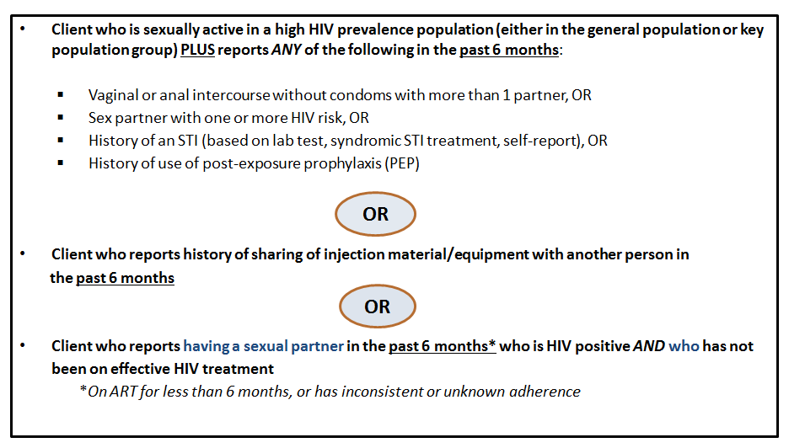

### E. Provider Checklist for Initial PrEP Visit

**❑ Conduct HIV testing (using the algorithm in the national HIV testing guidelines).**

Assess on HIV infection status.

**❑ Exclude acute HIV infection.**

* Ask about the last potential exposure to HIV.
* Ask about and look for flu-like symptoms.

**❑ Screen for substantial risk for HIV.**

**❑ Screen for signs and symptoms of kidney disease.**

To identify potential pre-existing renal impairment if lab results are not available on the day of testing.

**❑ Conduct serum creatinine testing (calculate eGFR).**

Absence of creatinine results should not delay PrEP initiation. Providers should do same-day initiation of PrEP, then discontinue PrEP if a patient’s eGFR is not within the appropriate range.

**❑ Screen for hepatitis B (HBsAg).**

* To identify undiagnosed hepatitis B (HBV) infection.
* To identify those eligible for vaccination against hepatitis B.

**❑ Screen for sexually transmitted infections (STI).**

* Perform syndromic and etiological STI testing (depending on local guidelines).
* Rapid plasma reagin test (RPR) for syphilis (if available).

**❑ Conduct risk reduction counseling.**

* Refer clients based on needs (i.e., for social support, harm reduction, gender-based violence programs, etc.).

**❑ Counsel on family planning.**

* Perform a pregnancy test for women.
* Provide condoms and lubricants.
* Provide other contraception.

**❑ Provide information on PrEP, including potential side effects; schedule a follow-up visit.**

**❑ Conduct PrEP adherence counseling.**

**❑**  **Prescribe PrEP.**

**❑**  **Schedule the next PrEP follow-up appointment, and provide an appointment card.**

*\*This checklist to be aligned with national guidelines on PrEP.*

**F.** **Provider Checklist for Follow-Up PrEP Visits**

❑ **Brief PrEP Counseling**

Ask about signs and symptoms of acute HIV infection.

Assess for substantial ongoing risk for HIV.

Confirm the client wishes to remain on PrEP.

Review facilitators and barriers to PrEP use.

❑ **Adherence Counseling**

Assess adherence and adherence challenges.

Provide adherence counseling.

Discuss the importance of effective use of PrEP.

❑ **Assessment and Management of Side Effects**

Ask about and manage side effects.

❑ **Confirmation of HIV-Negative Status**

Repeat HIV test 1 month after starting PrEP, then every 3 months thereafter.

❑ **Calculation of Estimated Creatinine Clearance (eGFR): Recommended Frequencies**

At least every 6 months—*more frequently* if there is a history of conditions affecting the kidney (e.g., diabetes, hypertension, any chronic nephropathy).

Check creatinine test results, calculate creatinine clearance, and add the results to the appropriate forms.

* **Screening for Sexually Transmitted Infections (STIs)**

❑ **Risk Reduction Counseling**

Refer clients based on their specific needs (i.e., for social support, harm reduction, gender-based violence programs, etc.).

❑ **Counseling on Family Planning**

Perform a pregnancy test for women, if indicated**.**

Provide condoms and lubricants.

Provide other contraception.

❑ **PrEP Prescribed**

❑ **Schedule next appointment, and provide appointment card**

**STOP PrEP  
when a client using PrEP tests positive for HIV  
and link promptly to treatment and care services.   
Start ART for HIV infection immediately.**

*\* Checklist to be aligned with national guidelines on PrEP \**

### G. Provider Checklist for Substantial Risk

|  |
| --- |
| **Providers should assess for a client’s substantial risk at each PrEP follow-up visit by asking the questions below. *If at least one item is ticked, the client is at substantial risk.*** |
| **Have you...**   * Had vaginal sexual intercourse with more than one partner of unknown HIV status in the past 6 months?   Y  N (If *yes*, tick substantial risk.)   * Had vaginal sex without a condom in the past 6 months?   Y  N (If *yes*, tick substantial risk.)   * Had anal sexual intercourse in the past 6 months?   Y  N (If *yes*, tick substantial risk.)   * Had sex in exchange for money, goods or a service in the last 6 months?   Y  N (If *yes*, tick substantial risk.)   * Injected drugs in the past 6 months?   Y  N (If *yes*, tick substantial risk.)   * Been diagnosed with a sexual transmitted infection (STI) more than once in the past 12 months?   Y  N (If *yes*, tick substantial risk.)   * Taken post-exposure prophylaxis (PEP) for exposure to HIV in the past 6 months?   Y  N (If *yes*, tick substantial risk.)   * Do you have a partner who is living with HIV?   Y  N Don’t know  (If *no* or *don’t know*, continue to Client Risk Classification.)   * Is your HIV-positive partner on ART?   Y  N Don’t know  (If *no* or *don’t know*, tick substantial risk.)   * Has your HIV-positive partner been on ART for at *less than* 6 months?   Y  N Don’t know  (If *no* or *don’t know*, tick substantial risk.) |
| **Client Risk Classification**  **SUBSTANTIAL RISK (***At least one item indicating substantial risk is ticked above)*  **NOT AT SUBSTANTIAL RISK** *(If none of the substantial risk items above are ticked)* |

**H.** **Frequently Asked Questions about PrEP**

**What is PrEP?**

PrEP stands for **pr**e-**e**xposure **p**rophylaxis. It is a single daily pill that **protects** you from getting infected with HIV. It works when you take it **before** you are exposed to HIV.

**Who should use PrEP?**

PrEP is for **anyone** (both men and women) who is at substantial risk of becoming infected with HIV. It is for situations and times when you may have a high risk of HIV infection.

**Is PrEP a new drug?**

No. PrEP is not new. PrEP is made of antiretroviral drugs (HIV medication) used to help treat people who are HIV positive and for preventing mother-to-child HIV transmission (PMTCT).

**When and how do I use PrEP?**

* See a health care provider to find out if you are eligible for PrEP.
* If you are prescribed PrEP, you must take 1 pill every day.
* You can take PrEP any time of day and at different times on different days, as long as you take 1 pill every day.
* You can take PrEP with or without food.
* When starting or re-starting PrEP, you must take it every day for at least 7 days before you are protected.
* You must see your health care provider for regular follow-up visits while on PrEP.
* While taking PrEP, you must test for HIV every 3 months to be sure you are not infected.

**How long do I use PrEP?**

PrEP is recommended as added protection for people who are at substantial and ongoing for HIV infection. For most people, PrEP will not be a lifelong medication. It is for a time in your life when you feel you are regularly or frequently at risk for HIV. As part of your follow-up care for PrEP, your health care provider will help you assess your risk and decide whether or not PrEP is still appropriate for you. If you wish to stop PrEP, talk to your health care provider about how to safely stop.

**How well does PrEP work?**

PrEP does not provide 100% protection, but it is highly effective and provides a great deal of protection against HIV. Among clients who take PrEP consistently, as prescribed, PrEP reduces the risk of HIV infection during sex by over 90%.

**What if I miss a dose?**

If you miss a dose, just take it when you remember. For example, if you usually take PrEP in the morning, but one day realize at 10 in the evening that you forgot, it is okay to take 1 pill then and resume your usual morning schedule the next day. Remember, PrEP is effective when taken every day.

**Is PrEP an HIV vaccine?**

No. PrEP is not an HIV vaccine. PrEP is a pill that works only when taken consistently and correctly—1 pill every day. Unlike a vaccine, PrEP stops working once you stop taking it.

**Will I have side effects while taking PrEP?**

You may experience some side effects—like nausea, vomiting, or abdominal pain—but these usually stop within the first weeks of starting PrEP.

**Will PrEP affect my liver?**

No. Several studies have shown that PrEP medication does not affect the liver. However, the same medication used for PrEP is also used to treat hepatitis B (a liver disease), so before you start PrEP, you should first be screened for hepatitis B to make sure your liver is okay.

**Will PrEP affect my kidneys?**

For some clients, PrEP can affect the kidneys. It is important for PrEP clients to have their kidneys checked regularly by a health care provider, using a creatinine test, because kidney problems caused by PrEP may not be obvious or show any symptoms.

**Can I take PrEP if I use alcohol or drugs?**

Yes. PrEP works if you drink alcohol and/or use recreational drugs.However, alcohol and drug use can cause you to forget to take PrEP. See your provider if you need help with alcohol or drug use.

**Will PrEP work if I am HIV positive?**

No. PrEP is only for HIV-negative people. You must be tested regularly for HIV while taking PrEP.

**I just had sex without a condom with someone who is HIV positive. Should I take PrEP?**

No. PrEP works only when it is taken **before** you are exposed to HIV. If you have sex with someone whom you believe may be HIV positive, go immediately to a health care provider and ask for **PEP** (post-exposure prophylaxis).

**If I take PrEP every day, can I stop using condoms?**

No. PrEP does not protect against other sexually transmitted infections (STIs) or pregnancy, as condoms do. Condoms also provide additional protection against HIV. You should use condoms even when taking PrEP.

**Can I use PrEP and hormonal contraception (e.g., oral, injectable, implants) at the same time?**

Yes. It is safe to use PrEP and hormonal contraception (i.e. birth control) at the same time. Taking them together does not make them less effective.

**Do I have to tell my partners that I am taking PrEP?**

No. PrEP can be private. You do not have to tell anyone that you are taking PrEP unless you want to. However, people sometimes find it helpful to tell a partner, friend or family member that they are taking PrEP so that people can help support their PrEP use.

**Will PrEP cause erectile dysfunction, “loss of man power,” sterility, or infertility?**

No. Over several years, men who have taken PrEP have not had any of these problems.

**Can I use PrEP if I am pregnant or breastfeeding?**

Yes. It is safe to use PrEP during pregnancy and breastfeeding.

**Can I take 2 PrEP pills just before having sex to avoid getting HIV?**

No.To avoid possible side effects, you should take your PrEP medication every day as prescribed.

**Can both my partner and I take PrEP?**

Yes. PrEP is for all people at substantial risk of HIV.

**Can I give PrEP to my children if they are sexually active?**

No. To ensure proper screening and follow-up, PrEP can be given only by professional health care workers. If you think your child is at substantial risk for HIV infection, seek services at a clinic.

**When and how can I stop PrEP?**

Starting PrEP does not mean taking PrEP for the rest of your life. You may stop if you are no longer at substantial risk for HIV infection. However, after your last potential HIV exposure, you should keep taking PrEP for 28 more days. If you want to stop PrEP, see your health care provider.

W**hat else can I do to stay HIV negative?**

* Use PrEP together with other ways of preventing HIV including:
* Use condoms every time you have sex.
* Get regular HIV testing for yourself and your partners.
* Get screened and treated for STIs.
* Get counseling and support to reduce behaviors that put you at risk for HIV.

**How does PrEP compare to PEP (post-exposure prophylaxis)?**

* You take PrEP before you are exposed to HIV; you take PEP after you are exposed to HIV.
* PrEP is taken as long there is substantial risk for HIV infection.   
  PEP is taken for only 28 days after exposure to HIV.
* Both are given by health care providers to HIV-negative people to keep from getting HIV.
* Both must be taken correctly and consistently to work well.
* Both use HIV treatment medication to help stop HIV infection in those exposed to HIV.

**What other countries are using PrEP?**

The medication in PrEP has been approved in the United States, South Africa, Brazil, Peru, Kenya, Canada, Australia, Belgium, Botswana, Czech Republic, Denmark, United Kingdom, France, Lesotho, Namibia, Netherlands, Taiwan, Thailand, Zambia, Zimbabwe, and others.

**REMEMBER**

* PrEP is a pill you take once a day to prevent HIV infection.
* PrEP works best if you take it every day as prescribed.
* If you take PrEP as prescribed, it will stop you from becoming infected with HIV.
* PrEP does not protect against other STIs or pregnancy.
* PrEP is private. You do not have to tell anyone you are using it.
* PrEP is safe. Mild side effects, which some people experience, usually go away after the first few weeks.
* You must take PrEP under the care of a health care provider and go to the clinic for regular follow-up visits.
* PrEP is not a lifelong medication. It is for a time of life when you feel at substantial risk of HIV exposure.

**Do you have more questions about PrEP?   
Come see us to learn more**!

1. http://www.who.int/hiv/topics/prophylaxis/en/ [↑](#footnote-ref-1)
2. Fonner VA, Dalglish SL, Kennedy CE, et al. Effectiveness and safety of oral HIV pre-exposure prophylaxis (PrEP) for all populations: A systematic review and meta-analysis. *AIDS* 2016(30):1973-1983. doi:10.1097/QAD.0000000000001145. [↑](#footnote-ref-2)
3. Adapted from: *WHO Implementation Tool for Pre-Exposure Prophylaxis (PrEP) of HIV Infection.* Module 3: Counsellors. Geneva: World Health Organization; 2017. License: CC BY-NC-SA 3.0 IGO. [↑](#footnote-ref-3)
4. Adapted from: *WHO Implementation Tool for Pre-Exposure Prophylaxis (PrEP) of HIV Infection.* Geneva: World Health Organization; 2017. License: CC BY-NC-SA 3.0 IGO. [↑](#footnote-ref-4)
5. Amico K R, McMahan V, Goicochea P, et al. Supporting study product use and accuracy in self-report in the iPrEx study: next step counseling and neutral assessment. *AIDS and Behavior.* 2012;16(5):1243-1259. [↑](#footnote-ref-5)
6. Adapted from: *WHO Implementation Tool for Pre-Exposure Prophylaxis (PrEP) of HIV Infection.* Geneva: World Health Organization; 2017. License: CC BY-NC-SA 3.0 IGO. [↑](#footnote-ref-6)
7. WHO. *WHO Technical Brief: Preventing HIV During Pregnancy and Breastfeeding in the context of Pre-Exposure Prophylaxis (PrEP).* Geneva: World Health Organization; 2017. License: CC BY-NC-SA 3.0 IGO. [↑](#footnote-ref-7)