Module 6
Course Summary, Practicum and Wrap Up

Module 6 Table of Contents

Session 6.1 Practicum Logistics and Expectations 2
Session 6.2 Practicum Debrief and Action Planning 3
Exercise 1 3
Exercise 2 5
Session 6.3: Reflection on Training Objectives and Concerns, Expectations, and Strengths 8
Session 6.4: Post-test, Training Evaluation and Closing 9
Exercise 3 9
Appendix 6A: Practicum Checklist 10
Appendix 6B: HIV-exposed Infant Care Action Planning and Implementation Template 13
Appendix 6C: Training Evaluation Form 15
References 17

Session 6.1 Practicum Logistics and Expectations

Session Objective
After completing this session, participants will:
- Understand the practicum logistics and expectations

Core Competencies
Participants will be asked to practise and demonstrate a number of skills learned during the training. Refer to Appendix 6A: Practicum Checklist for more information on these core competencies. Preceptors will be available to help and mentor participants as they master the skills learned during training.

Conduct During the Practicum
- Remember that we are guests at the health facility and must respect the wishes of the healthcare providers and managers who work at the facility.
- Keep all discussions and observations during the practicum confidential. Only share with other participants, trainers, or preceptors, and only for learning purposes. When discussing cases after the practicum, change any identifying information about specific clients so that no one will be able to guess who is being described.
- Always inform the preceptor if you need to take a break or leave the facility for any reason during the practicum.
- Always introduce yourself to other healthcare providers and clients. Tell them that you are currently completing a course about infant HIV testing and that the training includes observation and practise in the health facility.
- Always ask caregivers for their verbal consent for you to observe or practise skills. Keep in mind that clients have the right to refuse to consent or to withdraw their consent at any time. Participants and preceptors are obligated to concede to the client’s request.
- Always ask the preceptor if you have a question or concern.

Preceptors will be using Appendix 6A: Practicum Checklist to assess participant performance during the practicum. Participants should familiarize themselves with the content of this form, including how preceptors will make their final evaluations.

Session 6.2 Practicum Debrief and Action Planning

Session Objectives
After completing this session, participants will be able to:
- Identify their own strengths and weaknesses in providing infant HIV testing services
- Share ideas for a site-specific action plan to initiate or improve infant HIV testing services

Exercise 1

Exercise 1: Final practicum debrief: Small and large group discussion
Purpose | To share experiences and lessons learned during the practicum
Activities | Small Group Discussion (25 minutes):  - After breaking into small groups, you will be asked to take about 25 minutes to discuss and write down responses to the following questions:  - What was your overall experience during the practicum?  - What skills did you find the most difficult to perform?  - What skills did you find the least difficult?  - In which areas would you like more mentoring in the future?  - What did you learn during the practicum that you did not expect to learn?  - What was your most memorable experience during the practicum?  - Once the training is over, how can participants and preceptors continue to support each other in building their skills?  - The trainer will reconvene the small groups and facilitate a discussion focusing on ways to continue skills building.
Adapted from: ICAP. Module 15: Supervised Clinical Practicum. Adolescent HIV Care and Treatment: A Training Curriculum for Health Workers, Trainer Manual (1).

The WHO Global Strategy on People-centred and Integrated Health Services
There are many different aspects involved in the successful provision of HIV-exposed infant care. This training focused on the provision of quality, evidence-based services that are scientifically and medically appropriate. But anyone who has been treated poorly at a healthcare facility will tell you that in order to attract and retain clients, the staff at a healthcare facility have to be more than technically competent. Their services must also be people-centred.

The WHO global strategy on people-centred and integrated health services (see definitions in box below) represents a fundamental shift in the way health services should be funded, managed and delivered. Without a people-centred and integrated health services approach, health care will become increasingly fragmented, inefficient and unsustainable. The strategy proposes that all people have access to health services provided in a way that responds to their needs and that are equitable, safe, effective, efficient, timely and of an acceptable quality.

Within the context of HIV care service delivery, people-centred care includes:
- Building healthcare providers’ skills for effective communication with people;
- Providing information and supporting people to make informed decisions and for their active engagement in their own care and self-management;
- Offering a patient appointment system and acceptable frequency of facility visits;
- Avoiding long health facility waiting times during clinical consultations, medication pick-up or laboratory services;
- Coordinating care when people require multiple services (e.g. TB and HIV treatment, family-centred care); and
- Providing comprehensive integrated services, as appropriate and relevant.

People-centred and Integrated Health Services
People-centred health services involve an approach to care that consciously adopts the perspectives of individuals, families and communities and sees them as participants as well as beneficiaries of trusted health systems that respond to their needs and preferences in humane and holistic ways. People-centred care requires that people have the education and support they need to make decisions and participate in their own care. It is organized around the health needs and expectations of people rather than diseases.

Integrated health services are health services that are managed and delivered in a way that ensures that people receive a continuum of health promotion, disease prevention, diagnosis, treatment, disease management, rehabilitation and palliative care services at the different levels and sites of care within the health system and according to their needs, throughout their whole life.

Source: WHO, 2015 (3) and 2016 (4)

Exercise 2

Exercise 2: Action planning: Small group work and large group discussion
Purpose | To create an action plan to initiate or improve infant HIV testing services at participants’ individual facilities
Activities | - Refer to Appendix 6B: HIV-exposed Infant Care Action Planning and Implementation Template, as you complete this exercise. If you have your laptop computer, you may fill in an electronic (rather than paper) copy of Appendix 6B.  - Working in small groups (where possible, team up with co-workers), take about 60 minutes to discuss your clinic’s targets around HIV-exposed infant services. Focus on what you want to achieve in the next 6 months.  - The following questions might help identify priorities.  - Is your facility reaching all recently delivered mothers with HIV in your area?  - Is your facility testing all HIV-exposed infants at the 4–6 week visit?  - Are all HIV-infected infants getting into care? Do they stay in care until at least 3 months after breastfeeding?  - Is your facility testing 100% of HIV-exposed infants at 9 months of age and again 3 months after cessation of breastfeeding?  - Do clients miss appointments or drop out of care? Why?  - What percentage of your facility’s HIV-exposed infants acquire HIV? What can be done to improve this figure?  - As you identify activities that will allow you to achieve your priorities, fill in the Action Planning and Implementation Template. Think about the specific circumstances at your own clinic and be practical—try not to take on too many activities at once and focus on the activities that will have the most impact on the availability and quality of services for HIV-exposed infants.  - Use the questions in the box on the next page to help with brainstorming.  - For each objective, talk about likely challenges to implementing the action items and potential solutions to each.  - Note: you will need to meet (again) with colleagues from your agency to continue your action plan. Your plan will also need to be presented to your facility manager/supervisor before it can be finalized.

Exercise 2: Action planning: Small group work and large group discussion,
Questions to help with brainstorming
Identifying patients
- What is your clinic’s system for identifying exposed infants?
- Who will be responsible for identifying HIV-exposed infants in your clinic?

Conducting testing
- Who will test HIV-exposed infants in your clinic?
- How will those who did not attend this training be trained?
- Where will patients be tested?
- Will the test be done during the clinical encounter or will the child be sent to another staff member to do the test? If referring to another staff member, how will the referral process work to ensure that patients don’t get lost?

Recording data
- Do you have your own tracking system for exposed infants?
- Which register(s) or database(s) will you use you use?
- If you are HIV testing in multiple locations, how will the data be centralized?

Processing specimens
- Who will be responsible for storage and quality control?
- Where will specimens be stored?
- Who will be responsible for packaging specimens for transport?
- For clinics, how and when will you get the specimens to the central site for pickup?
- Who will be responsible for ordering new kits/supplies? From where will you get them?

Retrieving data and interpreting results
- Who will be responsible for retrieving, recording, and organizing results?
- Where will clients pick up their results?
- Who will communicate the results of an HIV test to the parents/guardian?

HIV-exposed infant care
- Who will be responsible for the follow-up, assessment, ongoing care, and counselling for exposed infants?
- Where is co-trimoxazole handed out?
- How will you trace infants who don’t return for their regular appointments? How will you follow babies who need repeat testing after weaning?
- How do you address the care of the mother? Do the mother and infant receive care together on the same day, or on separate visits?
- Do the infants get all services, including immunizations on the same day, or need to return for separate visits?
- What if someone doesn’t return to pick up HIV test results? What will you do if an infant has a positive NAT result but has not returned to the clinic? Does your clinic have a system for identifying patients who have not returned for their results and/or the resources to find them in the community? *If not started on ART, HIV-infected infants have a high risk of mortality, so tracking those lost to follow-up should be prioritized*

Linking to care
- What is your referral system for HIV-positive infants? Infants who are severely ill?
- How will you ensure that these children get into care?
- Who at your health centre can help facilitate referrals and ensuring that these infants get into care? Could volunteers, lay providers, outreach workers, or expert clients assist with this?

Adapted from: ICAP. Module 16: Action Planning, Course Evaluation, and Closure. Adolescent HIV Care and Treatment: A Training Curriculum for Health Workers, Trainer Manual (2).

Session 6.3: Reflection on Training Objectives and Concerns, Expectations, and Strengths

Session Objectives
After completing this session, participants will:
- Have discussed whether or not the training objectives were achieved
- Have reflected on the concerns, expectations, and strengths discussed on the first day
- Have listed next steps, including training follow-up and supportive supervision

Session 6.4: Post-test, Training Evaluation and Closing

Session Objectives
In this session, participants will:
- Complete the training post-test
- Evaluate the training and given suggestions for improvement

Exercise 3

Exercise 3: Training evaluation: Individual work
Purpose | To get participants’ feedback on the training
Activities | - Refer to Appendix 6C: Training Evaluation Form, as you complete this exercise.  - Working on your own take 10–15 minutes to complete the training evaluation.
Adapted from: ICAP. Module 16: Action Planning, Course Evaluation, and Closure. Adolescent HIV Care and Treatment: A Training Curriculum for Health Workers, Trainer Manual (2).

Appendix 6A: Practicum Checklist
Adapted from: ICAP. Module 15: Supervised Clinical Practicum. Adolescent HIV Care and Treatment: A Training Curriculum for Health Workers, Trainer Manual (1).

Preceptor instructions: Use 1 checklist per participant in your group. As you observe the participant using a specific skill, grade performance in the “Rating” column as GOOD, FAIR, or POOR. Be prepared to share your comments with the participant. Participant instructions: Complete this checklist during the practicum, assessing your own performance. In the “Comments” column, record areas where you feel you need improvement or further study.

Name of Participant: _____________ Dates of Practicum: ______________
Name of Preceptor(s): _____________ Name of Health Facility: _______________
Core competencies | Rating | Comment
Demonstrates how to routinely screen infants for HIV-exposure status
Observes at least 1 HIV-exposed infant routine 4–6 week visit, from beginning to end
Conducts at least 1 HIV-exposed infant focused clinical examination
Assesses growth (weight, length) for at least 2 HIV-exposed infants and plots on growth chart
Discusses infant ARV prophylaxis with at least 1 caregiver of HIV-exposed infants
Discusses co-trimoxazole prophylaxis with at least 1 caregiver of HIV-exposed infant
Provides adherence screening and support for at least 1 caregiver of an HIV-exposed infant
Provides infant and young child feeding counselling for at least 1HIV-exposed infants
Assesses mother’s health, ART adherence, and (if applicable) viral suppression
Conducts all steps of the pre-test session for at least 1 HIV-exposed infant caregiver
Conducts all steps of the post-test session for at least 1 HIV-exposed infant caregiver
Uses open-ended questions when communicating with and counselling caregivers
Empathizes with the caregivers and shows understanding
Avoids words that sound judging when communicating with caregivers
Orders correct HIV test procedure (virological vs serological testing) based on infant age
Correctly interprets HIV test result based on infant age and breastfeeding status
Uses Universal Precautions when handling body fluids and sharps
Identifies the best place to prick the infant according to infant size and age
Follows correct procedure when pricking infant for DBS: shows mother how to hold infant, warms the area, washes hands, cleans area to be pricked
Correctly collects blood from at least 2 infants on at least 2 DBS filter papers (samples must be valid)
Correctly dries, packs, labels and stores DBS specimens to send to the laboratory
Completes all laboratory forms associated with shipping DBS samples to the laboratory
Uses register to identify when follow up is required on a delayed or missing result
Uses register to identify which patients have not yet showed for a result that has been returned

Note to trainers: If POC testing is widely used, provide participants with exposure to POC testing during practicum experience.

FINAL EVALUATION BY PRECEPTORS:

Name of participant: ___________________________________________

Tick one:

____ Demonstrated a majority of core competencies effectively and is ready to start providing infant HIV testing services in a clinical setting

____ Demonstrated some core competencies effectively, but still needs more practice before providing infant HIV testing services in a clinical setting

____ Unable to demonstrate most skills and should participate in the training course again before providing infant HIV testing services in a clinical setting

Additional comments:

Preceptor(s) signature(s): _______________________________

Date: ______________________________

Appendix 6B: HIV-exposed Infant Care Action Planning and Implementation Template

Instructions: After brainstorming areas for improvement at your facility, select 2–3 objectives that you think are the most important areas for improvement. For each objective, list specific activities, persons, responsible, resources needed, timeline, and how activity outcomes will be measured (means of verification).

Objective | What is the specific activity? | Who is responsible? | What resources or support are needed? | When will the action happen? | Means of verification
 | 1.
 | 2.
 | 3.
 | 1.
 | 2.
 | 3.
 | 1.
 | 2.
 | 3.
 | 1.
 | 2.
 | 3.
 | 1.
 | 2.
 | 3.
Anticipated challenges to implementing this objective and possible solutions:
1.
2.
3.
4
Adapted from: Adapted from: ICAP. Module 16: Action Planning, Course Evaluation, and Closure. Adolescent HIV Care and Treatment: A Training Curriculum for Health Workers, Trainer Manual (2).

Appendix 6C: Training Evaluation Form

Name (optional): ______________________________________

Date: _____________

INSTRUCTIONS: Please rate the following statements on a scale from 1 to 5.
 | Strongly Disagree | Disagree | Neither agree nor disagree | Agree | Strongly Agree
- The training objectives were clear. | 1 | 2 | 3 | 4 | 5
- This training met my expectations. | 1 | 2 | 3 | 4 | 5
- The technical level of this training was appropriate. | 1 | 2 | 3 | 4 | 5
- The pace of this training was appropriate. | 1 | 2 | 3 | 4 | 5
- The facilitators were engaging (i.e., interesting). | 1 | 2 | 3 | 4 | 5
- The information I learned in this training will be useful to my work. | 1 | 2 | 3 | 4 | 5
- I am confident that after this training, I will be able to provide high quality HIV-related care, treatment, and support services to HIV-exposed infants. | 1 | 2 | 3 | 4 | 5

How helpful were each of the training modules to you and your work? If you have specific comments, please write them on the next page.
 | Not helpful |  |  |  | Very helpful
Module 1: Course Introduction | 1 | 2 | 3 | 4 | 5
Module 2: Testing of HIV-exposed Infants | 1 | 2 | 3 | 4 | 5
Module 3: Comprehensive Care for HIV-exposed Infants | 1 | 2 | 3 | 4 | 5
Module 4: Pre-test Information and DBS Collection for Infant Virological Testing | 1 | 2 | 3 | 4 | 5
Module 5: Post-test Counselling for Infant HIV Testing | 1 | 2 | 3 | 4 | 5
Module 6: Course Summary, Practicum and Wrap Up | 1 | 2 | 3 | 4 | 5

What was the best part of this training?

How could we improve this training?

Other comments:

Thank you for your participation and for your commitment to HIV-exposed infants and their families!

References

1. ICAP. Module 15: Supervised Clinical Practicum. Adolescent HIV Care and Treatment: A Training Curriculum for Health Workers, Trainer Manual. https://icap.columbia.edu/tools_resources/adolescent-hiv-care-and-treatment-a-training-curriculum-for-health-workers/2012.
2. ICAP. Module 16: Action Planning, Course Evaluation, and Closure. Adolescent HIV Care and Treatment: A Training Curriculum for Health Workers, Trainer Manual. https://icap.columbia.edu/tools_resources/adolescent-hiv-care-and-treatment-a-training-curriculum-for-health-workers/2012.
3. WHO. WHO global strategy on people-centred and integrated health services: Interim report. http://apps.who.int/iris/bitstream/handle/10665/155002/WHO_HIS_SDS_2015.6_eng.pdf;jsessionid=B29437C4D3EAE0F12E69D5B8F465FFF3?sequence=1; 2015.
4. WHO. Consolidated Guidelines on the Use of Antiretroviral Drugs for Treating and Preventing HIV Infection: Recommendations for a Public Health Approach. 2016.

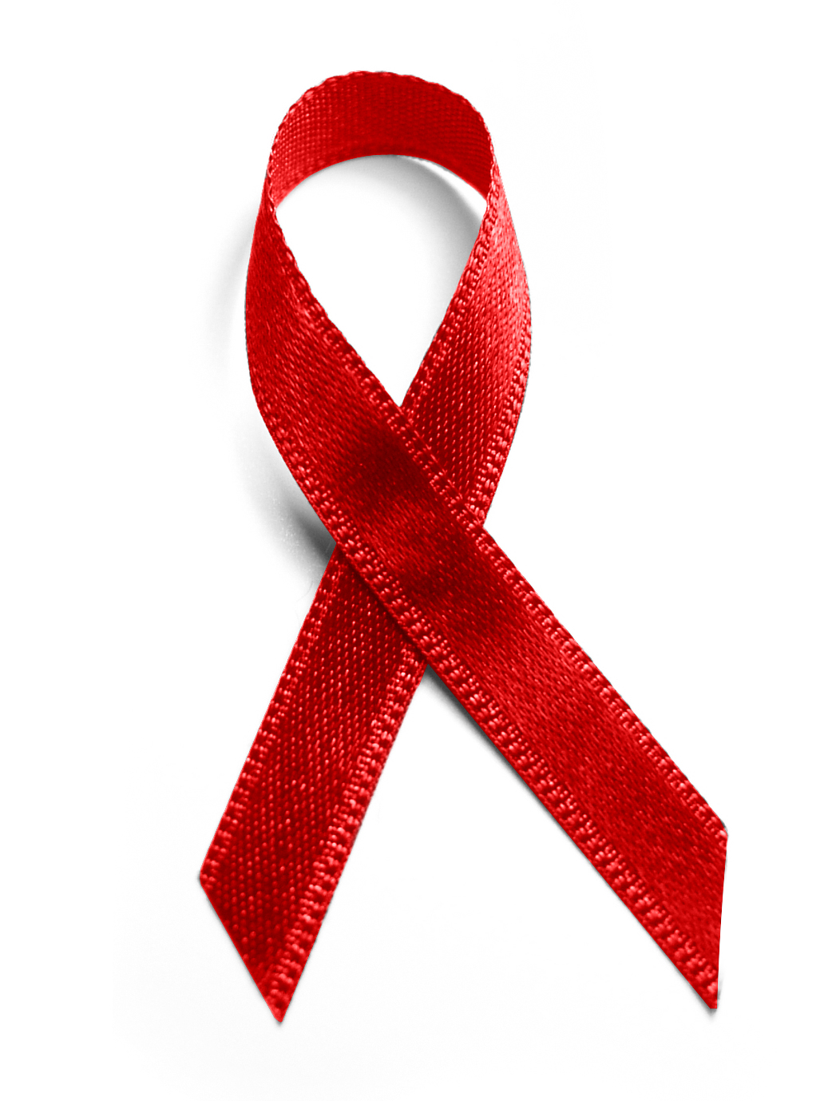
This Certificate is awarded to
for successful completion of clinical training in
Infant HIV Testing

Trainer

Official

Date

