**Module 4**

**Pre-test Information and   
DBS Collection for Infant Virological Testing**

##### 

**Module 4 Table of Contents**



**Session 4.1: Infant HIV Testing: Pre-test Information** 2

**Exercise 1** 4

**Session 4.2: Dried Blood Spot Collection, Drying, Packing and Shipment** 5

**Exercise 2** 14

**Exercise 3** 14

**Module 4: Key Points** 15

**Appendix 4A: Listening and Learning Skills Checklist** 16

**Appendix 4B: Infant PCR Laboratory Requisition Form** 17

**Appendix 4C: Specimen Delivery Checklist** 18

**Appendix 4D: Relevant Pages of Child Health Card** 19

**Appendix 4E: Collection of DBS from Infants for PCR Testing** 20

**Appendix 4F: Drying and Packaging DBS Samples for Transport** 21

**References** 24

**Session 4.1: Infant HIV Testing: Pre-test Information**

**Session Objective**

After completing this session, participants will be able to:

* Conduct the HIV pre-test information session for HIV-exposed infant testing

**Routine HIV Testing**

WHO recommends ***routine*** HIV testing for infants whose mothers are living with HIV. Like other diagnostic tests, routine HIV testing in paediatric settings requires the following:

* **Consent**: HIV testing must be voluntary; in paediatric testing, **consent** for infant testing is obtained by providing brief pre-test information to the parent or guardian and getting verbal agreement for testing. Written consent is not required.
* **Opportunity to refuse testing**: The caregiver should be informed of the process for HIV testing and the right to decline testing.

Testing of infants may be conducted by healthcare providers—nurses, midwives, doctors, counsellors, social workers, and laboratorians—or lay providers who are trained and supervised. In their 2015 and 2016 guidelines, WHO recognized the importance of task sharing with lay providers to support implementation of infant HIV testing. [2] [3] A lay provider refers to any person who performs functions related to healthcare delivery who has been trained to deliver specific services but has not received a formal certificate or degree. Lay providers play an important role in task sharing, i.e., the redistribution of tasks between cadres of healthcare providers with the aim of relieving upper level healthcare providers of certain day-to-day activities so that they can focus on other duties.

**HIV Testing of HIV-exposed Infants: The Pre-test Session**

Although PMTCT interventions are very effective, they do not eliminate the risk of HIV transmission to the infant, so routine HIV testing of HIV-exposed infants is necessary. The benefits of testing infants in the first 6 weeks of life include:

* Provide reassurance to families, particularly families whose infants test HIV-negative
  + Counselling after a negative result at 6 weeks should emphasize that there can be continued transmission during the breastfeeding period, so it is important to remain in care, keep taking ART every day, and re-test the infant according to national guidelines until after the end of breastfeeding
* Identify infected infants early so that they can initiate ART early, thereby increasing their chance of survival.

This session focuses on how to discuss the topic of routine, diagnostic early infant HIV testing with the caregiver of an HIV-exposed infant during the 4–6-week clinic visit. The pre-test information may be provided in a group setting and then continued with a one-to-one discussion between the caregiver and health care provider. In any counselling session, the healthcare provider is expected to use “listening and learning skills”. The listening and learning skills are summarized in Appendix 4A: Listening and Learning Skills Checklist.

The key points and model scripts for pre-test counselling are listed in Table 4.1. Note that scripts should be adapted to meet the client’s situation, as suggested by her understanding of her own HIV infection, level of anxiety, and her questions. The script will also be adapted based on test used, infant age, and whether the test is an initial HIV test or follow-up test.

**Table 4.1: The pre-test session, HIV-exposed infant nucleic acid testing (NAT) [1]**

|  |  |
| --- | --- |
| **Key point** | ***Script*/Key points**  **NAT (0–18 months of age)** |
| 1. **Assess** the parent/caregiver’s and child’s knowledge of HIV and the diagnostic procedure. | Use a question and answer format to gauge level of understanding:   * *What is HIV?* * *How is HIV passed from mother to baby?* * *How can mother-to-child HIV transmission be prevented?* Emphasize the importance of the breastfeeding mother taking and adhering to her ART regimen. |
| 1. HIV testing is **routine** for all HIV-exposed infants/benefit of testing | * *Even if you and the baby received medicine for PMTCT, there is still a small chance that he/she is HIV-infected. Because of this small chance, we routinely test babies for HIV at this age. If your baby is HIV-infected, the sooner we know the sooner we can start him/her on ART; if we can start ART before s/he gets sick s/he’ll stay healthier longer. We will do a test today, and your baby should be re-tested at regular intervals [follow national guidelines] until a final test after the end of breastfeeding.* |
| 1. How the test will be **conducted** | * *We will take a few drops of blood by pricking the [heel, toe or finger based on age]. The blood will be collected on a card that will be sent for testing.* [Script should be adapted to process and test kit to be used.] * *Although we strongly recommend testing, you have the right to decline.* * If the test result is not available same day:   *We will schedule you for an appointment to return for your result.* |
| 1. **Confidentiality** | * *The test result and anything we discuss today is confidential/private and will not be shared with anyone else unless you give permission.* |
| 1. Explanation of result.   5a. What a **positive** **result** means | * *If the baby’s test result indicates that he/she is HIV-positive, he will be started on ART right away. ART will help him to stay healthy.* |
| 5b. What a **negative result** means | * *If the baby tests HIV-negative, then this is the first test in a series of tests to confirm that your baby does not have HIV.*   **Adapt based on infant age:** *Your baby will also be tested at 9 months of age and 3 months after breastfeeding ends (or at 18 months if you stop breastfeeding early).* |
| 1. **Return** | * *Point of care (POC) testing: Your result will be ready in an hour.* * *You will need to return to the clinic in ___ weeks for the baby’s result. If the result comes back early, we may also contact you so that you can get the test result as soon as it is available. If you agree that we can contact you, we’d like to make sure that we have your correct phone number and address.* [Confirm contact information] |
| 1. Client **questions** | * *What questions do you have about HIV testing?* |

**Exercise 1**

|  |  |
| --- | --- |
| **Exercise 1: Infant HIV testing pre-test information: Role play** | |
| **Purpose** | To review the content of the pre-test session for infants who are 4–6 weeks of age. |
| **Activities** | 1. **Refer to both Table 4.1 and Appendix 4A during this exercise.** 2. After the trainer demonstration of the pre-test information session and discussion, you will be asked to break into pairs. 3. You will complete two role plays while working with your partner: one in which you are the healthcare provider and the other in which you will play the role of the mother. 4. When playing the role of the mother, make up your own patient scenario based on a patient you know, friend, or family member. When playing the role of mother, feel free to ask questions of the healthcare provider. 5. Role plays will be followed by a large group discussion and debriefing. |

**Session 4.2: Dried Blood Spot Collection, Drying, Packing and Shipment**

**Session Objectives**

After completing this session, participants will be able to:

* Understand the steps in collecting a blood sample using dried blood spot (DBS) procedure
* Dry, pack and store DBS specimens to send to the laboratory
* Distinguish between valid and invalid DBS samples
* Record DBS results in the designated database or register/log and follow up on missing or delayed results

**DBS, Introduction**

HIV infection in children under 18 months of age can be diagnosed with virological testing using nucleic acid testing (NAT) technologies. NAT can be conducted on either of the following:

* **High throughput instruments**: NAT is most commonly conducted using high throughput instruments that must be operated by trained laboratorians and are based in regional laboratories. These instruments can use DBS specimens, which facilitate storage and shipping to the laboratory. OR
* **PoC/near PoC instruments**. The Alere™ q HIV-1/2 Detect uses drops of freshly collected blood samples, whereas the Cepheid AB Xpert® HIV-1 Qual Assay can use either drops of freshly collected blood or DBS.

**DBS technology**

DBS technology has been used widely in the United States and Europe since the early 1970s to screen newborns for genetic disorders. More recently, DBS technology has been used to test samples for HIV using NAT. DBS is also used for viral load testing.

In DBS collection, small drops of whole blood are collected on strips of special filter paper, and the paper is then dried. The procedure for taking a DBS specimen involves obtaining blood from a heel, toe, or finger with a lancet and applying it directly onto filter paper.

Advantages of DBS testing include the following:

* A lower volume of blood is required for testing, so specimen collection is easier and requires less training.
* DBS specimens have a longer lifespan than whole blood or plasma, are more stable and therefore easier to transport and store.
* DBS specimens can be shipped to distant laboratories, because they can be transported relatively easily (in comparison to fluid samples) without compromising the specimen.
* Because specimens are dried, they pose little biohazard risk. Therefore, they are safer to handle than whole blood specimens.[4]

**The Healthcare Provider’s Responsibilities**

The healthcare provider’s responsibilities are to ensure the proper collection of valid DBS samples for NAT and complete and accurate labelling and documentation. The healthcare provider must:

* Collect valid samples.
* Label the samples correctly.
* Dry, package and store samples appropriately until they are transported to the laboratory
* Correctly complete all related documentation.

The following procedure is for the collection of DBS specimens that are sent to a laboratory for testing. Point-of-care testing follows different procedures depending on the platform used; providers using point-of-care testing should receive additional training on these methods.

**Getting Started: Documentation**

Although every country will have different paperwork for documentation, most countries will have the following:

1. **The laboratory requisition form**, which is sent with the samples to the laboratory, includes information that the lab will need to conduct the test on the blood sample. In general, this form requests information such as:
   * child’s name
   * date of birth
   * mother’s name
   * child/patient identification number
   * name of project site
   * name of provider requesting the test
   * information about where to send the results
   * date and time of specimen collection

This form needs to be completed for each specimen sent to the lab. Note: The child/ patient identification number is very important, since it is used to identify the child. Often for confidentiality reasons, the lab will not provide results by name but by number. Making sure this number is correctly recorded on the form is critical. The laboratory requisition form appears in Appendix 4B.

1. **Specimen delivery/transport checklist** tracks quantity and quality of specimens along the chain of custody. The specimen delivery/transport checklist appears in Appendix 4C.
2. **Electronic (database) or paper-based register/log** used for recording and tracking NAT specimens and results, e.g., EID/NAT/DBS Specimen Tracking Register/Log or Baby Testing and Follow-up Register/Log. As different countries have different methods for recording and tracking specimens and results, hereafter it will be referred to as the Infant NAT Register.

**Necessary Supplies**

The supplies needed to collect a DBS specimen from an infant or child include the following:

* DBS cards
* 2mm lancets
* Gloves, preferably powder-free
* Pen
* Laboratory requisition forms
* Disinfectant for skin, such as 70% spirits
* Gauze or cotton wool
* Sharps container

The supplies required for DBS drying and packaging include:

* Gloves, preferably powder-free
* Drying racks
* Glassine paper
* Sealable plastic bags
* Desiccant packets
* Humidity cards
* Envelopes for mailing
* Marker/pen
* Specimen delivery checklist

**Universal Precautions for Handling Body Fluids and Sharps**

Safety practices that should be followed when collecting blood specimens include the following:

* Wear gloves when in contact with blood, body fluids, secretions, excretions, mucous membranes and contaminated items.
* You must also wear gloves when handling the DBS card (even before it has blood on it).
* Wash hands before putting on gloves and immediately after removing them. If using gloves with powder, wash the powder off the gloves after putting them on.
* All sharps should be handled with extreme care and disposed of in sharps containers to prevent injury to others.
* Clean up spills of infectious material/fluids promptly.
* Ensure that patient care equipment, supplies and linen contaminated with infectious material/fluids is either discarded or disinfected or sterilized adequately.
* In the event of a sharps injury, inform supervisor immediately and follow national protocol for post-exposure prophylaxis (PEP).

**Procedure for DBS Blood Sample Collection**

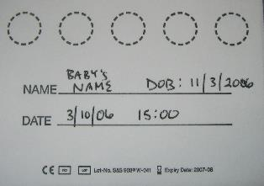The following is the procedure for DBS sample collection:

1. **Gather all necessary supplies** listed above.
2. **Complete all necessary documentation** including the clinic register(s), laboratory requisition form, and label the DBS card with the baby’s name, birth date, site code, date of collection, time of collection, and any other requested information. Write clearly and be sure to complete all fields.

Do not touch the circles with anything other than the infant’s blood. Your hands, glove powder, ink, or dirt will affect the result. It is important not to contaminate cards by contact with blood from other sources such as touching another DBS card.



1. **Decide where you will prick the infant** according to baby’s size and age:

* **Small infants** up to about the age of 4 months and up to 5 kg: prick the heel. The best area is the lateral section of the heel. Do not prick the back of the heel where the bone is.
* **Larger infants** between 4 and 10 months old, or 5–10 kg: prick the big toe. Never stick the other toes in children; it is too easy to hit and damage the bone.



* The lateral side or outside part of the big toe works best. Do not prick the very end of the toe where the bone is close to the skin.



* **Older infants** over 10 months or more than 10 kg—prick the finger. The best finger is the ring finger on the left hand as this finger will be the least used by the baby. Select the lateral side of the fingertip. Do not stick the very end of the finger where the bone is close to the skin. The thumb is not recommended because it will be the most painful

1. **Wash hands and then put on powder-free gloves**. If powdered gloves are used, rinse gloved hands to get the powder off.
2. **Position the baby and clean the area to be pricked**:

Have the mother sit on the examination bed with baby on her lap. Show her how to properly hold the baby depending on the site to be pricked. The baby’s foot or hand should be below the level of his heart so blood will flow more easily. Warm the area you will prick, especially if the infant is cold. The mother can hold the baby’s foot or hand in her hand. Rubbing it gently may help. A cloth or nappy soaked in warm water can be used—keep on for about 3 minutes.

Clean the area you will prick with 70% spirit or alcohol swabs, and let it dry for 30 seconds. It is important to let the disinfectant dry so that the spirit does not mix with the blood when you prick the site.

1. Gently squeeze and release the area to be pricked until it is ready to be bled. Prick the infant’s heel, toe or finger with a 2mm lancet. Do not use a needle or scalpel or longer lancet. The lancets are the correct length to puncture safely without damaging baby’s bone.
2. Wipe away the first drop of blood with dry cotton wool, and allow a large drop to form on the puncture site.
3. Touch the DBS card gently against the large drop and allow it to completely fill the circle on the paper. The first drop should fill the circle. Do not press the paper against the heel, toe or finger; just allow the droplet to touch the paper.

Fill all circles if possible. Three complete circles are needed by the laboratory. If a circle is poorly done, move to the next one.

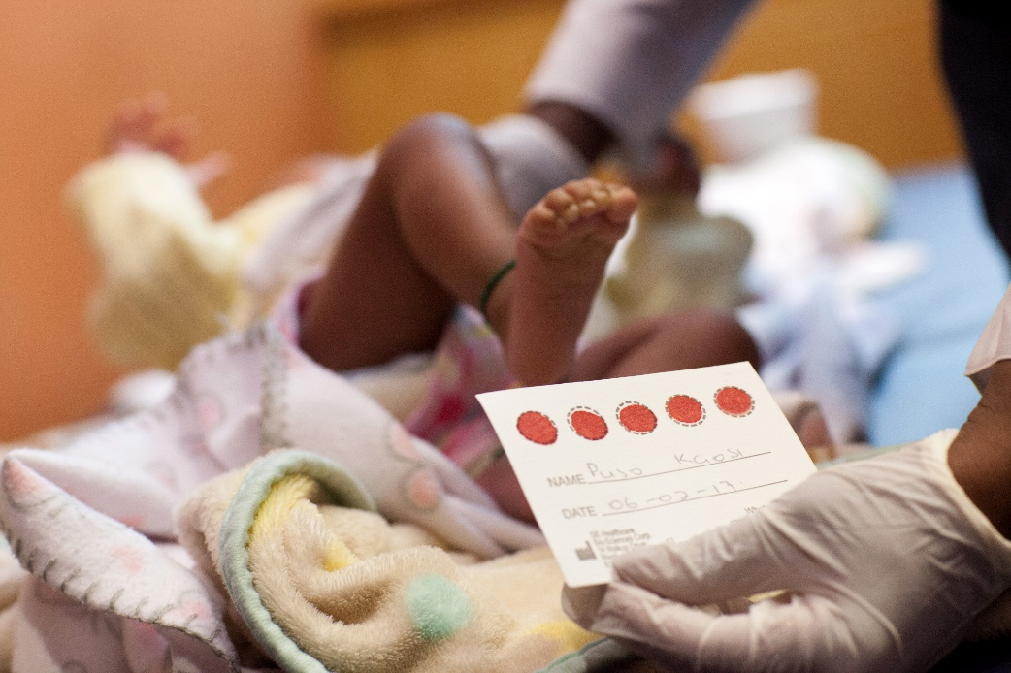

*A DBS card with 5 completely filled spots. [Note: Name is changed to protect patient identity.]*

Do not “milk” or squeeze the area that has been punctured as this will cause tissue fluid to mix with blood and contaminate the sample. If there is not enough blood, you can gently pump and release or apply gentle pressure to the whole lower leg, foot or hand (above the puncture site, depending on where the prick is made.) If this is not successful it may be necessary to prick the infant in another location to complete the collection.

**Note: it is important not to touch the circles with anything other than the infant’s blood. Fingerprints, glove powder, ink or dirt will all affect the result.**

1. When sufficient circles have been filled, clean the puncture site and press cotton wool against it until it stops bleeding. Do not use a bandage. Ensure the wound is clean and bleeding has stopped for at least 5 minutes. Complete documentation and recheck the wound before the baby leaves your care.

These steps are summarized in “Appendix 4E: Collection of DBS from Infants for PCR Testing.” Appendix 4E is a one-page job aid on DBS collection that you can use in your clinic.

**Drying and Packaging DBS for Transport to the Laboratory**

See “Appendix 4F: Drying and Packaging DBS Samples for Transport” for instructions on drying and packaging DBS specimens in preparation for sending them to the laboratory.

**Valid and Invalid DBS Specimens**

When specimens are not collected correctly, the specimen may be rejected by the laboratory or the result may be inaccurate.

Try to fill all 5 spots on the card completely. If that is not possible, at least 3 completely filled spots are needed. Remember: 3 well-filled spots are better than 5 partially filled spots.

Some common errors and how to prevent them are shown in Table 4.2.

**Table 4.2. Common DBS errors and how to prevent them**

|  |  |
| --- | --- |
| **Error/Problem** | **Solution** |
| Labelling and documentation errors | * Complete DBS card, lab requisition forms and all other documentation completely, accurately and with legible handwriting |
| Yellow rings around the spots - could be due to disinfectant or tissue fluid contamination | * Allow disinfectant to dry completely before pricking the patient * Do not squeeze the skin directly around the spot where the patient was pricked |
| Scratches or smudges on the filter paper | * Do not scratch or dab blood on the filter paper surface |
| Drops are too small | * Warm the site * Apply pressure (but not right at the site) * Consider choosing another site * For fingerpick: ensure hand is below the level of the heart |
| Caking or layering blood on the filter paper | * Do not put a new drop of blood on top of a drop that is already dry |
| Drop is not centred on the card | * Ensure site is centred directly over the centre of the spot * Show caregiver how to hold the infant/child firmly so that he/she is not moving during the procedure |
| Specimens are not dried or packaged properly | * Follow instructions in Appendix F for drying and packaging DBS specimens. * Do not start packaging until DBS specimens are completely dry (4 hours or longer). |

**Responsibilities of the Laboratory**

Note: This section should be adapted based on local/national standard operating procedures.

1. The laboratory should acknowledge receipt of all specimens by completing and returning the specimen delivery checklist.
2. Any specimen rejected at the laboratory should be identified on the specimen delivery checklist. The laboratory should immediately inform the sending health facility that the sample was rejected and reason for sample rejection, so that the facility can trace the infant and organize the drawing of a new sample as soon as possible.
3. All specimens should be entered in the designated register as per Standard Operating Procedures. The laboratory will keep the second copy of the checklist for reference purposes.
4. There should be a system so that the laboratory can notify a health facility of a positive infant virologic test result on the same day of testing, since it is important that the infant is started on ART right away.

**Ways to Return Results from the Lab to the Health Facility**

Even when results are returned as hard copies via courier or postal service, WHO recommends use of technology to expedite return of results to the clinic and, in turn, to the patient. Examples of methods for returning results electronically include the following.

* **Short message service (SMS) printers**: The SMS printer is a small battery-operated printer that can take a SIM card and has the capability of receiving messages without the need for a handset (see Figure 4.1). SMS printers can receive and print test results without computer or internet access. SMS printers will function where there is cellular network coverage.
* **SMS text messages**: Automated text messages may be used to notify health providers of test results and to notify caregivers that results are available at the health facility. Text messages to caregivers should encourage them to come to the clinic to get test results and should not disclose any confidential information.
* **Secure webpage or electronic medical record system**. Another option is for the laboratory to develop password protected clinic-specific webpages. Results would then be posted on the webpage by laboratory staff to be accessed by clinic staff who visit the web-based portal and input the correct password. This system is a viable option where clinics and laboratories have reliable access to the internet and where web-based results can be printed so that documentation of test result can be added to the patient medical record. Some electronic medical record systems can also be accessed by the lab to record test results and flag positive results to the health care provider.
* **Telephone:** Telephone calls may be used to notify caregivers of test results, especially for urgent follow-up of positive test results. Given the need for documentation, phone communication of results should be followed-up with a paper printout (sent by courier or post) from the laboratory for the patient medical record.

In many settings, test results will be returned using a combination of methods, e.g., urban centres with access to the internet might access results using a web-based portal while remote sites rely on SMS printers.

Point-of-care platforms for infant virological testing have the potential to allow for same-day return of results and avoid the challenges of specimen transport and delayed turn-around time (TAT).

**Figure 4.1 Example of an SMS printer**

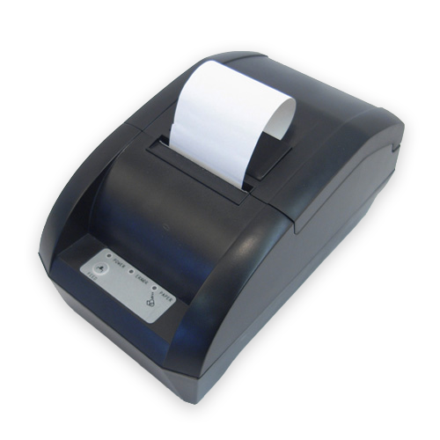**Steps When Receiving Results**

The steps to take when receiving infant HIV test results at the health facility are the same regardless of method of return (electronic or paper):

* Document receiving the results and date receipt/review of results (electronically or with date stamp if paper copy).
* Write the results in the designated register and/or clinical database; and the individual patient chart. If a paper copy of result is received, file it in the patient chart.
* If HIV-positive: re-enter baby’s name—together with the necessary details for follow-up and linkages—in the designated register/patient chart to enable prompt follow-up of infant and ensure appropriate person is notified to urgently trace the infant’s caregiver to come to the clinic for test result, counselling and prompt ART initiation.

It is important that the designated register is completed accurately. Information from the designated register is used for monitoring and reporting the number of specimens sent for testing, tracking return of results, calculating positivity rates, tracking time it takes for results to be returned, tracking infants in need of post-test counselling and ART. This information is vital for programme monitoring and evaluation.

* When the caregiver receives the infant’s test result, enter the post-test counselling date in the patient chart and designated register.
* When counselling the caregiver (see Module 5), ensure she understands that the child will be retested:
  + If the 6-week NAT result is negative, then retest at 9 months **and** at either 18 months or 3 months after completion of breastfeeding (whichever is later) [Adapt as needed based on national guidelines].
  + If the NAT result is positive, the healthcare provider should collect a second DBS specimen to be retested for confirmation of the first result. However, the child should be initiated on ART immediately; do not wait for the confirmatory test result to be returned.

**Tracking No Shows**

Every clinic should have a mechanism—whether paper-based or electronic—for identifying patients that did not attend for testing, scheduled clinic visits or for their post-test result. The Infant DBS Register can be used to identify patients who have not returned to receive test results. Clinics with computer-based records and appointment systems have the option of developing a database to assist with identifying patients who have missed appointments or are lost to follow-up.

Health care providers should ask patients at the time of enrolment about permission for tracing by phone or home visit as needed for reporting of critical test results, if missed appointments or other urgent medical issues. If the patient consents, locator information (address/location and phone number) should be documented at the health facility.

Once a patient has been identified as missing an appointment or lost to follow-up, that individual must then be traced. Where the technology is available, invite patients back into care using SMS messages, phone calls, or e-mail. Where that technology is not available, then consider making a home visit. Patients who have not yet collected a positive HIV test result, should be reached in person via an outreach worker or other peer navigator if they do not respond within 1–2 days of an electronic message.[1]

**Missing and Delayed Results**

Healthcare providers have an important role to play in ensuring that all requested test results are returned in a timely manner. In their 2016 guidelines, WHO states that “it is strongly recommended that test results from NAT in infants be returned to the clinic and child/mother/caregiver as soon as possible, but at the very latest within 4 weeks of specimen collection.”[3]

HIV-positive infants should be identified and followed up as soon as possible to enable early initiation in care and treatment with full cooperation of their caregivers and HIV healthcare providers.

Responsibilities for ensuring timely results are:

* Health facility: should use the designated register to identify results not received within 28 days, and immediately notify the laboratory.
* Laboratory: should check if samples were received, when was the test done and date when the results were dispatched.

**Re-collecting specimens from infants where no results were found**

If results have not been received by the health facility within 28 days and tracing the result with the laboratory is unsuccessful, use the post-test appointment to take another DBS specimen and re-send for testing. If the infant did not have an appointment or does not show for the appointment, phone or visit the infant’s caregiver as soon as it is known that the results have been lost to ask them to come in for retesting.

**Exercise 2**

|  |  |
| --- | --- |
| **Exercise 2: DBS specimen collection practice: Pair work** | |
| **Purpose** | To give participants opportunity to practise the DBS collection method and complete the required forms. |
| **Activities** | 1. **Use “Appendix 4E: Collection of DBS from Infants for PCR Testing” as reference during this exercise.** 2. In this exercise you will work in pairs to practise taking DBS specimens using a finger stick. This blood collection exercise is just for practice and the DBS specimens will neither be tested nor given to anyone. 3. It is extremely important that you observe Universal Precautions during this exercise as you would in any clinic setting. 4. Once you have finished your DBS collection practice, the trainer will lead a large group debrief as well as a discussion on next steps. |

**Exercise 3**

|  |  |
| --- | --- |
| **Exercise 3: Packing samples and receiving results: Demonstration in large group** | |
| **Purpose** | To review the process of packing samples for shipment to the laboratory and what to do when results are returned. |
| **Activities** | 1. **Refer to Appendix 4F: Drying and Packaging DBS Samples for Transport” for this exercise.** 2. Using a number of participant volunteers, the trainer will facilitate a discussion on drying DBS specimens, packing, completing required documentation, and sending them to the laboratory. 3. This exercise also includes a discussion on what to do when receiving results. |

**Module 4: Key Points**

* HIV testing of HIV-exposed infants is routinely conducted at the 4–6 weeks, 9 months and 18 months of age (or 3 months after stopping breastfeeding, whichever is later). The pre-test counselling should cover 7 points:

1. **Assess:** assesscaregiver’s knowledge of HIV
2. **Routine testing**: explain that we routinely test all HIV-exposed babies for HIV
3. **Explain the procedure**: discuss the steps of the testing procedure
4. **Confidentiality:** explain that the discussion is private
5. **Result**: explain what a positive or negative result means
6. **Return**: discuss when to return for results and routine care
7. **Questions**: ask if the caregiver has any questions

* Dried blood spot (DBS) refers to small drops of whole blood that are collected on strips of special filter paper that are then dried. If properly dried and stored, specimens remain stable for an extended period of time and can be transported with minimal special handling to a central laboratory.
* When results are received, record them in the designated register/database as well as the patient chart.
* If a client does not come for the scheduled post-test counselling session, ensure s/he is tracked by phone, text or e-mail if available. If she does not respond to electronic messaging, or does not have a phone, reach her in person via outreach staff.
* If a positive NAT result if received, trace the caregiver immediately for post-test counselling and ART initiation.
* Actively follow up delayed results. If the patient shows for the post-test session and the results are not available, contact the laboratory. If the sample was lost or rejected by the laboratory, use the visit as an opportunity to take a new specimen for testing.

**Appendix 4A: Listening and Learning Skills Checklist**

|  |  |  |
| --- | --- | --- |
| Skill | Specific strategies, statements, behaviours | (🗸) |
| Skill 1: Use helpful non-verbal communication | * Shows a relaxed and natural attitude |  |
| * Adopts an open posture |  |
| * Leans forward when talking |  |
| * Makes eye contact |  |
| * Sits squarely facing client |  |
| * Other (Specify) |  |
| Skill 2: Ask open-ended questions | * Uses open-ended questions to get more in-depth information from the client |  |
| * Asks questions that reflect interest, care and concern rather than interrogation or judgement |  |
| * Other (Specify) |  |
| Skill 3: Use responses and gestures that show interest | * Nods, smiles reassuringly; uses encouraging responses (such as “yes,” “okay,” “Mmm,” or “aha”) |  |
| * Clarifies statements effectively |  |
| * Takes time to summarise information the client shares |  |
| * Comments on client’s challenges while also indicating client’s strengths |  |
| * Other (Specify) |  |
| Skill 4: Reflect back and re-formulate what your client says | * Reflects emotional responses back (re-formulates) to the client using different words |  |
| * Other (Specify) |  |
| Skill 5: Empathize—show that you understand how she feels | * Demonstrates empathy: shows an understanding of how the client feels |  |
| * Avoids sympathy. Sympathy is when the healthcare provider moves the focus to herself (“I know how you feel, my sister has HIV.”) whereas empathy focuses on the client (“You’re really worried about what’s going to happen now that you’ve tested HIV-positive.”) |  |
| * Other (Specify) |  |
| Skill 6: Avoid words that sound judgemental | * Avoids judging words such as good, bad, correct, proper, right, wrong, adequate, inadequate, satisfied, sufficient, fail, failure, succeed, success, etc. |  |
| * Uses words that build confidence and give support (for example, recognises and praises what a client is doing right) |  |
| * Other (Specify): |  |

**Adapted from**: WHO, CDC (2008). PMTCT Generic Training Package. Module 5 HIV Testing and Counselling for PMTCT. [5]

**Appendix 4B: Infant PCR Laboratory Requisition Form**

Countries should include their Infant PCR Laboratory Requisition Form in this appendix.

**Appendix 4C: Specimen Delivery Checklist**

Countries should include their Specimen Delivery Checklist in this appendix.

**Appendix 4D: Relevant Pages of Child Health Card**

Countries should include the relevant pages of their Child Health Card in this appendix.

**Appendix 4E: Collection of DBS from Infants for PCR Testing**



**Appendix 4F: Drying and Packaging DBS Samples for Transport**



****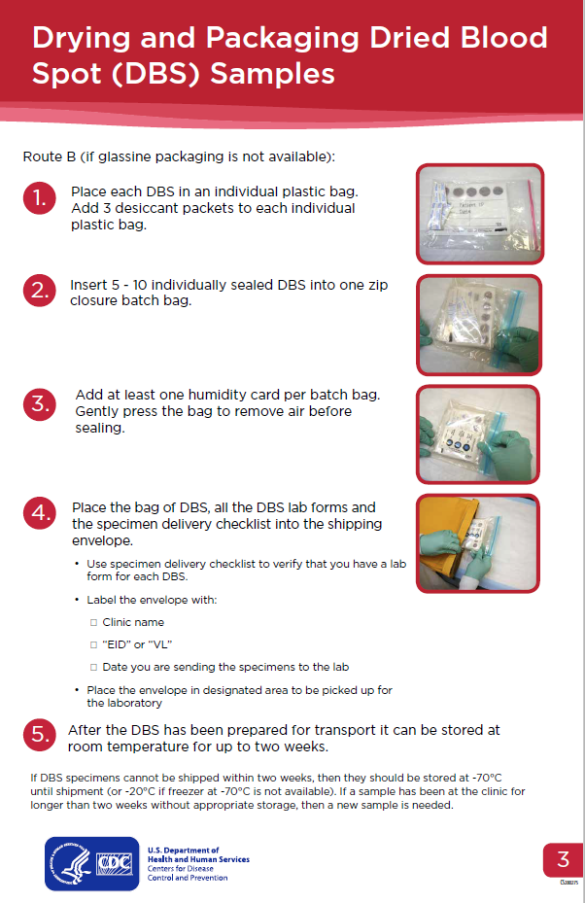

******References**



1. WHO Regional Office for Africa. *Operational guidelines on HIV testing and counseling of infant, children and adolescents for service providers in the African region*. 2014; Available from: <http://apps.who.int/iris/handle/10665/192410>.

2. WHO. *Consolidated Guidelines on HIV Testing Services*. July 2015; Available from: <http://www.who.int/hiv/pub/guidelines/hiv-testing-services/en/>.

3. WHO. *Consolidated Guidelines on the Use of Antiretroviral Drugs for Treating and Preventing HIV Infection: Recommendations for a Public Health Approach, Second Edition.* . June 2016; Available from: <http://www.who.int/hiv/pub/arv/arv-2016/en/>.

4. WHO, *Recommendations on the diagnosis of HIV infection in infants and children: Laboratory methods for diagnosis of HIV infection in infants and children.* 2010.

5. WHO and CDC, *PMTCT Generic Training Package. Module 5 HIV Testing and Counseling for PMTCT.* 2008.

1.