Module 2 The Nature of Adolescence and the Provision of Youth-Friendly Services

Session 2.1: Stages and Changes of Adolescence

Session 2.2: Adolescent Vulnerabilities, Risk-Taking Behaviors, and Their Consequences
Session 2.3: Providing Youth-Friendly Services to Adolescents

Learning Objectives
After completing this module, participants will be able to:
- Define adolescence
- Identify some of the physical changes that occur during adolescence
- Define the stages of adolescent development
- Describe how ALHIV are different from children and adults living with HIV
- Discuss the ways in which adolescents are a heterogeneous group
- Discuss risk-taking as a normal part of adolescence as well as the consequence of negative risk-taking
- Discuss some of the vulnerabilities faced by adolescents
- Describe the characteristics of youth-friendly HIV care and treatment services

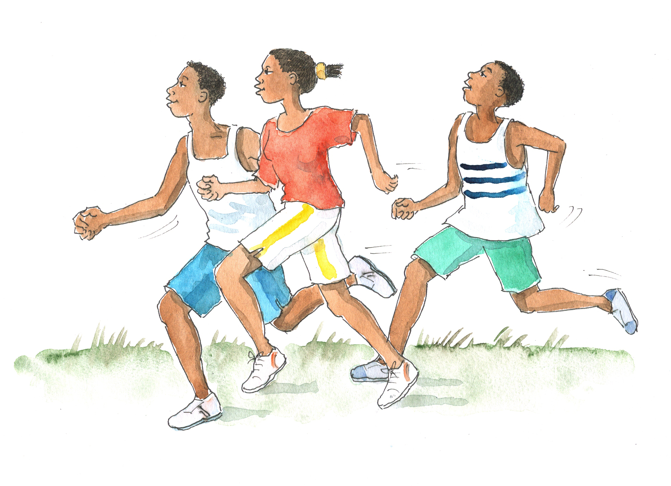

Session 2.1 Stages and Changes of Adolescence

Session Objectives
After completing this session, participants will be able to:
- Define adolescence
- Identify some of the physical changes that occur during adolescence
- Define the stages of adolescent development
- Describe how ALHIV are different from children and adults living with HIV
- Discuss the ways in which adolescents are a heterogeneous group

Who Are We Talking About?
Who are we referring to when we talk about “adolescents?” In general, the term “adolescent” refers to people in their second decade of life, meaning those between the ages of 10 and 19 years. Other commonly used terms are “youth” and “young people.” These terms have slightly different definitions (see Table 2.1) but are sometimes used interchangeably with the term “adolescent.”

Table 2.1: Key definitions
Group | Age range  (according to WHO)
Adolescents | 10–19 years
Youth | 15–24 years
Young people | 10–24 years
Focus of this training

Figure 2.1: Young people (age 10–24 years) includes the overlapping categories of “Youth” and “Adolescents”
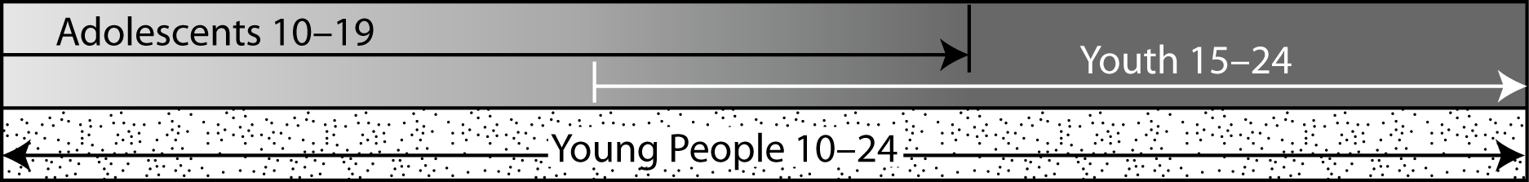

Adolescence has many dimensions: physical, psychological, emotional, and sociological. Adolescence is a phase of an individual’s life that is defined differently across cultures and communities.

Key Changes During Adolescence
There are a number of physical and sexual changes that occur during adolescence.

In females:  - Development of breasts  - Appearance of pubic and underarm hair  - Widening of the hips  - Menarche  - Development of the vulva and pelvis | In males:  - Growth of the penis, scrotum, and testicles  - Appearance of pubic, underarm, chest, and leg hair  - Night-time ejaculation  - Morning erection  - Development of back muscles
In both females and males:
- Accelerated growth
- Increased perspiration
- The presence of acne
- Face has characteristics of young adult
- Change in tone of voice
- Sexual desire activated
- Initiation of sexual activities

The system used most frequently to categorize these physical and sexual changes in girls and boys is referred to as the "Tanner staging system" (see Appendix 2A: Tanner Staging System). The first stage represents the pre-pubertal child and the final stage represents the “mature” or adult stage. The Tanner staging system can be used to determine maturity when deciding whether an adolescent should receive an adult or pediatric ARV dosing, as discussed in the next module.

There are also a number of psychological and emotional changes that occur during adolescence:
- Mood swings
- Insecurities, fears, and doubts
- Behavioral expressions of emotion, which may include withdrawal, hostility, impulsiveness, and non-cooperation
- Self-centeredness
- Feelings of being misunderstood and/or rejected
- Fluctuating self-esteem
- Interest in physical changes, sex, and sexuality
- Concern about body image
- Concern about sexual identity, decision-making, and reputation
- A need to feel autonomous and independent

The Stages of Adolescent Development
Adolescence can be categorized into 3 overlapping developmental stages:
- The ages listed are approximate — maturation is more important than specific ages when discussing adolescent development.
- Maturation occurs in fits and starts and is not always coordinated.
- Growth in each of the categories listed in Table 2.2 can occur at different rates. For example, an adolescent girl may look like an adult physically (a characteristic of late adolescence), but may not yet be capable of abstract thinking (a characteristic of early adolescence). Another adolescent may appear small and stunted, but may demonstrate advanced intellectual or psychological maturity.
- HIV disease impacts maturation in a number of ways (as discussed in the next section).

Table 2.2: Stages of adolescence
Category of change | EARLY  (10–15 years) | MIDDLE  (14–17 years) | LATE  (16–19 years)
GROWTH OF BODY | - Secondary sexual characteristics appear  - Rapid growth reaches a peak | - Has advanced secondary sexual characteristics  - Growth slows down; reaches approximately 95% of adult size | - Physically mature
COGNITION  (ability to get knowledge through different ways of thinking) | - Thinks in concrete terms (i.e. the “here and now”)  - Does not understand how actions affect future | - Thinking can be more abstract (theoretical) but goes back to concrete thinking when under stress  - Better understands long-term results of own actions | - Abstract thinking now established  - Plans for the future  - Understands how current choices and decisions have an effect on the future
PSYCHO-LOGICAL AND SOCIAL | - Worries about rapid physical growth and body image  - Has frequent mood changes | - Has established body image  - Thinks about fantasies or impossible dreams  - Feels very powerful  - May experiment with sex, drugs, friends, risks | - Plans and follows long-term goals  - Has established sense of identity (who he or she is)
FAMILY | - Still defining comfort with independence/ dependence | - Has conflicts with authority figures | - Is moving from a child-parent/ guardian relationship to more adult-adult relationships
PEERS | - Peers very important for development  - Has intense friendships with same sex  - Has contact with opposite sex in groups | - Has strong peer friendships that help affirm self-image  - Peer groups define right and wrong | - Decisions/values less influenced by peers and more influenced by individual friendships  - Selection of partner based on individual choice rather than on what others think
SEXUALITY | - Focus is on self-exploration and evaluation | - Has preoccupation with romantic fantasy  - Tests how he or she can attract others  - Sexual drives emerging | - Forms stable relationships  - Has mutual and balanced sexual relations  - Is more able to manage close and long-term sexual relationships  - Plans for the future
Sources:

WHO. (2003). Orientation programme on adolescent health for health-care providers. Geneva, Switzerland: WHO Press.
WHO. (2010). IMAI one-day orientation on adolescents living with HIV. Geneva, Switzerland: WHO Press.

Effects of HIV Infection on the Changes of Adolescence

Growth:
HIV affects growth in adolescents who are perinatally infected with HIV. The following section is not meant to pertain to ALHIV who were infected as adolescents, as they have typically already reached their adult height by the time they are diagnosed with HIV. Even in perinatally infected children, the physical effects of HIV may be minimized through the use of effective ART.
- If HIV disease is fairly advanced, an adolescent may experience delays in physical development, including delays in the physical changes of puberty (for example, delayed or irregular menstrual cycles in girls). As a result, ALHIV may appear younger and smaller than other adolescents because they have not yet begun the physical process of becoming adults.
- ALHIV may be shorter than their peers, either because of stunting early in life or slowed growth throughout childhood and adolescence. This may lead to a negative self-image and may also affect how other people view the adolescent (e.g. as sick and younger than his or her actual age).
- ALHIV may experience drug-related side effects, including those that change physical appearance, like lipodystrophy (changes in fat distribution on the body).

Cognition:
- Adolescents perinatally infected with HIV may experience neurological consequences of longstanding HIV infection. The result may be developmental delays and learning problems.

Psychological and social effects:
- ALHIV are very likely to experience emotional difficulties. These difficulties may not necessarily be due to health status, but rather to the pressures of life and a history of loss (including the loss of parents and home).
- Illness may prevent ALHIV from going to school regularly, from making friends, and from learning sports and hobbies. Due to illness, ALHIV may miss out on activities that help define adolescents’ identities.
- HIV can bring with it concerns about prognosis; body image; stigma and isolation; fear of disclosure; and having to take multiple medications. These concerns may affect ALHIV’s mental health and their sense of fitting in with peers.
- Many ALHIV live with either one or neither birth parent. Although they may be living with extended family, in some cases these adolescents may not feel “attached” or like they are a part of their adopted home. This can lead to a sense of isolation or a sense that “nobody loves them.”

Peers:
- ALHIV may experience peer problems, which can be exacerbated by the stigma associated with HIV.
- ALHIV may have to regularly miss school to attend clinic appointments. This may impact their educational attainment and their sense of fitting in with peers.
- In some places, few ALHIV attend school. This suggests that the school environment is not supportive of ALHIV’s needs, which further alienates them from their school-attending peers.
- If adolescents feel different from their peers, they have a harder time bonding with them. This can have an adverse effect on the attachments of ALHIV, making it difficult for them to separate from their parents or caregivers.

No Longer Children, Not Yet Adults
There are a number of characteristics that distinguish adolescents from both children and adults. As these are generalizations or even stereotypes, however, they are not applicable to every adolescent client. Distinguishing characteristics of adolescents may include:
- Energetic, open, spontaneous, inquisitive
- Unreliable and/or irresponsible
- Moody
- Desire independence
- Influenced by friends
- Less influenced by family
- Looking for role models (often outside the family)
- Embarrassed to talk to adults about personal issues
- Desire to be different from parents and previous generation in general

HIV prevention, care, treatment, and support services need to be tailored to meet the needs and characteristics of adolescent clients. Services that are tailored in this way are referred to as “youth-friendly services” and are discussed further in Session 2.3.

Exercise 1: Adolescents: Not Big Children or Little Adults: Small group work and large group discussion
Purpose | - To understand some of the important things health workers should consider about the special needs of adolescent clients  - To understand how and why adolescents are a heterogeneous (diverse) group and what implications this has for their care
While working in small groups, participants will be asked to discuss 1 of the following questions:
- What are some of the special characteristics of adolescents that health workers need to consider when providing them with HIV care and treatment?
- How and why do the needs of adolescent clients differ from those of pediatric and adult clients?
- Adolescents are a heterogeneous/diverse group. What are some of the differences health workers may see among different adolescent clients? What are the implications of these differences for their HIV care?

Special Considerations for Adolescent Clients²

Adherence to medicines:
- Although younger adolescents may still rely on a parent or caregiver to remember to take their medicines, older adolescents need to take some or all of the responsibility for taking their medicines every day and as directed by the health worker.
- Often, adolescents struggle with adherence at various points in their development, as they strive to form their own identity and to fit in with peers.
(Adherence to medications is discussed further in Module 8.)

Adherence to care:
- Adolescent clients often have less disciplined or structured lives than adults. They may also have less stable relationships outside of the family. These factors make adherence to care and treatment more difficult.
- Adolescent clients are more likely than adults to lack the skills to negotiate health services and to understand side effects, treatment options, and regimen requirements.
- Outreach is more difficult with adolescents because they are scattered and it is harder to bring them into care (while children are accessible through their parents and caregivers).
- Adolescents can become lost in the system when in transition from pediatric to adult HIV services. (Transition is discussed further in Module 13.)
(Adherence to care is discussed further in Module 8.)

Stigma and discrimination:
- Blame is often placed on adolescents living with HIV (especially those who acquire HIV behaviorally) because of an assumption that they were infected after voluntarily engaging in “risky behavior.” This blame — often misplaced and always oversimplified — results in stigma and discrimination.
- The stigma and discrimination associated with HIV prevents many adolescents from disclosing their HIV-status. This may be a particular issue when adolescents decide to become involved in a sexual relationship.
(Stigma and discrimination is discussed further in Module 5.)

Counseling adolescents:
- Adolescents’ cognitive abilities and skills are different from adults. They require both different counseling approaches and, in many cases, more extensive and intensive counseling sessions.
- Conflicts between cultural or parental expectations and adolescents’ emerging values can present serious challenges for adolescents.
- Adolescent clients often depend on their parents or caregivers (for example, for money and housing) and can therefore not always make independent decisions.
- Adolescent clients have a range of future decisions to make, like whether to have children, whether to get married, etc.
- Adolescents face strong peer pressure and tend to be dependent on peers for lifestyle guidance.
(Counseling is discussed further in Module 4.)

Safer sex:
- Adolescents may not understand risk-taking behavior or the importance of risk reduction. This makes them vulnerable to unintended pregnancy and sexually transmitted infections (STIs).
- There is a widespread belief that adolescents living with HIV are “not supposed” to be having sex. As a result, they often hide their sexuality.
- Adolescents may have limited access to condoms and other contraceptives. Even when they do have access to contraceptives, they may lack the skills to use them correctly and/or negotiate their use.
  - For young women living with HIV, gender inequality may further reduce their ability to negotiate condom use.
(Safer sex is discussed further in Module 10.)

How Adolescents Differ from One Another
Adolescents are a heterogeneous group. By definition, they range in age from 10 to 19 years. The personality and expectations of a person who is 10 years old is very different from that of a 19-year-old, even though both are adolescents.

Adolescents differ according to their stage of development; gender; sexual orientation; home and family situation; and educational level. Some come from well-off families, others come from poor families; some are from urban areas while others are from rural areas. Some adolescents are in a relationship, some are married, and others have yet to have a romantic relationship. Some adolescents know their HIV-status while others do not; some have never experienced stigma or discrimination while others may face it every day.

Health workers need to assess each adolescent client’s care, treatment, and support needs. They must also ensure that the adolescent’s care and treatment plan is tailored to meet these unique needs. In particular, counseling and education need to “meet the adolescent where he or she is.”
(Sexual orientation is discussed further in Module 10.)

Session 2.2 Adolescent Vulnerabilities, Risk-Taking Behaviors, and Their Consequences

Session Objectives
After completing this session, participants will be able to:
- Discuss risk-taking as a normal part of adolescence as well as the consequences of negative risk-taking
- Discuss some of the vulnerabilities faced by adolescents

Risk-Taking As a Normal Part of Growing up
Risk-taking is simply part of an adolescent’s struggle to test out an identity that provides self-definition and separation from others, including the adolescent’s caregivers. Adolescents must attain social autonomy during their second decade of life and this often involves moving away from dependence on their family. As the influence of their family decreases, new social relationships — especially with peers — begin to gain greater importance. Adolescents’ peers often influence their risk-taking.

Risk-taking can be healthy or unhealthy. Healthy-risk taking provides important opportunities for growth, whereas unhealthy risk-taking involves activities that are dangerous.
- Healthy risk-taking includes participating in sports, developing artistic and creative abilities, traveling, making new friends, and contributing constructively to one’s family or community.
- Curiosity, sexual maturity, a natural inclination toward experimentation, and peer pressure can lead to unhealthy or negative risk-taking (risk-taking that can be dangerous). This includes drinking, smoking, using drugs, driving recklessly, unsafe sexual activity, self-mutilation, running away, and stealing.
- A sense of powerfulness, feelings of invulnerability, and impulsiveness can lead to a lack of future planning and can compromise protective behavior.
- Sometimes, unhealthy risk-taking is caused by a lack of knowledge about life’s risks. For example, adolescents may know little about STIs, may find it difficult to use condoms consistently and correctly, or may lack communication and negotiation skills. As a result, they may not use condoms during sex.
- In some cultures, young men are encouraged to take risks as a way of proving their masculinity.

Health workers should:
- Encourage and help adolescents to find healthy risks, which may prevent unhealthy risk-taking.
- Help adolescents evaluate risks, anticipate the consequences of their choices, and develop strategies for diverting their energy into healthier activities when necessary.
- Share lessons learned from their own histories of risk-taking and experimenting.
- Advise adolescents to seek additional help if they are:
      - Experiencing psychological problems (such as persistent depression or anxiety that goes beyond more typical adolescent "moodiness")
      - Having problems at school
      - Engaging in illegal activities
(Psychosocial support and mental health issues are discussed further in Modules 5 and 6.)

Types and Consequences of Unhealthy Risk-Taking Behavior^{1,}2,
Unhealthy risk-taking can result in:
- Poor adherence to ART or HIV care and treatment, resulting in a drop in CD4 count, disease progression, opportunistic infections (OIs), a greater chance of passing HIV to sexual partners, and drug-resistance
- Unprotected sex, resulting in putting partners at risk of HIV infection and resulting in a risk of unwanted pregnancy, unsafe abortion, and contracting STIs (including re-infection with different strains of HIV)
- Experimentation with substances, such as alcohol and marijuana, resulting in short- and long-term consequences:
  - Substance use and abuse can interfere with judgment and adherence; poor medication adherence will cause a decline in immune-system function.
  - Alcohol use can suppress the immune system, can lead to increased susceptibility to opportunistic infections, and can compromise the body’s response to AZT.²
  - Many illicit drugs, including nicotine, can reduce the functioning of the immune system, which may strengthen the virus.²
  - For adolescents on ART, substance use and abuse can adversely interact with HIV medications, causing illness.²
  - Like many ARVs, illegal substances are often processed through the liver. Combining illegal substances with ARVs can lengthen the time that illegal substances stay in the bloodstream, thus increasing toxicity and the chance of overdose.²
  - Alcohol reduces inhibitions and affects decision-making. Alcohol can also cloud people’s judgment and give them the “courage” to do things they would not normally do. A study from Botswana (the study focused on people age 15–49, but findings are most likely applicable to adolescents) found that people who drink heavily were more likely to have unprotected sex, to have multiple partners, and to pay for sex with money or other resources. ⁶ Intergenerational sex was also strongly associated with heavy drinking.
(Substance abuse is discussed further in Module 9).

Physical Vulnerabilities^{1,}
- Young people are more vulnerable to STIs than adults for many reasons (see next section).
  - Young women are particularly susceptible to STIs because the cells that line the inside of the normal adolescent cervical canal are more vulnerable to infections than the cells that line the mature cervical canal of an adult.
  - The prevention and early treatment of STIs in people living with HIV is important to reduce the risk of both STI and HIV transmission to sexual partners (and babies), as well as to prevent the long-term health consequences of STIs.
- Adolescence is a time of rapid growth and development, creating the need for a nutritious and adequate diet. ALHIV, like all people living with HIV, are particularly vulnerable to nutritional and caloric deficiencies, due to the increased energy demands that HIV imposes on the body.
- HIV can contribute to compromised physical and psychological development, including stunting and slower than normal growth.

Social, Psychological, and Emotional Vulnerabilities¹
- Psychological factors that put many adolescents at increased risk of physical harm (e.g. of having an automobile accident or getting an STI) include a general sense of invulnerability, the desire to try new things (including drugs and alcohol), and a willingness to take risks (e.g. having unsafe sex, changing sexual partners often, or having a partner who has multiple partners).
- Adolescents may be living in family situations where there is little social and material/ financial support.
- Mental health problems can increase during adolescence, due to the hormonal and other physical changes of puberty and changes in adolescents’ social environment. (Mental health issues of ALHIV are discussed further in Module 6.)
- Adolescents often lack assertiveness and good communication skills, which can make them unable to articulate their needs and withstand pressure or coercion from peers or adults.
- Adolescents may feel pressure to conform to stereotypical gender roles.
- Often, there are unequal power dynamics between adolescents and adults (adults may still view adolescents as children).
  - Adolescents are more vulnerable than adults to sexual, physical, and verbal abuse because they are less able to prevent these shows of power.
- Adolescents may lack the maturity to make good, rational decisions.

Socioeconomic Vulnerabilities¹
- During adolescence, young people’s need for money often increases, yet they typically have little access to money or gainful employment. This may lead adolescents to steal or take work in hazardous situations. Girls, in particular, may be lured into transactional sex.
- Poverty and economic hardship can increase health risks, particularly if accompanied by poor sanitation, lack of clean water, or an inability to afford/access health care and medications.
- Adolescents are more likely to experiment with drugs and alcohol, and disadvantaged adolescents are at greater risk of substance abuse.
- Young women often face gender discrimination that affects food allocation, access to health care, adherence to care, the ability to negotiate safer sex, and opportunities for social and economic well being.
- In many societies, a girl’s status is only recognized when she marries and has a child. Some young women marry very young to escape poverty and, as a result, may find themselves in yet another challenging situation.
- Many young people are at risk due to other socioeconomic and political reasons. These especially vulnerable youth include street children, sex workers, child laborers, refugees, young criminals, those orphaned because of AIDS or other circumstances, and other neglected and/or abandoned youth. (Most-at-risk adolescents are discussed further in Module 5.)

Session 2.3 Providing Youth-Friendly Services to Adolescents

Session Objective
After completing this session, participants will be able to:
- Describe the characteristics of youth-friendly HIV care and treatment services

Characteristics of Youth-Friendly Services

Table 2.3: Characteristics of youth-friendly services
Health worker characteristics | Health facility characteristics | Program design characteristics
- Specially trained/oriented staff*  - All staff display respect for youth  - All staff maintain privacy and confidentiality  - Enough time for health worker-client interaction | - Separate space for young people  - Special times when young people can receive services  - Convenient hours  - Convenient location  - Adequate space and privacy  - Comfortable, youth-friendly surroundings  - Peer Educators available | - Youth involvement in program design and monitoring  - Drop-in clients welcomed  - Short waiting times  - Set up to provide chronic disease management, including multiple appointments and medications  - Appointment systems in place as well as tracking systems for clients who miss appointments  - Affordable rates or no fees for services  - Publicity, marketing, or recruitment materials that inform and reassure youth  - Friendly to both male and female clients  - Wide range of services available —“1-stop shopping”  - Referrals available to clinical and community-based services  - Youth-friendly educational materials available to take away  - Youth support groups  - Peer Educators available
* Including training in the following areas:
- Clinical HIV care for adolescents
- How to build trust with and counsel adolescents
- Providing psychosocial support to adolescents
- Mental health assessment, counseling, and referrals
- Disclosure counseling
- Adherence counseling
- Positive living counseling
- Sexual and reproductive health counseling and services
- Preparing adolescents for the transition to adult care
Adapted from: Senderowitz, J., Solter, C., & Hainsworth, G. (2004). Comprehensive reproductive health and family planning training curriculum. 16: Reproductive health services for adolescents. Watertown, MA: Pathfinder International.

Organizing Youth-Friendly Services
There are many things health workers, health facility managers, and youth can do to improve the youth-friendliness of comprehensive HIV care and treatment services. Sometimes even the smallest adjustments or changes can help — without necessarily creating additional workload or incurring any additional costs. A step-by-step guide for making services more youth-friendly is provided in Table 2.4. In addition, a sample of a client satisfaction survey for youth is provided in Appendix 2C. Please note that the topics of program modification and quality improvement will be discussed further in Module 14.

Table 2.4: Making services more youth-friendly
Step | How
Assess clinic needs: figure out what needs to be done to make services more youth-friendly. | - Conduct an assessment using a tool such as the one included in Appendix 2B: Checklist and Assessment Tool for Youth-Friendly HIV Care and Treatment Services.  - Ask clients what they like about the clinic and what needs improvement.  - Interview clients who have dropped out of care — ask them why they decided not to come back and what could be done to make the clinic more youth-friendly.  - Ask parents what could make services more welcoming for their children.  - Ask colleagues what needs to change in order to ensure that services are accessible and meet the needs of young people.  - Review national or local reports on the topic or review manuals from other clinics or programs to find out what others have done to attract and retain young people.  - Visit a neighboring clinic that has been very successful in welcoming youth.
Design an action plan that will respond to the needs identified in the assessment. This plan should list the most important activities first. For each activity, it should include a timeline and list the person responsible for that activity. | - Based on interviews and research done during the assessment phase, list the areas that need improvement and how they can be improved.  - For example, if several clients mentioned that they are scared of the receptionist because she is rude, one of the areas for improvement might be: “Ensure that receptionist makes clients feel welcome.” Then suggest ways to address this need; for example, by providing one-to-one training and support for the current receptionist, by relieving the receptionist of other duties so that he or she can focus solely on welcoming clients, by recruiting a new receptionist, etc. Be sure to include the date by which this activity should be completed and the person who is going to make it happen. (See Module 16 for a template.)
Identify the needed human and material resources. | - If an activity requires funds, identify the budget where these funds could come from. Remember that making services youth-friendly does not need to be expensive.

Step | How
Present the action plan to stakeholders. | - To gain general agreement and support for the action plan, first present it to the manager/supervisor.  - Work with others in management to ensure that the needed support exists to implement the recommended changes.  - The action plan may need to be revised several times to incorporate the suggestions of those in management and ensure their support.  - Once management has approved the plan, present it to the health workers and youth that will be involved in the program.
Implement, monitor, and evaluate the planned activities. | - Start implementing the activities in the action plan.  - Provide support to the people responsible for each activity.  - Revisit the action plan monthly at first to see what progress has been made and where adjustments are needed.  - Six months to a year after implementation, evaluate: find out if the action plan has had an effect on the number of clients retained in care by comparing the present year’s figures with those of the previous year.

Remember that setting up youth-friendly HIV care and treatment services is a start, but in order to really meet the needs of adolescent clients, quality, evidence-based HIV care must be provided within the context of youth-friendly services.

Exercise 2: Making Services Youth-Friendly: Small group work and large group discussion
Purpose | - To learn more about the characteristics of youth-friendly HIV care and treatment services  - To begin to assess gaps and challenges, and to start planning next steps for providing youth-friendly HIV care and treatment services at participants’ health facilities
Refer to Appendix 2B: Checklist and Assessment Tool for Youth-Friendly HIV Care and Treatment Services when working in small groups.

Module 2: Key Points

- Adolescence, the years between the ages of 10 and 19, is characterized by rapid growth and development as well as significant psychological and emotional changes.
- During adolescence, social relationships move from being family-centered to being more peer- and community-centered. It is also a time when new skills and knowledge are acquired and new attitudes are formed.
- ALHIV may experience adolescence differently. Most notably, long-standing HIV infection and/or advanced HIV disease may affect ALHIV’s expected physical and emotional development. Social development may be atypical as well, particularly if the adolescent has been ill for significant periods of time or if he or she has felt alienated from peers because of HIV-related discrimination or because he or she feels different from peers.
- As part of growing up, adolescents take risks. Risk-taking is the tool adolescents use to define and develop their identities. Healthy risk-taking is a valuable experience.
- Unhealthy risk-taking, however, can sometimes have lifelong consequences. For ALHIV, such consequences can include poor adherence to medications or the discontinuation of care. ALHIV may also take sexual risks, which can lead to the further spread of HIV.
- Health workers should remember the reasons that clients may be vulnerable as well as the ways these vulnerabilities relate to risk-taking behavior and their participation in and adherence to HIV care and treatment. An understanding of their adolescent clients’ lives can help health workers work with ALHIV to transition safely into adulthood.
- In order to serve adolescent clients with HIV-related health services, clinics and programs must be able to attract, meet the needs of, and retain these clients.

Appendix 2A: Tanner Staging System

Girls — breast and pubic hair development
Stage | Breast development | Pubic hair development | Description
1 | 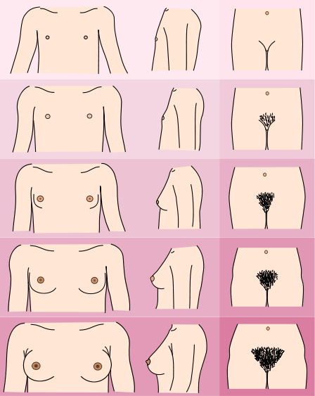 |  | Breasts: pre-pubertal, no breast tissue with flat areola. No pubic hair.
2 |  |  | Breast budding with widening of the areola. Small amount of long hair at base of female labia majora.
3 |  |  | Larger and more elevated breast extending beyond the areola. Pubic hair: moderate amount of curly and courser hair extending outwards.
4 |  |  | Larger and more elevated breast; areola and nipple projecting from the breast contours. Pubic hair resembles adult hair but does not extend to inner surface of thigh.
5 |  |  | Mature stage: breast is adult size with nipple projecting above areola. Pubic hair: adult type and quantity extending to the thigh surface.
Female Tanner staging image by Michał Komorniczak, medical illustrations. Poland.

Boys — development of external genitalia and pubic hair
Stage | Development of external genitalia and pubic hair* | Testicular volume in ml,  length in cm | Description
1 | 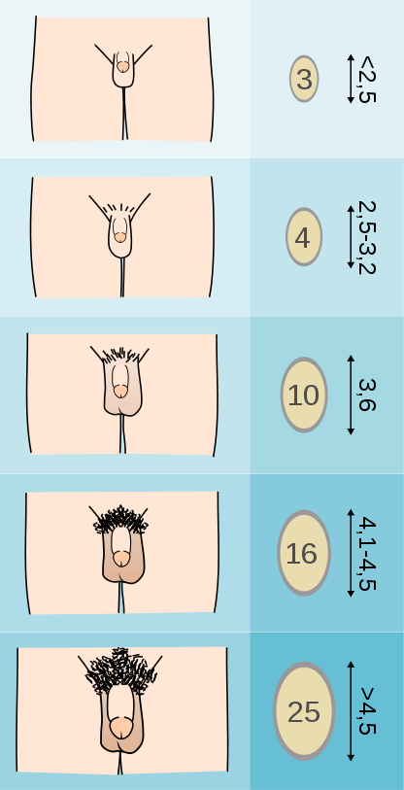 |  | Genitals: pre-pubertal, testes small in size with childlike penis. No hair.
2 |  |  | Testes reddened, thinner, and larger (1.6–6cc) with childlike penis. Small amount of long hair at base of male scrotum.
3 |  |  | Testes larger (6cc–12cc) and scrotum enlarging; increase in penile length. Moderate amount of curly and courser hair extending outwards.
4 |  |  | Testes larger (12cc–20cc) with greater enlargement and darkening of the scrotum; increase in length and circumference of penis. Pubic hair resembles adult hair but does not extend to inner surface of thigh.
5 |  |  | Testes over 20cc with adult scrotum and penis. Pubic hair: adult type and quantity extending to the thigh surface.
* Note that a circumcised penis is depicted here — an uncircumcised penis would look slightly different.
Male Tanner staging image by Michał Komorniczak, medical illustrations. Poland.

Appendix 2B: Checklist and Assessment Tool for Youth-Friendly HIV Care and Treatment Services

Facility name: Type of facility/clinic:

Questions to Assess Youth-Friendliness | Answer | Comments/Recommendations
Location
How far is the facility from public transportation?
How far is the facility from places where adolescents spend their time?
How far is the facility from local schools?
Facility hours
During what hours is the clinic open?
Does the clinic have separate hours/days for youth?
Is there a sign listing services and clinic working hours?
What times are convenient for adolescents to seek services?
Facility environment
Does the facility provide a comfortable setting for young clients?
Does the facility have a separate space to provide services to adolescent clients?
Does the facility have a separate waiting area for adolescent clients?
Is there a counseling area that offers both visual and auditory privacy?
Is there an examination room that provides both visual and auditory privacy?
Are both young men and women welcomed and served at the clinic?

Staffing
Are all health workers trained in pediatric HIV care and treatment?
Are all health workers trained in adolescent HIV care and treatment?
Have all staff members (including data clerks, pharmacists, receptionists, etc.) received orientation about adolescent services?
Do health workers show respect for adolescent clients during counseling sessions and group sessions?
Are there job aides available to help health workers in their daily work with adolescents?
Services provided
Is 1-stop shopping provided to adolescent clients? Describe.
Are the following services provided to adolescent clients directly (note if through referral):
  - HIV testing and counseling
  - Comprehensive care, including the prevention and treatment of OIs
  - Malaria prophylaxis and treatment
  - ARVs/ART
  - Adherence preparation
  - Ongoing adherence assessment & counseling (at each visit)
  - Pregnancy testing, antenatal care, and PMTCT
  - Sexual and reproductive health counseling
  - Condoms and water-based lubricant
  - Contraception (which methods?)
  - STI screening and treatment
  - Positive prevention counseling
  - Psychosocial counseling and support
  - Nutrition counseling
  - Laboratory tests (CD4, other HIV tests)
  - PEP, as per national guidelines
Are there outreach services, especially targeting most-at-risk adolescents? Explain.
Do adolescent request services other than the ones offered? Which ones?
Is there a formal referral system for services not provided at the clinic?
Is there a formal referral system for services required by most-at-risk adolescents (sexual abuse counseling and treatment, drug/alcohol rehabilitation, support for youth-heads of household, etc.)? Which ones?
Is there a tracking and follow-up plan in place for clients who do not return?
Peer education and counseling
Is a peer education program available?
How many Peer Educators are working at the facility?
How many hours/days per week do Peer Educators work at the facility?
What are the roles and responsibilities of Peer Educators?
How are the Peer Educators trained?
Is there a system for supervising and monitoring Peer Educators?
Educational activities
Are educational/information materials available? Which ones?
Are there educational posters displayed?
Are there posters or brochures that describe clients’ rights?
Are there materials for adolescent clients to take home?
In what languages are the materials?

Are group education sessions held with younger adolescents? Describe.
Are group education sessions held with older adolescents? Describe.
Are group education sessions held with parents/caregivers? Describe.
Are adolescent support groups held (with younger adolescents)? Describe.
Are adolescent support groups held (with older adolescents)? Describe.
Are there ways for adolescent clients to access information or counseling off-site (via a hotline, etc.)?
Youth involvement
Are adolescents involved in decision-making about how programs and services are delivered?
What ways are there for adolescents to give feedback to clinic staff?
How could adolescents be more involved in decision-making at the facility?
What other roles could adolescents play in clinic planning, operations, and evaluation?
Supportive policies
Do clear, written guidelines or standard operating procedures (SOPs) exist for adolescent services?
Do written procedures exist for protecting client confidentiality?
Are records stored so that confidentiality is ensured?
Is parental/guardian/spousal consent ever required? In what cases?
Is there a minimum age required for adolescents to receive HIV testing?
Is there a minimum age required for adolescents to receive contraceptives?
Are there policies or procedures that pose barriers to youth-friendly services?
Administrative procedures
Is the registration process private so that others cannot see or hear?
Can adolescent clients be seen without an appointment?
How long do adolescent clients normally have to wait?
What is the average time allotted for client/health worker interaction?
Publicity/recruitment
Does the clinic publicize the services available to adolescents, stressing confidentiality?
Are there staff or volunteers who do outreach activities? Describe.
Fees
Are adolescents charged for any services? If so, which ones and how much?
If there are fees, are they affordable to adolescent clients?
OTHER?

Adapted from: Senderowitz, J., Solter, C., & Hainsworth, G. (2002). Clinic assessment of youth friendly services: A tool for assessing and improving reproductive health services for youth. Watertown, MA: Pathfinder International.

Appendix 2C: Sample Client Satisfaction Survey for Youth

Clinic/Facility: _______________________
Lead physician or nurse (if applicable): _________________
Your name (optional): ____________________ Date: _________________

Please help us improve our services by answering some questions about the services you received.

We are interested in your honest opinion — whether positive or negative. Your answers will be kept confidential.

1. The staff at the clinic communicated clear information to me.

1 | 2 | 3 | 4 | 5
Strongly Disagree | Disagree | Somewhat Agree | Agree | Strongly Agree

2. People at the clinic included my opinions when making decisions.

1 | 2 | 3 | 4 | 5
Strongly Disagree | Disagree | Somewhat Agree | Agree | Strongly Agree

3. The staff at the clinic listened to me.

1 | 2 | 3 | 4 | 5
Strongly Disagree | Disagree | Somewhat Agree | Agree | Strongly Agree

4. The staff at the clinic involved my family/caregivers in my care.

1 | 2 | 3 | 4
More than I wanted | About the right amount | Less than I wanted | No involvement,  which is what I wanted

5. I am satisfied with the progress I have made toward my treatment goals (taking medication/adherence, participating in psychosocial support activities, etc.)

1 | 2 | 3 | 4 | 5
Strongly Disagree | Disagree | Somewhat Agree | Agree | Strongly Agree

6. The staff at the clinic worked well together.

1 | 2 | 3 | 4 | 5
Strongly Disagree | Disagree | Somewhat Agree | Agree | Strongly Agree

7. The staff at the clinic spent enough time with me.

1 | 2 | 3 | 4 | 5
Strongly Disagree | Disagree | Somewhat Agree | Agree | Strongly Agree

8. The staff at the clinic treated me with respect.

1 | 2 | 3 | 4 | 5
Strongly Disagree | Disagree | Somewhat Agree | Agree | Strongly Agree

9. The staff at the clinic gave me support.

1 | 2 | 3 | 4 | 5
Strongly Disagree | Disagree | Somewhat Agree | Agree | Strongly Agree

10. I would recommend this clinic/program to a friend who needed similar help.

1 | 2 | 3 | 4 | 5
Strongly Disagree | Disagree | Don’t Know | Agree | Strongly Agree

11. On a scale from 1-10, how would you rate the care you received?

1 | 2 | 3 | 4 | 5 | 6 | 7 | 8 | 9 | 10
WORST |  |  |  |  |  |  |  |  | BEST

12. Is there a staff member who worked especially well with you? If yes, can you explain why?
______________________________________________________________________________________________________________________________________________________
______________________________________________________________________________________________________________________________________________________

13. Comments? (Please use the back of this page if necessary)
______________________________________________________________________________________________________________________________________________________
______________________________________________________________________________________________________________________________________________________

Thank you for helping us improve the quality of our services. Your opinion is important to us!

Adapted from: Foster Family-based Treatment Association. Sample TFC youth satisfaction survey (2008) and Customer satisfaction survey, Child version (2007).
References

Senderowitz, J., Solter, C., & Hainsworth, G. (2004). Comprehensive reproductive health and family planning training curriculum. 16: reproductive health services for adolescents. Watertown, MA: Pathfinder International.
? Baylor International Pediatric AIDS Initiative. (2010). HIV curriculum for the health professional. Houston, TX: Baylor College of Medicine.
Usitalo, A. Psychiatric issues in adolescents with HIV/AIDS. PowerPoint presentation for the Florida/Caribbean AIDS Education and training Center, May 13-14, 2011 in Orlando, Florida.
Obare, F., van der Kwaak, A., et al. (2010). HIV-positive adolescents in Kenya: access to sexual and reproductive health services. KIT Development Policy and Practice, Bulletin 393. Amsterdam: KIT Publishers.
? WHO. (2010). IMAI one-day orientation on adolescents living with HIV.
? Weiser SD., Leiter K., Heisler M., McFarland W., Percy-de Korte F., et al. (2006). A population-based study on alcohol and high-risk sexual behaviors in Botswana. PLoS Med, 3(10): e392. Available at: http://www.plosmedicine.org/article/info:doi/10.1371/journal.pmed.0030392
? Hsu, JW., et al. (2005). Macronutrients and HIV/AIDS: a review of current evidence: consultation on nutrition and HIV/AIDS in Africa: evidence, lessons and recommendations for action. Durban, South Africa: WHO, Department of Nutrition for Health and Development.

