Supplemental Counseling Cards for the Essential Package: Early Stimulation and Responsive Parenting
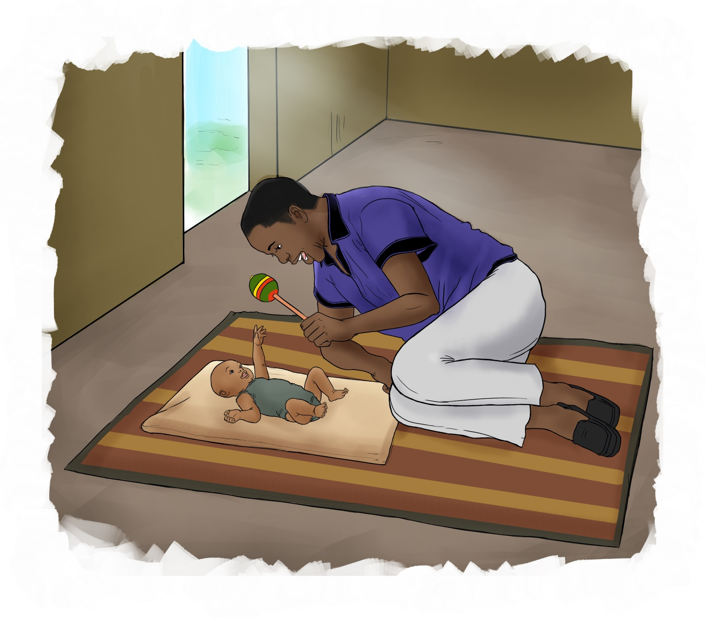

The mark “CDC” is owned by the US Dept. of Health and Human Services and is used with permission. Use of this logo is not an endorsement by HHS or CDC of any particular product, service, or enterprise.

This job tool was created by ICAP at Columbia University with funding from the U.S. President’s Emergency Plan for AIDS Relief (PEPFAR) through the Centers for Disease Control and Prevention (CDC) under the terms of cooperative agreement #U2GGH000994. Its contents are solely the responsibility of the authors and do not necessarily represent the views of the U.S. Government.
Prenatal Period

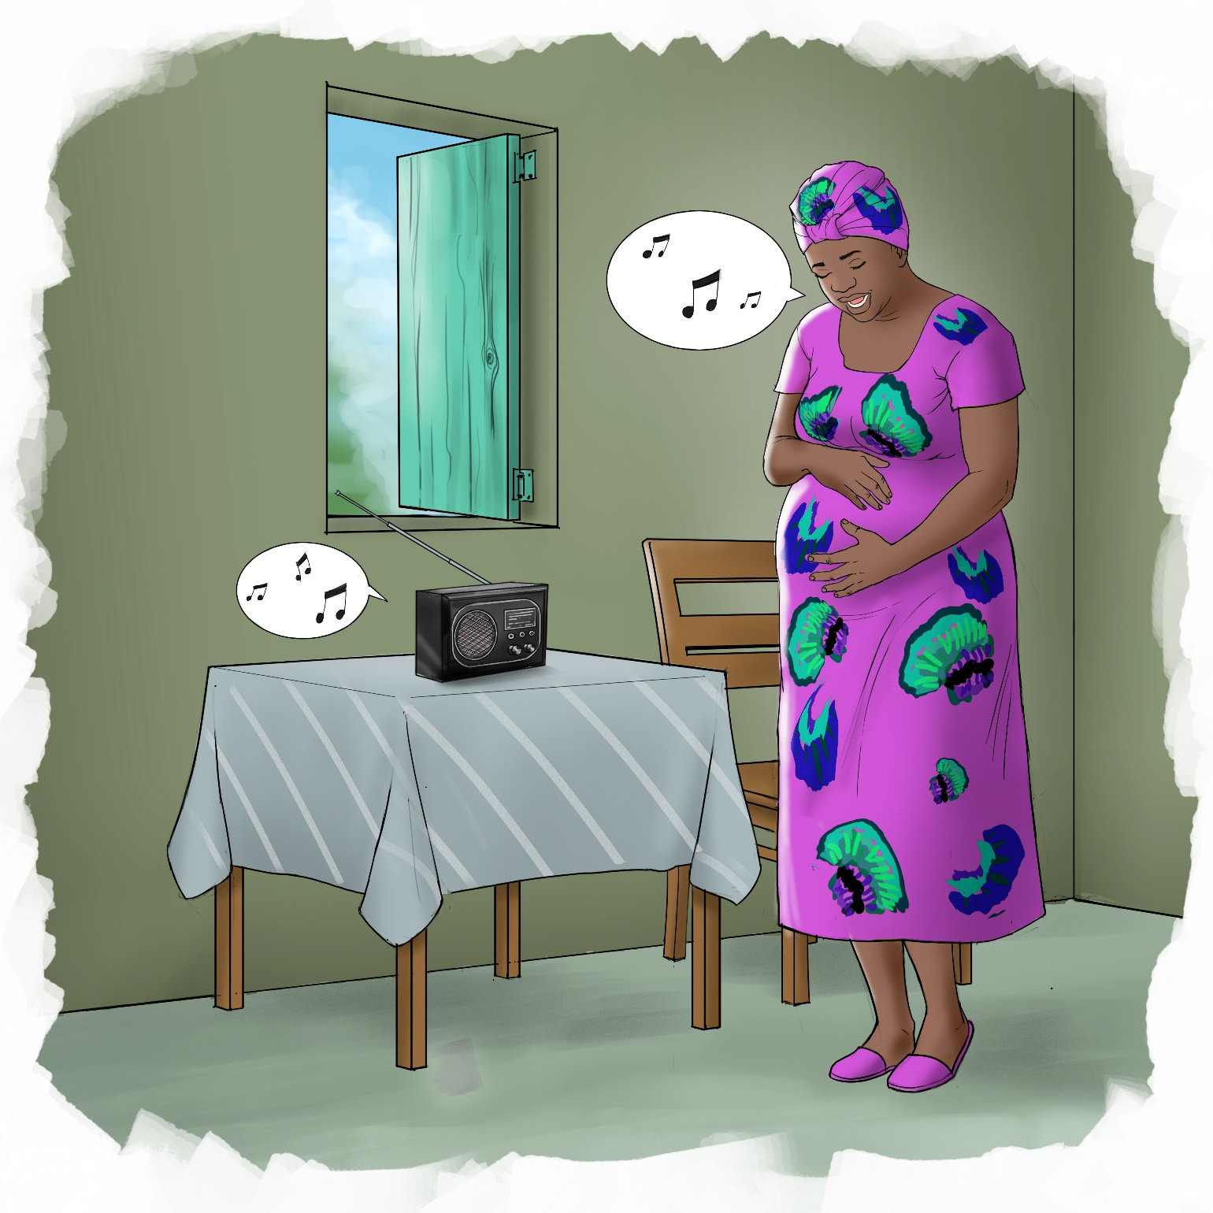

1

Prenatal Period

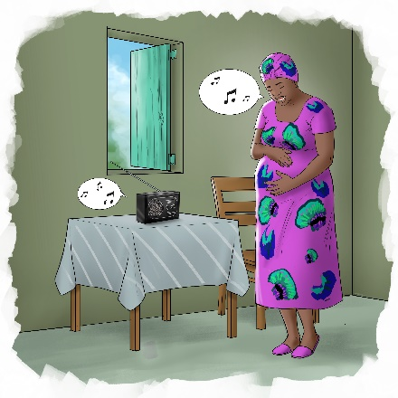
Reflection Questions:

▪ What do you see happening in this picture? Is this common in your community?
▪ Did you know that your baby starts learning even before being born?
▪ What are the things you can do now to help your baby start learning?
▪ How can a partner, or other people close to a pregnant woman support her to help her baby learn?

Suggested Actions:

▪ Sing and talk to your baby now so she can hear you.
▪ Eat plenty of fresh vegetables and proteins such as chicken, beans, eggs, and milk.
▪ If there is not enough food at home, find a nutrition program that may be able to help provide food.
▪ Think about who you can trust to seek help from if you are feeling overwhelmed, lonely, or sad. It may be a family member, a partner, a friend, or even a healthcare worker from the clinic

Key Messages:

▪ Babies start to learn even before they are born. Their brains start growing and developing early in pregnancy.
▪ There are many things you can do from the time you learn you are pregnant and throughout your child’s life to encourage her to keep learning.
▪ To be able to focus on learning, it is important for babies and younger children to have a caregiver that loves them and makes them feel safe.
▪ It is also important that mothers feel supported and cared for by their partner, family or community so they can focus on caring for their babies.
▪ Your baby can also hear even before she is born. Talking to your baby teaches her to recognize your voice.

2

Birth to 1-month

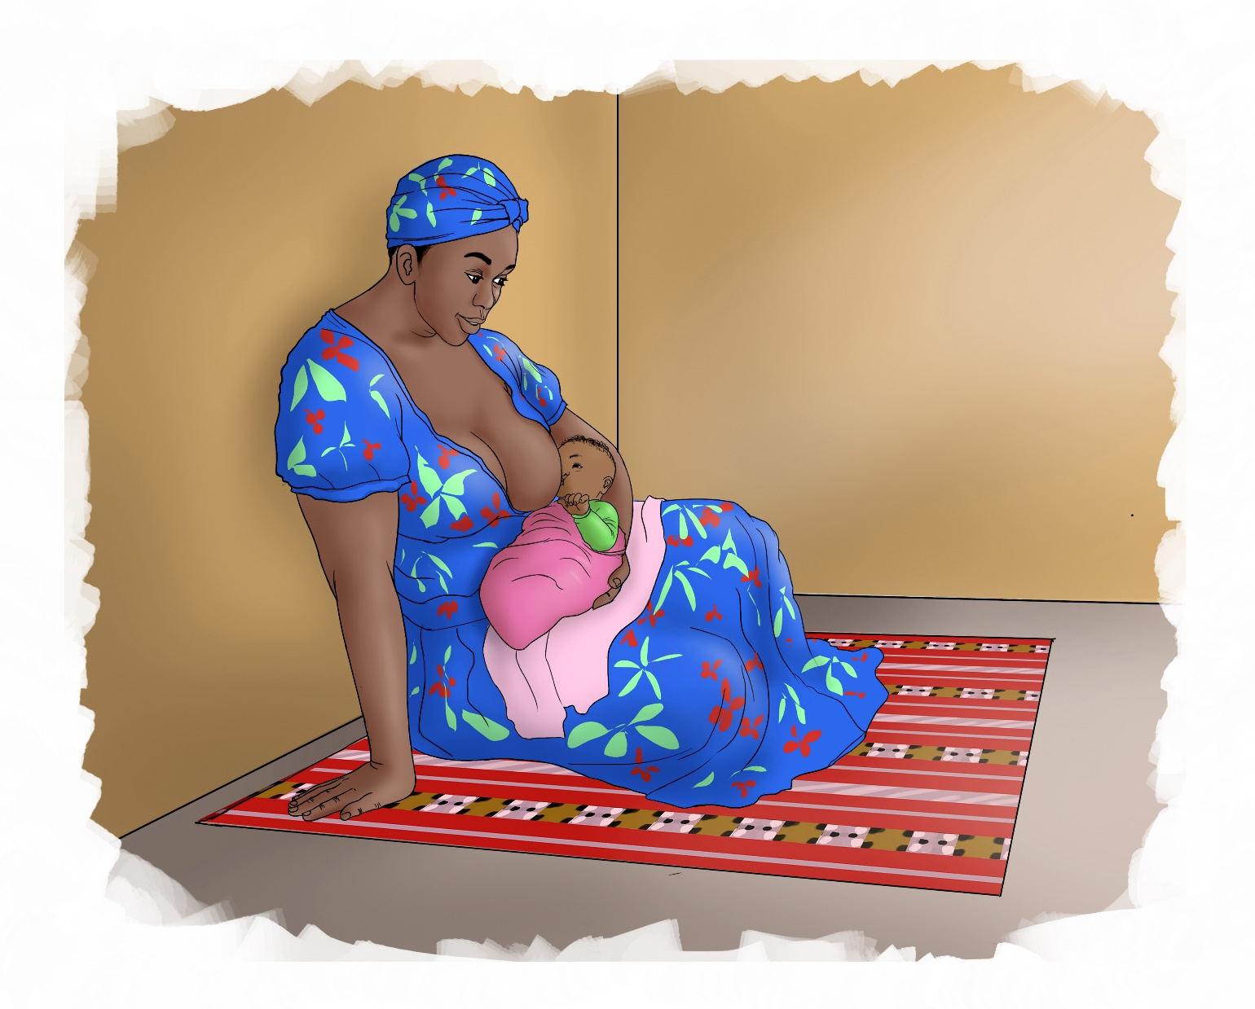

3

Birth to 1-month

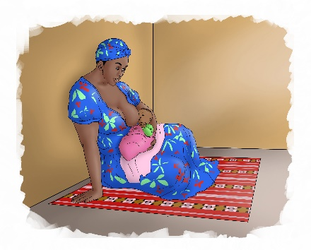
Reflection Questions:

▪ What do you see happening in this picture?
▪ Why do you think it is important for the baby to develop a close connection to her mother and other primary caregivers?
▪ How much time will you have to spend with your baby every day?
▪ Who else in your home will be spending time with the baby? How can they be supportive during this period?

Suggested Actions:

▪ Spend as much time as you can bonding with your baby. Hold your baby so your skin touches his skin.
▪ Strengthen your baby’s eyes by making different facial expressions. Make sure your face is at a distance that she can see and follow with her eyes.
▪ Pay attention to how your baby is trying to communicate to you. She may cry or fuss if she is hungry, has a dirty nappy or is uncomfortable. Even though she will not be able to use words, the connection you develop with your baby will help you to understand what she wants to tell you.

Key Messages:

▪ After you deliver, keep your baby close to your skin to keep your baby warm and breastfeed her easily.
▪ Keeping your baby close to you also helps you develop a close connection between you and your baby.
▪ At first your baby will only be able to see things that are close. At the time babies are born they can see their mothers’ face while they are breastfeeding. To help strengthen your baby’s eyes show him different facial expressions.
▪ Keep talking or singing to your baby so she becomes used to the sound of your voice.

4

1- to 2-months

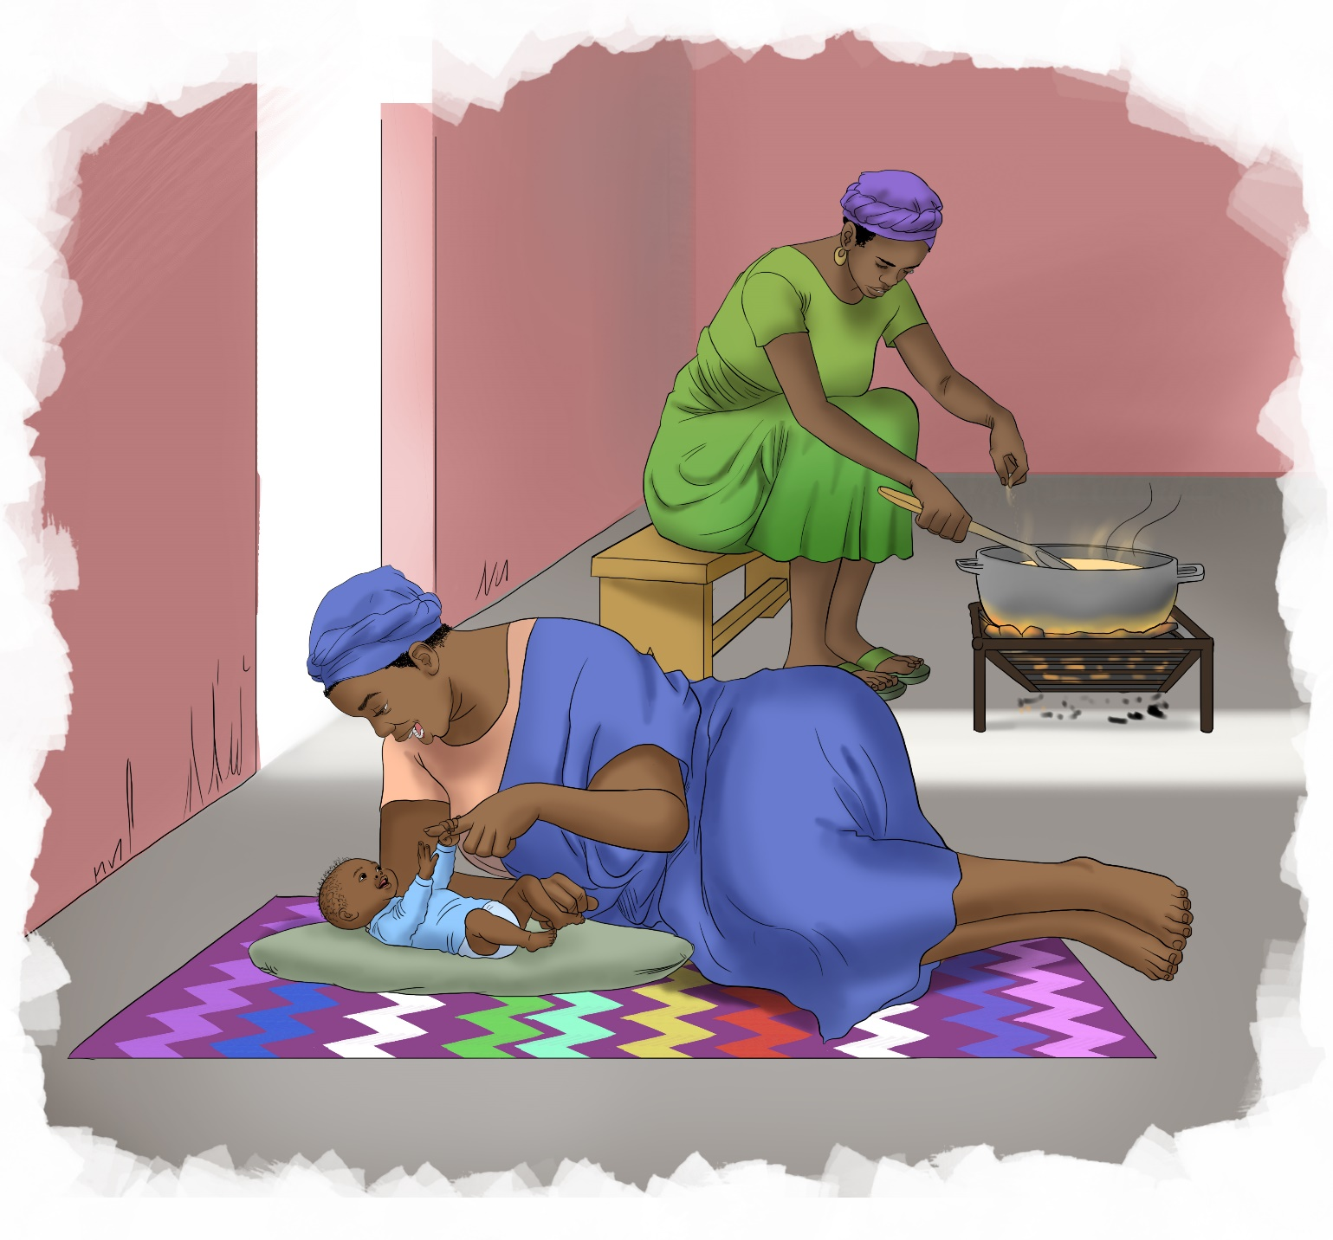

5

1- to 2-months

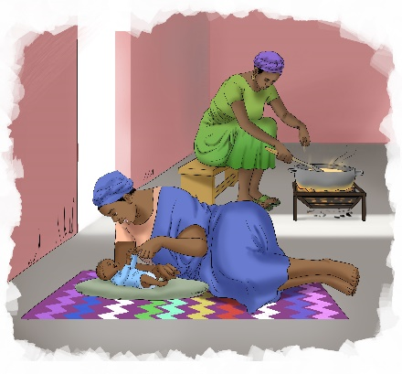
Reflection Questions:

▪ What do you see happening in this picture?
▪ Do you know how you can help your baby’s muscles become stronger?
▪ Why do you think it is important for a caregiver to respond to a baby when she cries?

Suggested Actions:

▪ For about five minutes every day put your baby down on her stomach so she can practice lifting his head and pushing himself up on his arms. This will help her muscles grow strong.
▪ When your child cries, pick him up and give her some comfort. This will help her feel safe and loved so he can continue to focus on learning.
▪ When your baby is on her back, gently move her arms and legs.
▪ Talk to your baby and tell her the words for different things so she will start to learn language.

Key Messages:

▪ Your baby will start to move more on her own so it is good to help her move her arms, legs and other muscles so they grow strong.
▪ Your baby will also be able to express her emotions more so may start to smile when she is happy or cry and fuss when bored, hungry or uncomfortable.
▪ All babies are different, and they may learn to do things in different ways. Some may learn how to do one thing quickly such as smiling but may be slower at something else such as crawling.
▪ Babies learn things and become stronger step by step. Before your baby can crawl, her arms must be strong enough to hold her up:
▪ Your baby will learn in her own way but there are things you can do to help her learn better and become stronger.

6

2- to 4-months

7

2- to 4-months

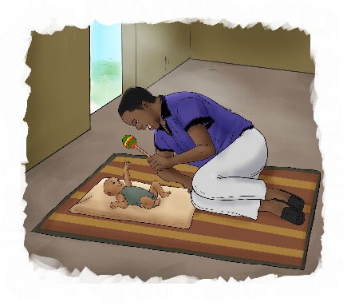
Reflection Questions:

▪ What do you see happening in this picture?
▪ How do you know when your baby is happy, hungry or tired?
▪ What do you do to make your baby smile or laugh?
▪ What kind of things does your baby enjoy playing with?

Suggested Actions:

▪ Play with your baby using things that have different colors or things that make noise. It can be as simple as a small plastic bottle with stones inside to rattle, or a colorful cloth that you move from side to side as your baby watches it.
▪ Encourage your baby to babble and make the same sounds he makes.
▪ Let your baby spend some time on his stomach, around five minutes at a time. Cheer and encourage him as he presses up or lifts his head which will help strengthen his muscles.
▪ Look through the pages of a book, magazine or even a pamphlet with your baby and tell him the words for different pictures.

Key Messages:

▪ As your baby grows, he will pay more attention to the people around him and show them how he is feeling.
▪ Around this age your baby will also start to enjoy playing more and may try to reach or grab things to play with.
▪ Your baby will also start to copy some of your movements and expressions and may start making sounds as he tries to talk (babbling).
▪ Your baby will also be able to push up onto his elbows when he is laying on his stomach. As he grows stronger he may even be able to roll from his stomach to his back.

8

4- to 6-months

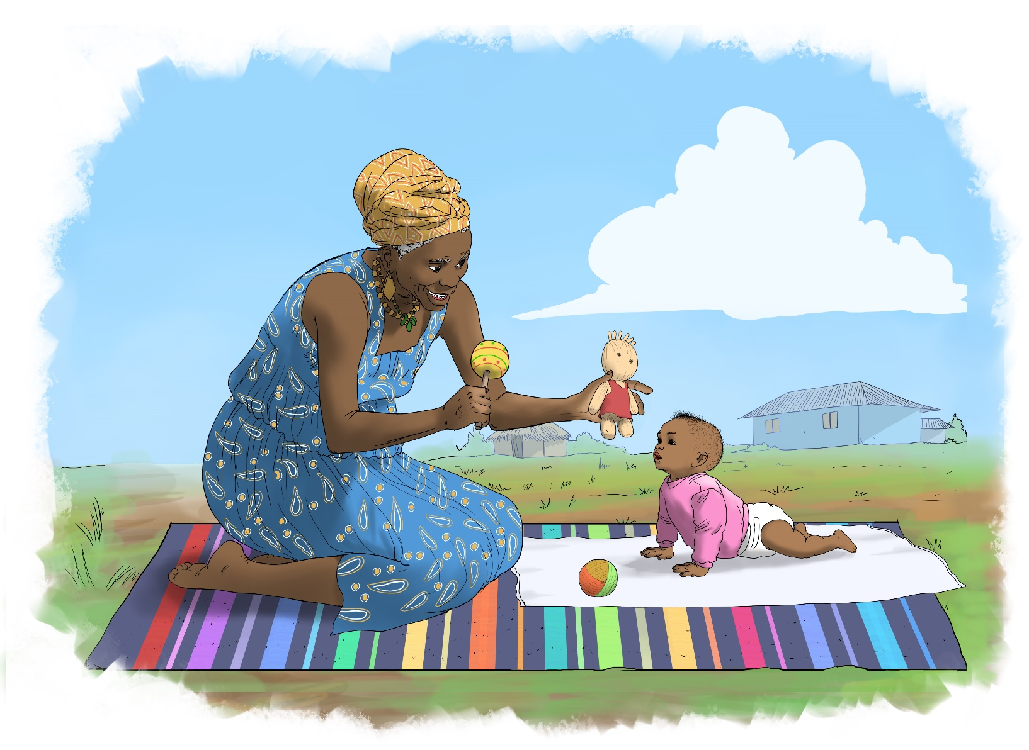

9

4- to 6-months

Reflection Questions:
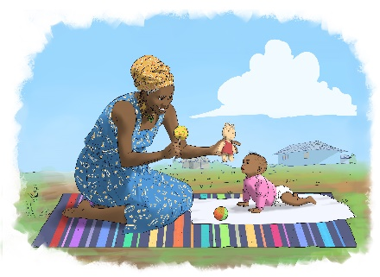
▪ What do you see happening in this picture?
▪ What kind of sounds does your baby make when he is happy?
▪ What kind of things does your baby reach for, what do you think attracts him?

Suggested Actions:

▪ Make time to play with your baby, including when breastfeeding and changing the baby’s nappy.
▪ Make colorful toys out of string/cloth and use household items for your baby to play with.
▪ Call your baby’s name to get his attention and let your baby try to imitate the sounds you make.
▪ Keep your baby safe, make sure there are no small objects around that he may put in his mouth and choke on.

Key Messages:

▪ As your baby gets older and his muscles are stronger, he will be able to roll in both directions and when on his stomach may push himself forward using his arms.
▪ Once your baby can move make sure to always put him down somewhere safe where he won’t fall.
▪ Your baby will also be able to sit up by himself, at first using his arms to prop himself up and then be able to sit without any other support.
▪ Your baby will also be more curious about things around him and try to reach or grab them and bring them to his mouth.
▪ Your baby will start to recognize his own name and make more sounds (cooing and raspberries).

10

6- to 9-months
11

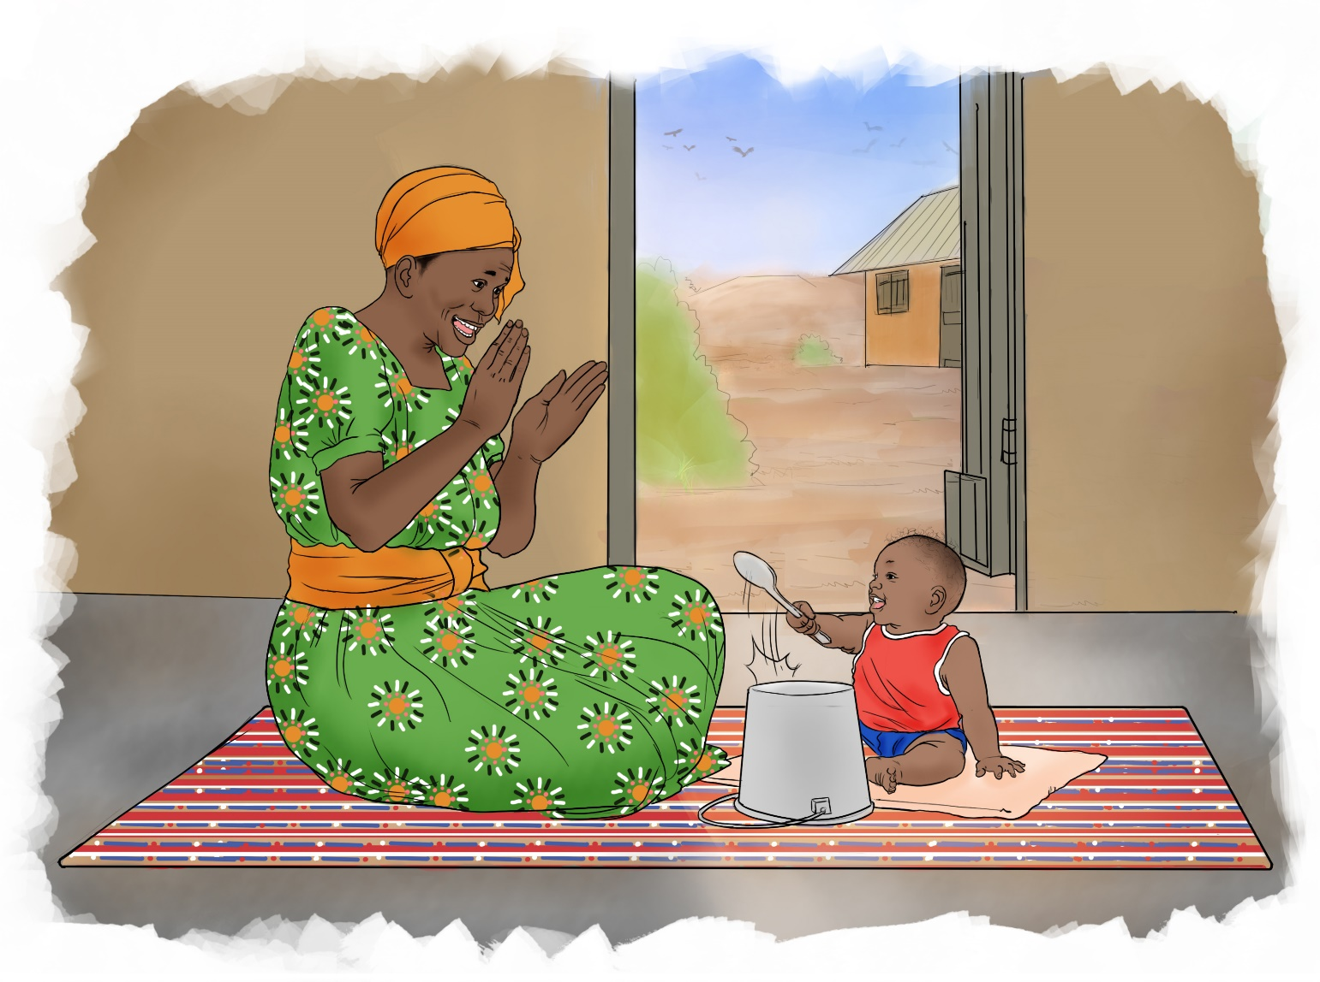

11

6- to 9-months

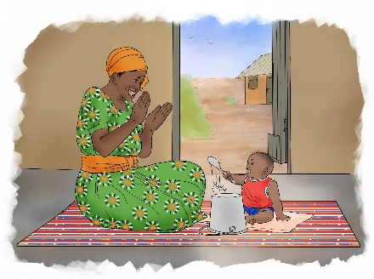
Reflection Questions:

▪ What do you see happening in this picture?
▪ How does your baby move around on his own now?
▪ What words do you think your baby understands?
▪ How does your baby tell you what he is feeling? What kinds of things does he tell you?

Suggested Actions:

▪ Talk to your baby and let your baby try to mimic the sounds you are making.
▪ Play peek-a-boo with your baby. Your baby will learn that you are there for him even if he can’t see your face.
▪ Give your child toys or objects that he can safely play with and pick up.
▪ Let your baby hold on to your hands and practice walking.
▪ When you put your baby down, make sure he is safe and will not fall into danger such as if he is near the cooking fire or near water.
▪ Encourage him to crawl when he is on his stomach by placing a small toy or object just in front of him, so he has to move to pick it up.

Key Messages:

▪ Your baby will be able to move much more as he gets older, first by crawling, then by pulling to stand up.
▪ He will also mimic different sounds he hears and babble more.
▪ Even though your baby may not speak much he will communicate in other ways such as pointing to things that he wants. He may also be able to understand simple words you say.

12

9- to 12-months

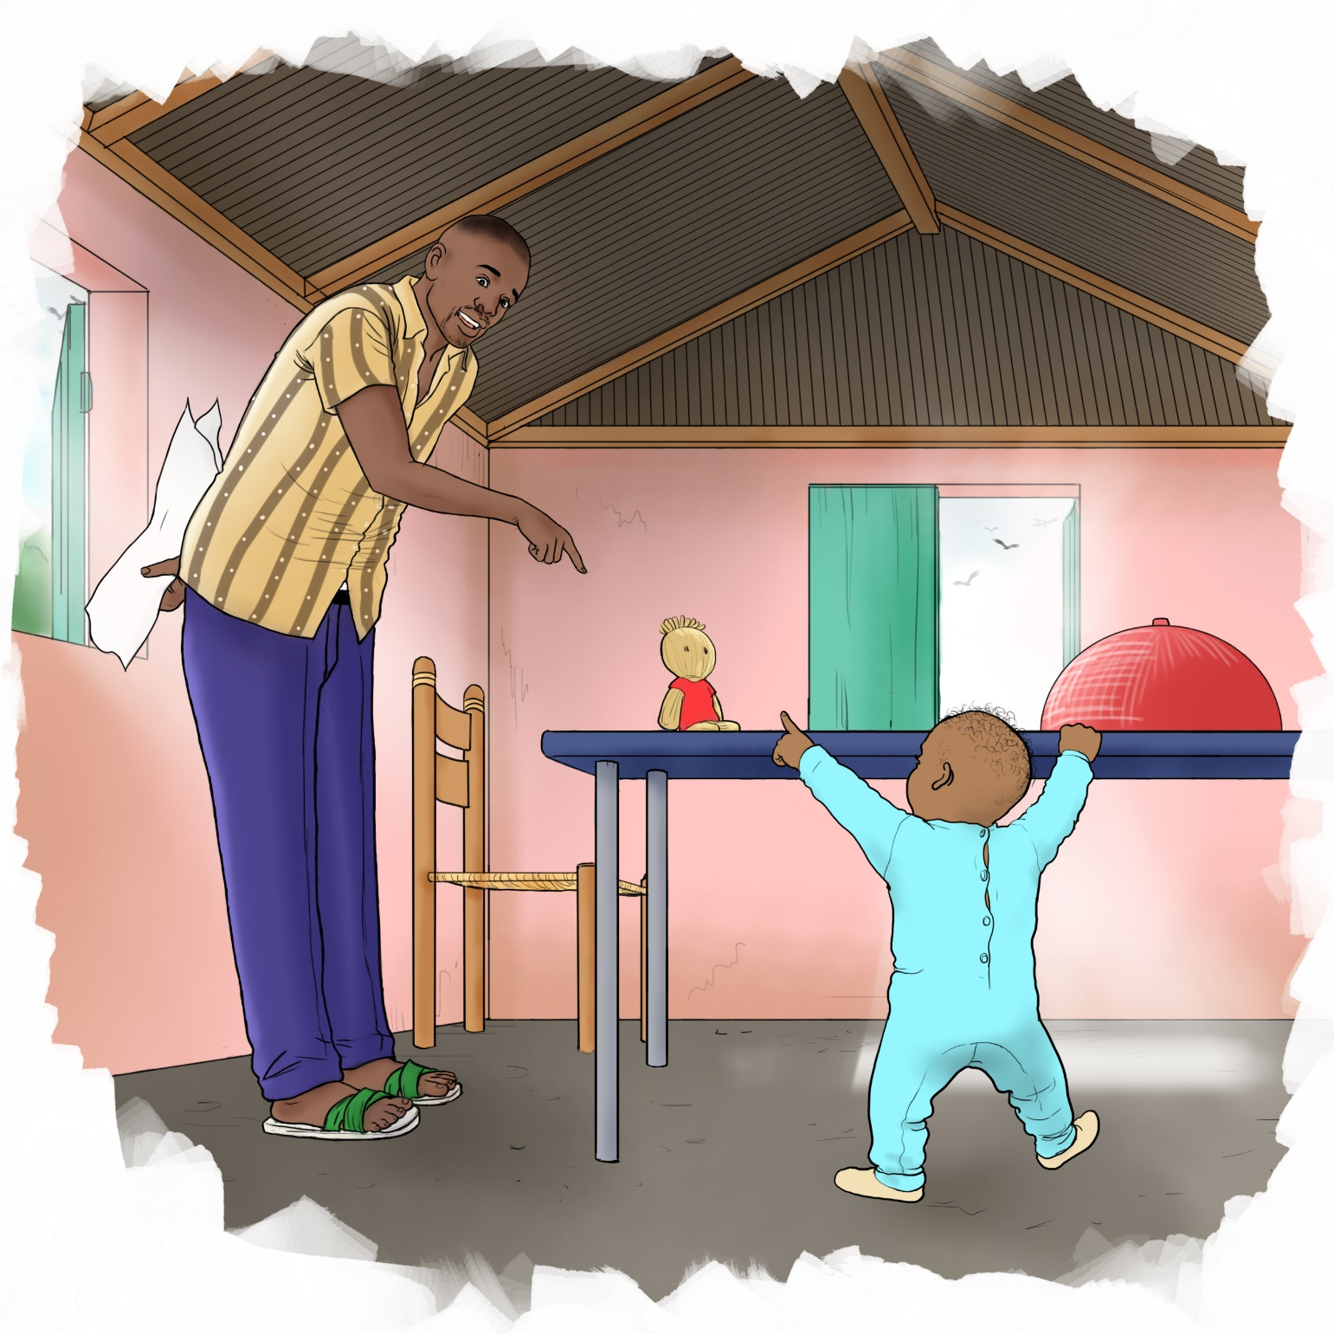

13

9- to 12-months

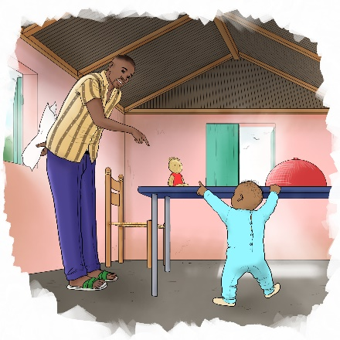
Reflection Questions:

▪ What do you see happening in this picture?
▪ How do you show love to your baby?
▪ How do you play with your child?
▪ What words or sounds does your child make?

Suggested Actions:

▪ Listen to music and sing with your child.
▪ Clap with your child and let him imitate you waving hello.
▪ Vocalize to your baby the names of different things and other people.
▪ Give your baby a box or pot and help him practice putting things inside it and taking them back out.
▪ Hold your baby’s hands when he is trying to walk.

Key Messages:

▪ Your baby will be able to move on his own by crawling and walking with help.
▪ Your baby will also start understanding more words and can follow simple instructions and tell you “yes” and “no” by shaking his head.
▪ With help, your baby may be able to hold a cup and drink.
▪ Around this age your baby may also become more fearful of strangers and cry if you are not around.

14

12- to 18-months

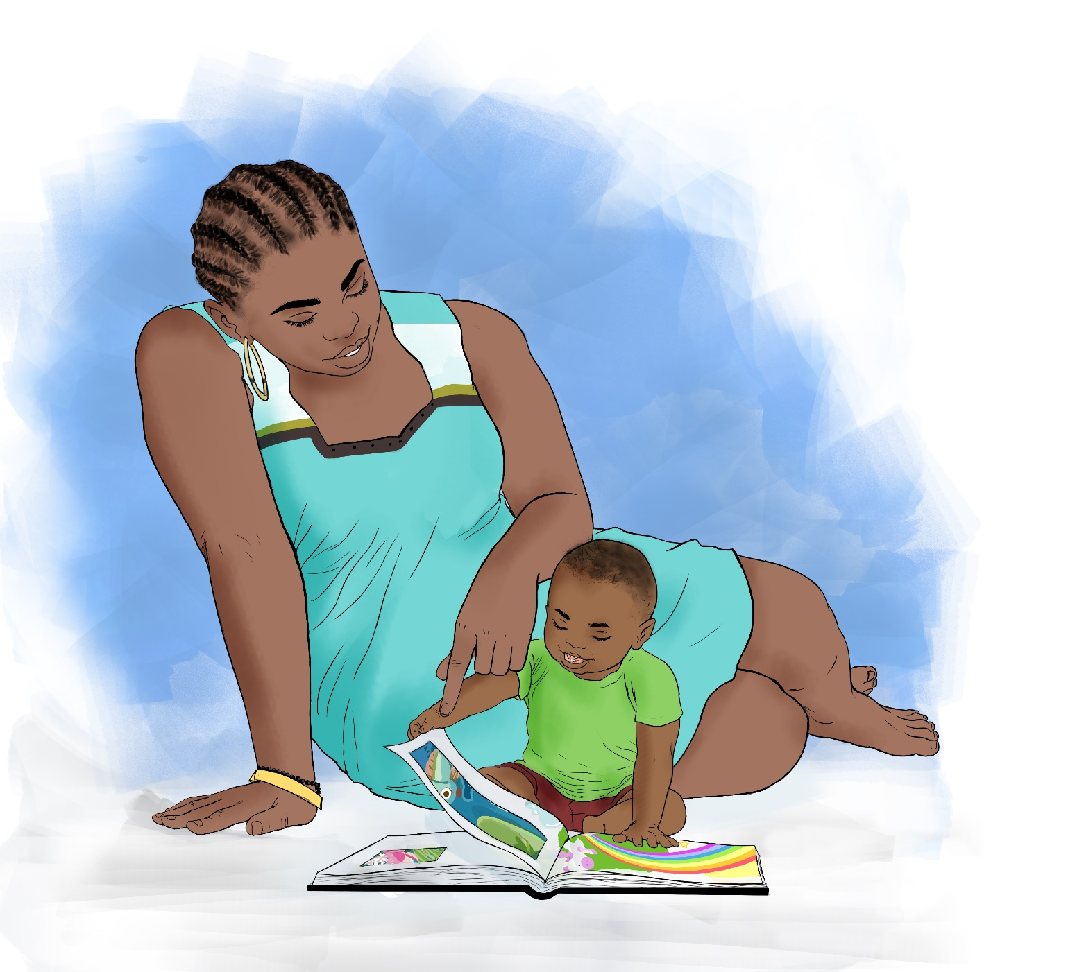

15

12- to 18-months

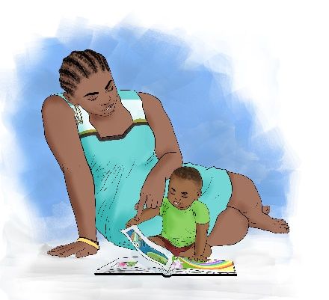
Reflection Questions:

▪ What do you see happening in this picture?
▪ What actions does your child try to do on his own?
▪ How do you think reading or looking at books together with your child will help later in life?

Suggested Actions:

▪ Find something to look at that has pictures. It can be a children's book, a magazine or even a pamphlet.
▪ If you can read the words, read them to your baby and point to the pictures describing them in simple words. Even if you cannot read the word, you can show your baby pictures and tell him the names of different things.
▪ Let your child turn the pages of a book or magazine on his own.
▪ When you feed your baby, help him hold the cup or spoon himself and help guide them to his mouth.
▪ Encourage your child to scribble using a pencil or crayon on a piece of paper- this will help him learn to write later in life.

Key Messages:

▪ Looking at books at an early age can help your child prepare to learn reading and writing when they get older.
▪ Children at this age are very active and require a lot of patience from their caregivers, as they will require guidance.
▪ Children at this age can learn from copying what others do so your child may try to copy some of your movements and activities.
▪ At this age children will start learning how to do things more independently like walking and feeding themselves. They will not be able to do these things correctly right away, but still need help and encouragement while they practice.

16

18- to 24-months

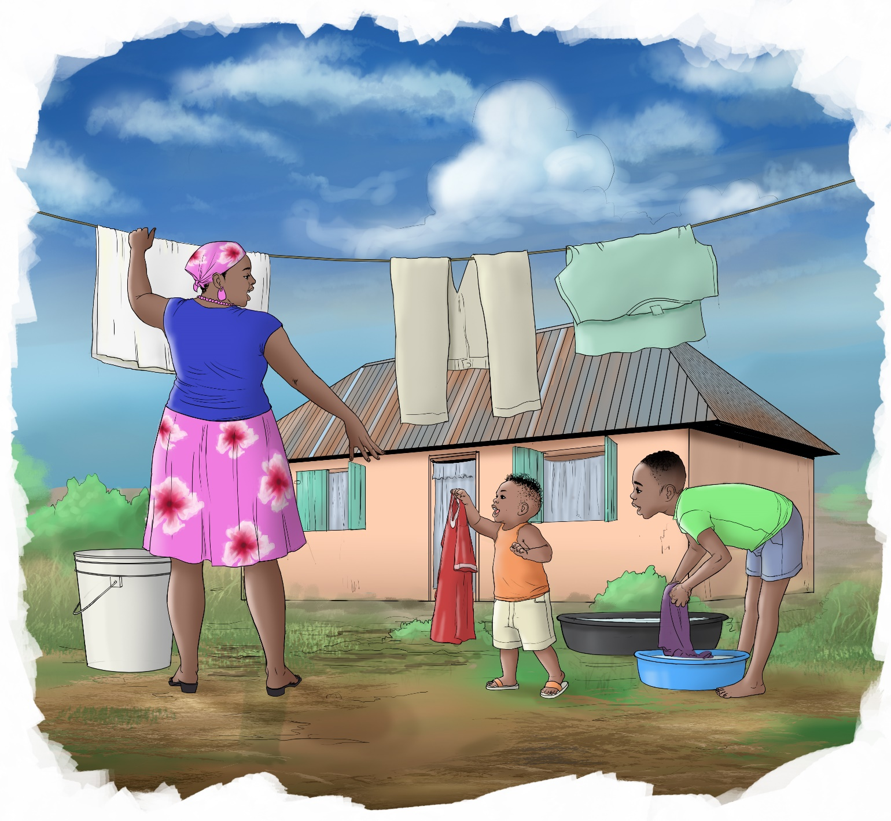

17

18- to 24-months

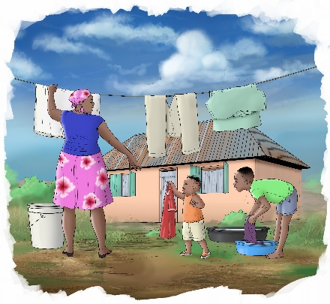
Reflection Questions:

▪ What do you see happening in this picture?
▪ Why do you think children start to imitate the actions of others?
▪ What words can your child say?

Suggested Actions:

▪ Encourage your child to play and run in a safe space where he will not fall and hurt himself.
▪ Let your child participate in household chores with you.
▪ Teach your child different words by pointing to things, like different body parts or images in a book and naming them and encourage your child to repeat the words.
▪ Let your child draw circles and straight lines with a crayon or pencil on paper, or even with a stick on the ground.
▪ Encourage your child to interact with other children but pay attention to what he is learning from others so you can correct him.

Key Messages:

▪ At this age your child will do more by himself, he will start to walk by himself and run but still may need help going up and down stairs.
▪ Your child’s language is developing so he will speak more and will know the names of familiar people or things.
▪ Children learn from copying the actions of others and may imitate whatever you are doing such as pretending to help you do work around the house.

18

