Supplemental Counseling Cards for the Essential Package: Child Safety and Violence Prevention
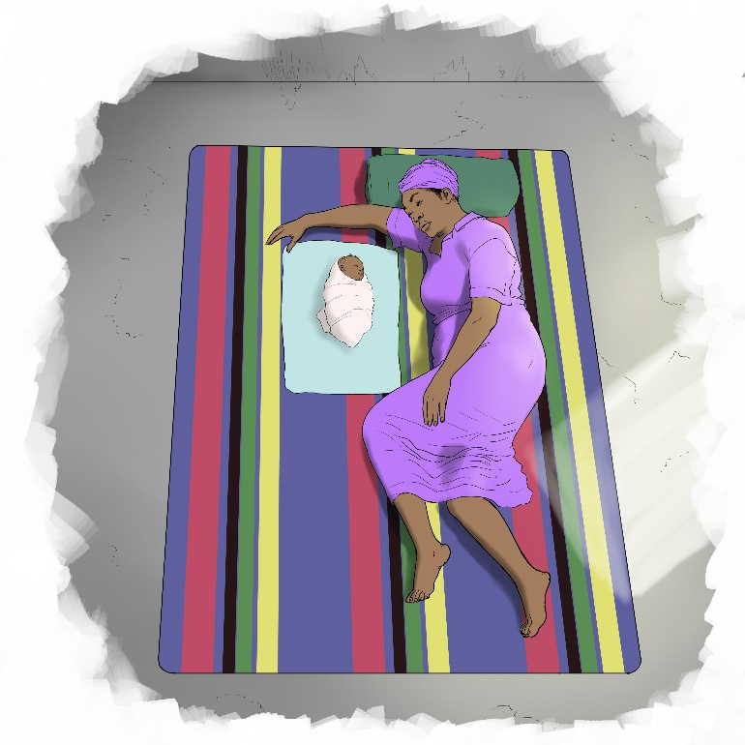

The mark “CDC” is owned by the US Dept. of Health and Human Services and is used with permission. Use of this logo is not an endorsement by HHS or CDC of any particular product, service, or enterprise.

This job tool was created by ICAP at Columbia University with funding from the U.S. President’s Emergency Plan for AIDS Relief (PEPFAR) through the Centers for Disease Control and Prevention (CDC) under the terms of cooperative agreement #U2GGH000994. Its contents are solely the responsibility of the authors and do not necessarily represent the views of the U.S. Government.
Prenatal Period

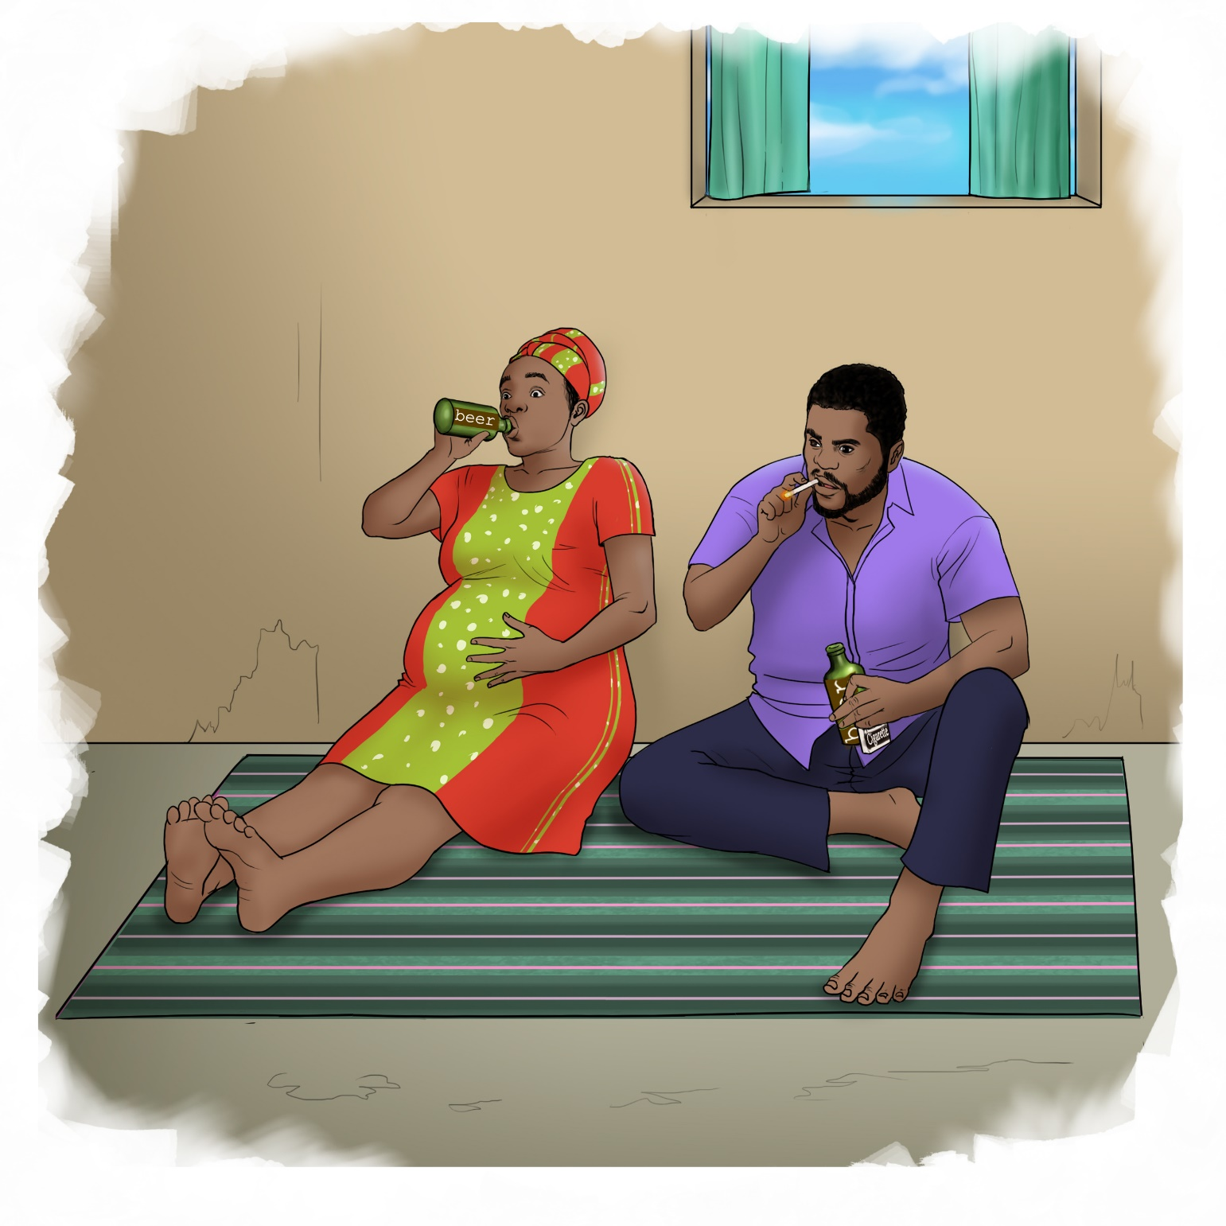

1

Prenatal Period

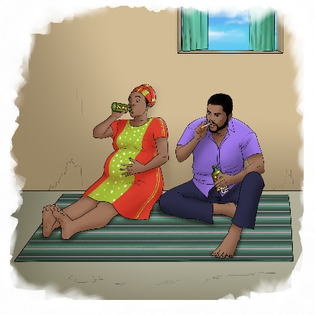
Reflection Questions:

▪ What do you see happening in this picture?
▪ Does anything in these pictures apply to you?
▪ How do you think cigarettes, alcohol or other drugs may affect your baby, even if you aren’t drinking?

Suggested Actions:

▪ It can be difficult to stop using cigarettes, alcohol or other drugs. If you use any of these things but have difficulty stopping, talk to your healthcare worker or a counselor for help.
▪ If your partner or someone else who is close to you drinks or uses drugs and you worry that they may harm you or your baby, ask someone you trust to find a safe place for you to stay.

Key Messages:

▪ It is important for both you and your baby to stay safe and keep away from things that may be harmful.
▪ Cigarettes, alcohol and other drugs are things that can hurt your baby even before you deliver.
▪ Even if you are not the one taking them, other people who are under the influence of alcohol or drugs may do something that may hurt you or your baby.

2

Birth to 1-month

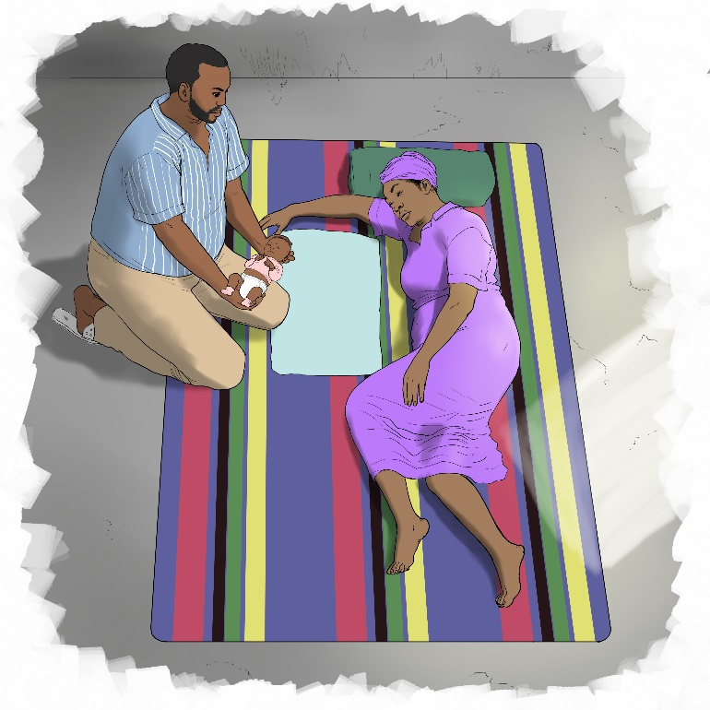

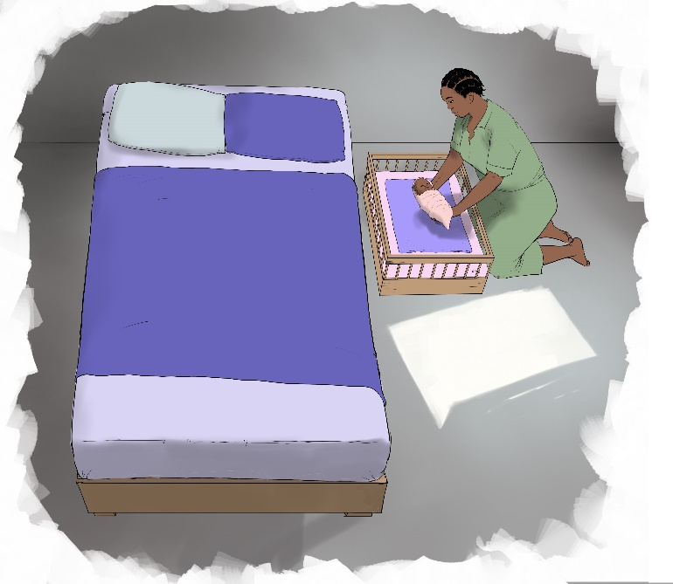

3

Birth to 1-month

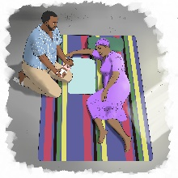
Reflection Questions:

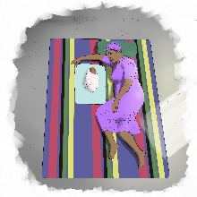
▪ What do you see happening in these pictures?
▪ Where will your baby sleep at home?
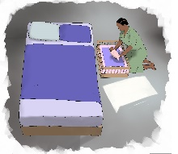
▪ Why do you think it is important not to have any blankets or pillows nearby when the baby is sleeping?

Suggested Actions:

▪ Find a warm, safe place for your baby to sleep. Make sure there is nothing else near your baby such as pillows or blankets.
▪ If you can, sleep next to your baby, but not in the same bed. Then you can reach your baby easily in the night to breastfeed or soothe him, but you will not risk crushing him if you roll over in your sleep.
▪ If you do sleep with your baby in the same bed, sleep on your side, curled around your baby, putting your arm above your baby’s head and your knees under his feet. This helps you avoid rolling over onto your baby.

Key Messages:

▪ At first, babies’ muscles are not strong enough to let them move by themselves. They are not even strong enough to hold their heads up.
▪ It is important to support your baby’s head whenever you pick up your baby.
▪ Babies also sleep more safely on their backs. You should always put your baby on his or her back to sleep, they may be able to roll over as they get older, but at first, they will not be able to move themselves.

4
1- to 2-months

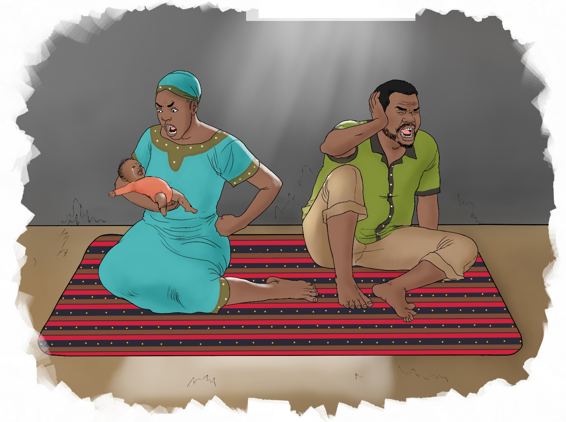

5

1- to 2-months

Reflection Questions:
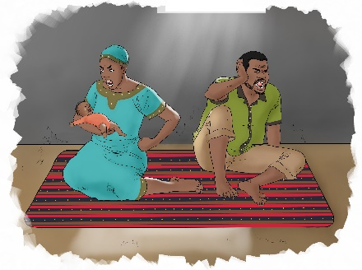
▪ What do you see happening in this picture?
▪ What do you do when your baby cries?
▪ How do you feel when your baby cries?

Suggested Actions:

▪ When your baby cries make sure he is wearing a dry nappy, has breastfed and is not hungry. Also make sure he is not sick or injured.
▪ Think of a list of things you can do to calm yourself if you find yourself becoming angry or upset that your baby is crying so you don’t become angry enough to harm your baby or someone else.
▪ Talk with your family and neighbors to identify people who can care for your baby if you need a little bit of time to become calm.
▪ Identify a safe space in the home for you to put down your baby for a few minutes and take a break if no one is around to help you and you feel you may be upset or angry enough to harm your baby.

Key Messages:

▪ Babies cry for lots of reasons, they may be hungry, uncomfortable, in pain or tired. Some babies cry more than others and it can be hard to make them stop no matter what you do.
▪ When you have a baby that doesn’t stop crying it can be very upsetting, especially if you are tired or stressed. It is normal to feel this way, but it is important to make sure you keep your baby safe.
▪ Babies are fragile. Their brains are also growing and need to be protected. Shaking or striking a baby can cause severe injuries or even death.

6
2- to 4-months

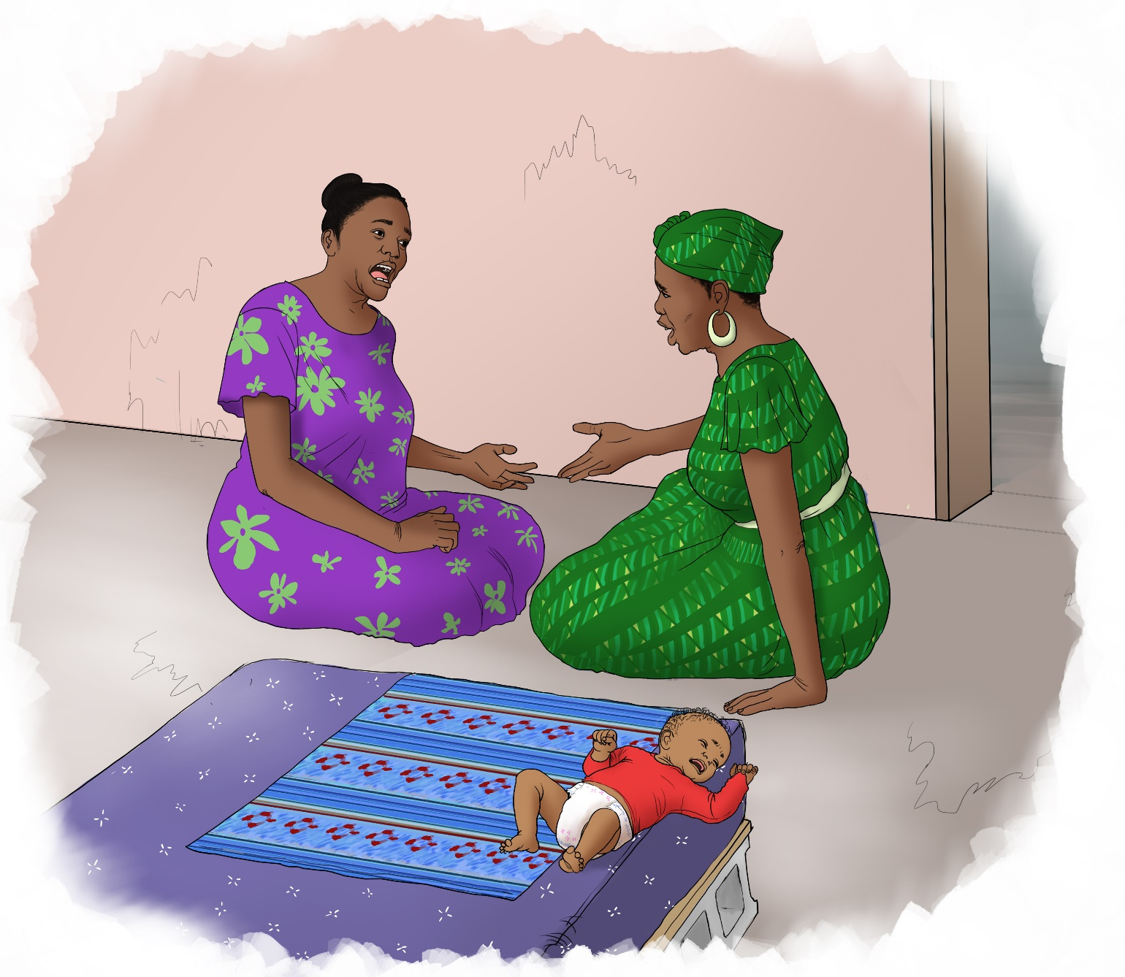

7

2- to 4-months

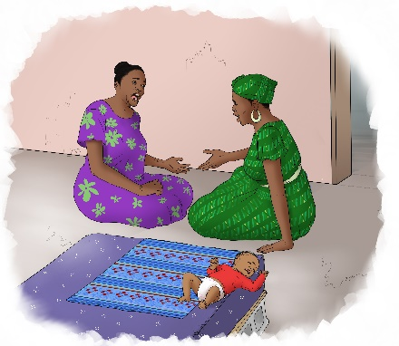
Reflection Questions:

▪ What do you see happening in this picture?
▪ What kind of things can you do to prevent your baby from falling?

Suggested Actions:

▪ When you put your baby down on a bed or table, make sure you or someone else is always very close to your baby to stop him from rolling or falling. You can also put him on the floor but make sure he is away from anything that may be dangerous to him.

Key Messages:

▪ Once your baby can roll over, it is important to make sure he won’t fall if you put him down.
▪ Falls and other accidents can happen very quickly, so it is important to always watch your baby and stay close.
▪ A caregiver should always take care of where they put down the baby.
▪ Even if a baby falls a short distance, it can cause injuries or even death.

8
4- to 6-months

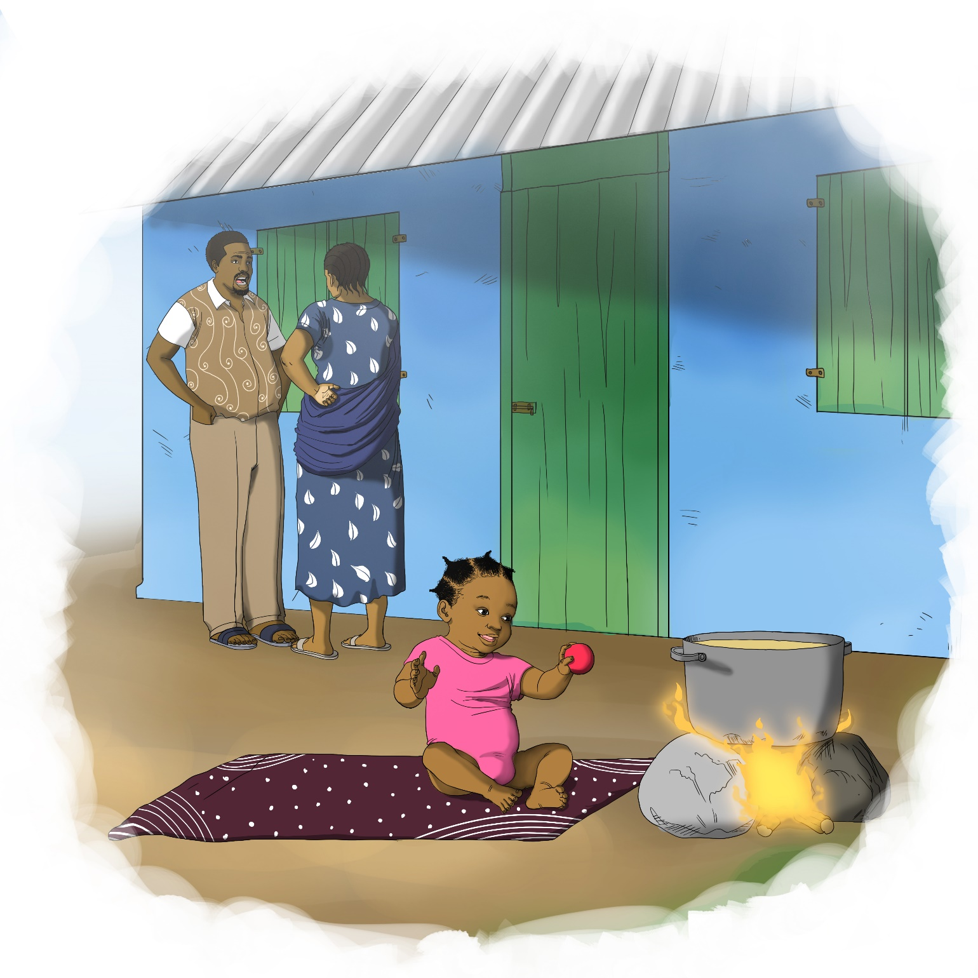

9

4- to 6-months

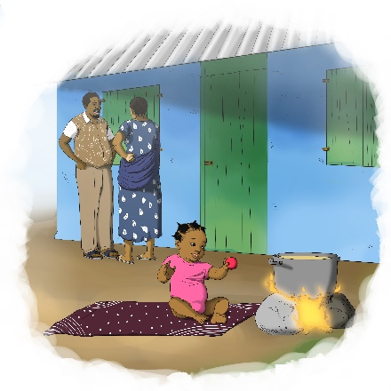
Reflection Questions:

▪ What do you see happening in this picture?
▪ What do you think may happen if this mother leaves her baby near the cooking fire for just a few minutes?
▪ Have you ever left your baby alone for a few minutes and then returned to find he had moved or done something you didn’t expect him to do?

Suggested Actions:

▪ Never leave your baby alone for even a few minutes and be extra careful to stay attentive around things that may be dangerous such as fire or water nearby.
▪ Look around your home and imagine you are seeing things through your baby’s eyes, if there is anything that may be a danger, move it out of your baby’s reach.
▪ If you leave your baby with someone else, make sure they also know how to keep your baby safe.

Key Messages:

▪ Your baby will be moving more on his own and will need to be watched carefully.
▪ You may get distracted when you are with your baby but remember accidents can happen very quickly.
▪ Babies can drown in just a little bit of water, so whenever there is a tub, bucket or pot of water nearby, it is important to stay with your baby to make sure he doesn’t drown.
▪ Babies may find cooking fires interesting and may want to explore around them, so be mindful of your baby when there is a fire nearby.

10
6- to 9-months

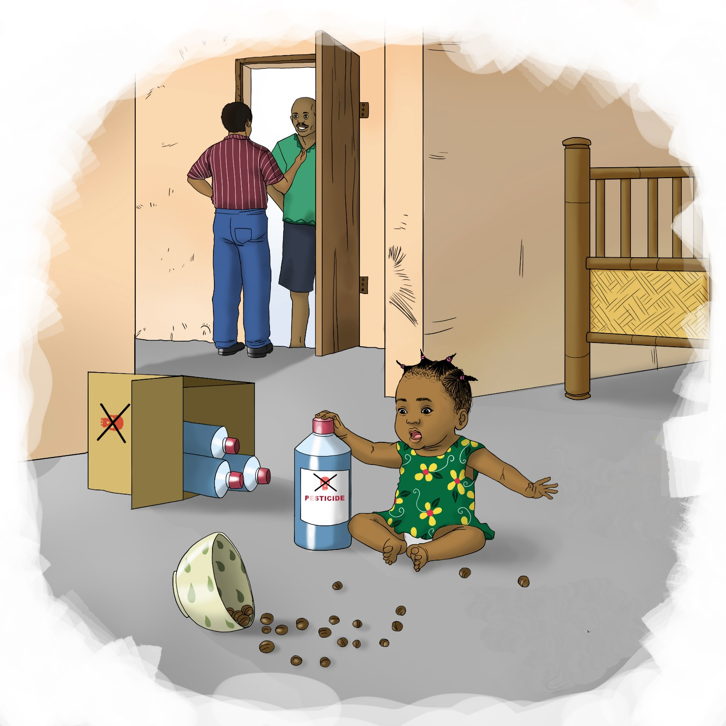

11

6- to 9-months

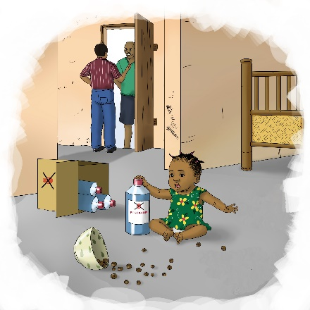
Reflection Questions:

▪ What do you see happening in this picture?
▪ How can some of these things harm this baby?
▪ Are there things in your home that may be harmful for your baby?
▪ How can you help your baby explore new things safely?

Suggested Actions:

▪ Encourage your baby to explore new things on his own in safe places where there is nothing that may accidentally harm him.
▪ Look around your home through your baby’s eyes and move the things that he may be able to reach that could be harmful.
▪ Create a safe space for your baby to play and explore that is clear of anything that may be dangerous. This may be a whole room, or a blocked off space where he can move freely and safely.

Key Messages:

▪ Babies learn by exploring the world around them. They want to go to new places, touch different things and put things in their mouths.
▪ It is good to let your baby explore to learn new things and you should encourage him to do this so he will build confidence.
▪ Once your baby can move on his own, it is important to make sure he is not able to get to anything harmful such as poisons, sharp objects, or small things that he may choke on.

12
9- to 12-months

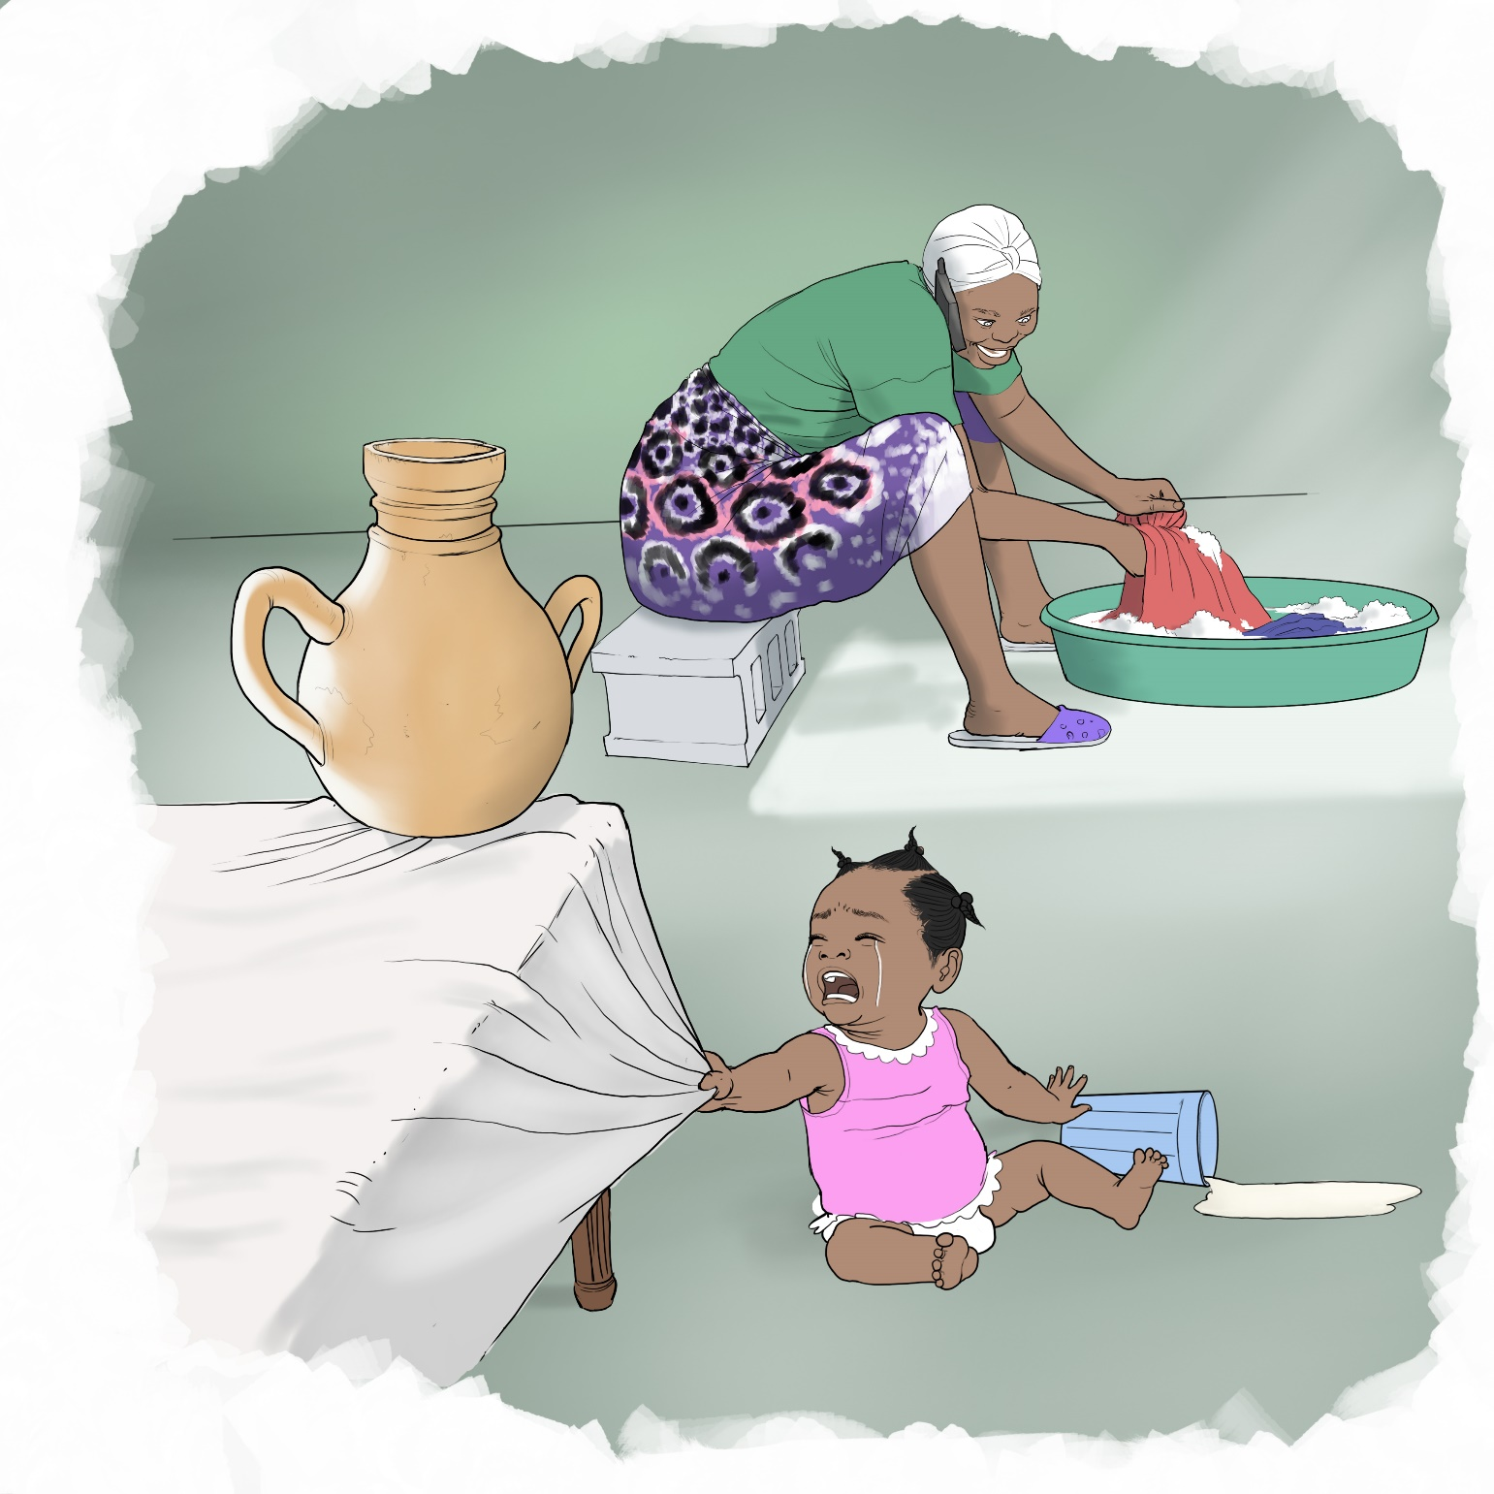

13

9- to 12-months

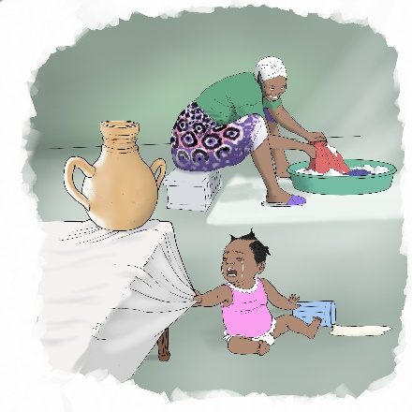
Reflection Questions:

▪ What do you see happening in this picture?
▪ How do you think this baby is feeling? What kind of response does she want from her caregiver?
▪ How do you know when your baby is upset, tired, hungry or sick?

Suggested Actions:

▪ Show affection to your child every day so she feels she is loved.
▪ If your child is upset, try to see things through her eyes and respond in the way that is gentle and affectionate.
▪ Never leave your child alone or ignore your child. If you are not with her make sure she is in the care of another responsible adult who can make sure she is safe.

Key Messages:

▪ Your child also needs to feel loved and safe so she can focus on learning new things.
▪ It is important to pay attention to your baby’s needs and emotions and respond to them in a loving way. This is not spoiling your baby, but it helps your baby to feel secure so she can focus on learning.
▪ When you are upset or angry with something your child has done, it is easy to react according to your own emotions, but it is very important to consider things through your child’s eyes. This can also help your baby feel connected to you and know she is safe with you.
▪ Your baby may sometimes be frustrated because she cannot express herself and will try to tell you what she is feeling through body language and the sounds she can make.

14
12- to 18-months

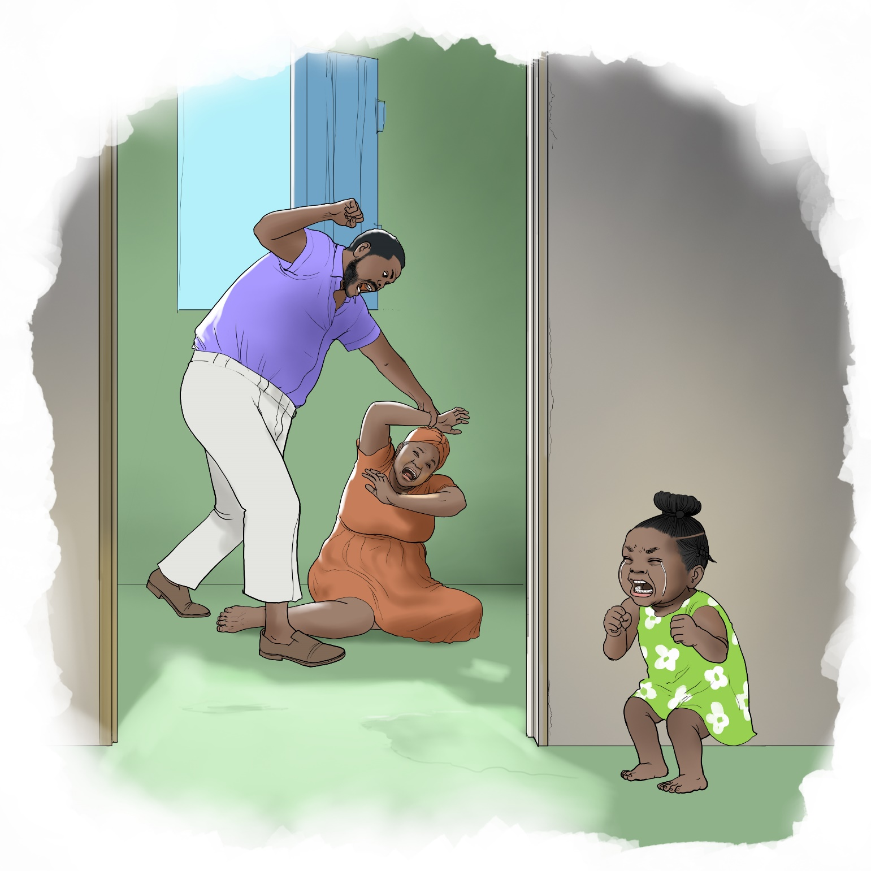

15

12- to 18-months

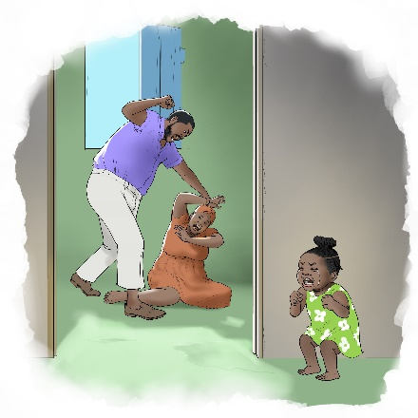
Reflection Questions:

▪ What do you see happening in this picture?
▪ Is there anything in this picture that relates to you?
▪ How do you think this child is feeling?
▪ How could this woman be supported? What might be a stopping her from seeking services or support?

Suggested Actions:

▪ Know that you have rights and options to keep yourself safe and there are laws against violence. Find out what community services are available to support you.
▪ Speak with a counselor, social worker or healthcare worker and tell them if anyone is harming you in your home or community. Talking openly with someone about what is happening can be helpful to manage your own emotions.
▪ If your child begins to behave differently after being near violence, understand this may be a reaction to stress. Make her feel safe and loved and stay with your normal routine as much as possible.

Key Messages:

▪ A woman should always be able to feel safe in her home and community. Intimate partner violence affects not only the couple, it impacts all members of the household.
▪ When children are around any violence, it affects them, even when the violence is not directed at them.
▪ Seeing, hearing or otherwise experiencing violence can make a child feel stressed and instead of learning they focus on their stress.
▪ When caregivers experience violence it also makes it difficult to focus on helping their children grown and develop.
▪ The effects from experiencing any form of violence may last a long time in a child, even after the violence stops.

16
18- to 24-months

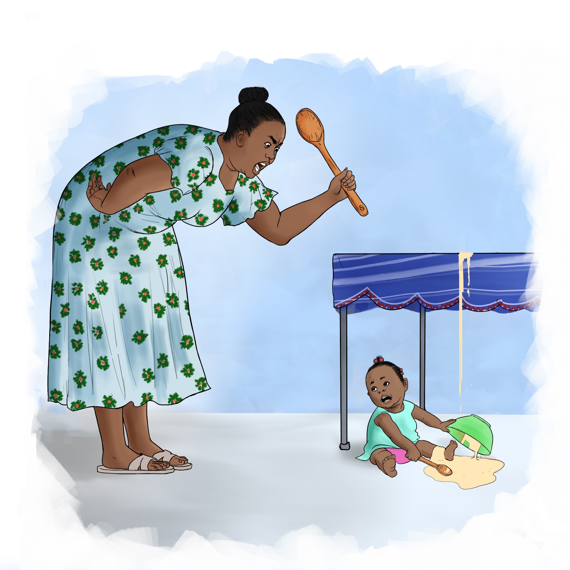

17

18- to 24-months

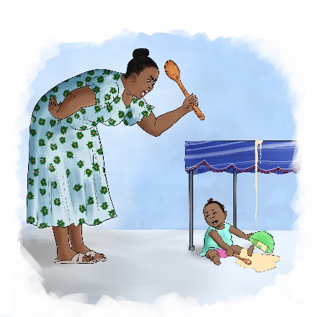
Reflection Questions:

▪ What do you see happening in this picture?
▪ What do you think this mother is feeling?
▪ What kinds of things does your child do to get your attention? What do you do when your child is “misbehaving”?

Suggested Actions:

▪ Though it is easy to be angry, stay calm and understand that your child is exploring what she can do, which is normal at this age.
▪ Praise your child whenever she behaves well, give her lots of attention when she does the right thing.
▪ If your child is trying to get your attention by misbehaving a little bit, ignore what she is doing and only pay attention again when she stops.
▪ If your child is seriously misbehaving, stay calm, but put her in a quiet corner or a nearby room, away from other people and things sshe enjoys. Keep your child standing or sitting there quietly for one to two minutes. If she runs away, pick her up and put her back until she finishes her time. Stay calm but firm and consistently do this every time she misbehaves.
▪ When your child stops misbehaving or completes her “time out”, immediately praise her and show her affection.
▪ If your child refuses to eat, be patient but allow your child to make a small choice, such as choosing what to eat first.

Key Messages:

▪ As children grow older, they become more independent and want to test the limits of what they can do.
▪ Children may not listen when you tell them to do something or may start doing things that annoy you on purpose.
▪ Even though your child can move more independently, she still needs and wants a lot of attention from you and will find ways to get your attention.
▪ If your child is doing something she is not supposed to do, you can teach her to do the right thing without having to hit her or shout.
▪ Children who are beaten or physically hurt learn that violence is normal and may grow up to become physically violent themselves.

18

